|  |
| --- |
|  |
| The Carbon Challenge: |
| Education for Sustainable Development |
|  |
|  |
| **C:\Documents and Settings\crawforde\Local Settings\Temporary Internet Files\Content.IE5\6HRXJ5J0\19490dldgngeexz[1].jpg** |

|  |
| --- |
|  |

About this Workbook

The author of this workbook is Mrs Elaine Crawford who is the Sustainable Development Adviser at Dumfries and Galloway College. Elaine has a MA in Environmental Sustainability and an MSc in Carbon Management, both from the University of Glasgow. The project to produce this range of workbooks began during a work placement with the Crichton Carbon Centre as part of the MSc in Carbon Management, when the first workbook was produced. As a result of this, a range of workbooks is now being developed to highlight Dumfries and Galloway College’s commitment to raising awareness of global issues that will affect us all and to ensure education for sustainable development is fully embedded within all aspects of the curriculum at the college. In places this workbook uses examples that are particular to Dumfries and Galloway College however the information it contains can easily be applied to any college. Answers are provided where appropriate; however some of the activities do not have right or wrong answers and are designed to generate awareness and/or debate. Guidance is provided for these activities.

Copyright Statement

© Dumfries and Galloway College 2012

All rights reserved

This work is designed to be adaptable for different curriculum levels and to be stored in retrieval system form for uploading to a Virtual Learning Environment, which is acceptable to Dumfries and Galloway College. However, no part of this work may be reproduced, transmitted or forwarded to any other organisation, in any form or by any means, without the prior written permission of Dumfries and Galloway College.

Any enquiries regarding reproduction or distribution of all or any part of the work must be made in writing to Dumfries and Galloway College.

Table of Contents

1. Introduction 4

1.1 Climate Change 4

1.2 Sustainable Development 6

1.3 Education for Sustainable Development 7

2. The Life Cycle of Everyday Objects 9

2.1 The Life Cycle of a paper clip 10

3. Carbon Footprints 11

3.1 Your Carbon Footprint 12

3.2 Carbon Footprints around the World 14

4. Calculating Energy Consumption 16

4.1 Electricity – Understanding Watts and Kilowatt Hours 16

4.2 Changing Light Bulbs 17

4.3 Energy Use at Home 18

5. Travel and Transport 21

5.1 Lifestyle Changes Relating to Travel 22

6. Food 23

6.1 Environmental Impact of Food 24

6.2 Fairtrade 24

6.3 Environmental Impacts of Food Production 25

7. Buildings 26

7.1 Case Study – The Empire State Building 27

8. Waste 28

8.1 Waste Generated in the Household or College 31

9. Water Use 32

9.1 Water Conservation 32

9.2 Water Calculator 33

9.3 Water Resources and Climate Change 34

10. Reference List 35

# 1. Introduction

The purpose of this workbook is to introduce the importance of sustainable development and how education can be used as a tool to convey this message. There are a number of reasons why sustainability and sustainable development have increasingly come to the fore in recent years, including the issue of human induced climate change. However, sustainability also addresses issues such as population growth, the use of limited resources and social justice. The workbook begins by explaining why climate change is a cause for concern and what sustainable development and education for sustainable development are. The following chapters aim to provide the knowledge required to make decisions about living more sustainably.

## 1.1 Climate Change

The Earth’s climate has varied naturally throughout its history, with periods when it was much warmer than today and ‘ice ages’, when Scotland was under glaciers a kilometre deep. However, during these times the Earth was much less densely populated than it is today. As you are probably aware, the Earth is now going through another period of warming – but this is different from those that have happened in the past. Over the last century global temperatures have been rising and scientists have concluded that this recent warming cannot simply be explained as natural variability. Human activities, mainly the emission of greenhouse gases (GHGs), are playing a major part. The main causes are the burning of fossil fuels (such as oil, coal and gas), and changes in land use, such as deforestation. As we increase emissions, the GHGs in the atmosphere also increase. This is resulting in an increase in global average temperatures, average sea level is rising, and snow and ice are melting at an alarming rate (IPCC, 2007). The Intergovernmental Panel on Climate Change has also concluded that most of the warming that has occurred since the mid 20th century is very likely due to man-made GHG emissions.

These GHG emissions are ‘enhancing’ the natural greenhouse effect. The greenhouse effect is a process which keeps the planet warm due to GHGs in the atmosphere trapping radiation from the sun – without it, the Earth would be much colder, around -18°C. The best known GHG is carbon dioxide (CO2), but there are a number of others, including methane, nitrous oxide and water vapour. Put simply, adding GHGs to the atmosphere enhances the greenhouse effect and results in global warming.

The latest research conducted by experts at the Met Office suggests that if we (and others around the world) continue to operate on a ‘business as usual’ basis, then we could see an increase in the global average temperature of ~4°C before the end of the 21st century. In addition to the changes already mentioned, this increase in global temperature will bring with it major changes to weather patterns and an increasing frequency and intensity of extreme weather events such as hurricanes, heavy rainfall events and heat waves. Such a large and fast change in climate is dangerous and will have severe and costly impacts (Stern, 2007). For example, our ability to produce food around the world will decrease significantly, hundreds of millions of people will face water stress while millions of others will face flooding, and around a third of all species are likely to become extinct (IPCC, 2007).

**The Natural Greenhouse Effect**

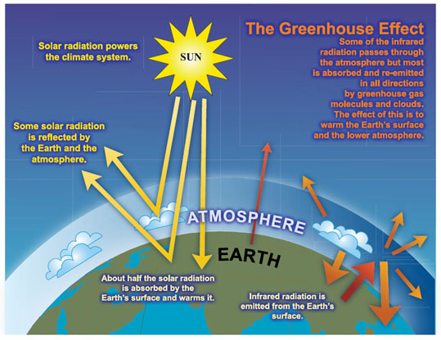

Source: Intergovernmental Panel on Climate Change Assessment Report 4 (2007)

Scotland, and the rest of the UK, will not be immune from the effects of climate change. Unless we seriously change our lifestyles to cut CO2 emissions, average temperature increases of up to 3°C in the winter and 4°C in the summer are likely to be experienced by our grandchildren and great-grandchildren (Met Office, 2009). The related weather changes are likely to mean floods, droughts and dangerous heat waves, with a rise in heat-related deaths. In 2003, 37,000 people died as a result of a heat wave in Europe, over 2,000 of which were in the UK (Met Office, 2009). Winters will be significantly wetter, with more intense rainfall. This would mean more flash floods, with rivers bursting their banks more often. Other impacts include an increasing incidence of severe gales and sea level rise affecting coastal areas causing flooding of coastal homes and businesses and coastal erosion.

Action now needs to be taken to reduce GHG emissions to ensure that global temperatures do not rise by more than 2°C; this will help to limit the most severe impacts of climate change. This challenge has been accepted by the UK and Scottish governments with the passing of The Climate Change Act 2008 and The Climate Change (Scotland) Act 2009, both of which set a legally binding target to reduce emissions by 80% from 1990 levels by 2050. In Scotland, the first interim target is a reduction of 42% below 1990 levels by 2020. As a result, we will see an increasing regulatory requirement to reduce emissions in both the workplace and the home. Everyone has to play their part in the drive to a more resource efficient, low carbon system if we are to meet these targets and avoid catastrophic interference with the climate system.

Due to the global recession, it is likely that global emissions have fallen due to a reduction in fossil fuel use. The Earth’s climate is also going through a natural cooling period, hiding the true extent of climate change for a short period. This may make it seem like we have turned a corner and that the problem has been solved. This will not be the case. Tackling the global climate will be a major project for the whole of humanity and throughout the lives of everyone at the college. We need to do all we can to reduce our GHG emissions by using fewer fossil fuels, more renewable energy and changing our lifestyles to reflect this. Climate change is coming, but with your help, we can reduce its impacts for ourselves and the generations which follow us.

## 1.2 Sustainable Development

Climate change will affect us all, and is impacted by our current economic model which is reliant upon the use of fossil fuels for continual economic growth. However, people around the world are increasingly recognising that current economic development trends are not sustainable and that there is an alternative model which is sustainable development. Sustainable development is a difficult concept to define and it is continually evolving making it even more difficult to define. One of the original descriptions and arguably the most famous was coined by the Brundtland Commission and states that,

**‘Sustainable development is development that meets the needs of the present without compromising the ability of future generations to meet their own needs’ (WCED, 1987).**

**HUMAN**

**WELL-BEING**

With sustainable development the economy is not considered alone but in conjunction with society and the environment. All three aspects are considered to be just as important as each other therefore if the three aspects of sustainable development are considered as three circles of the same size, the overlap in the centre is where human well-being is achieved. As the three elements of society, environment and economy become more aligned, the area of overlap will increase and so will human well-being.

In order to move towards sustainability, public awareness, education and training are required, which is the purpose of this range of workbooks. Whilst it is acknowledged that education is one of the key drivers to moving society towards global sustainability, the difficulty in defining sustainable development and whether it is achievable or not, continues to hamper progress. Different cultures have different visions of what a sustainable community will look like and how it will function. The lack of agreed definition and vision has made efforts to implement education for sustainable development (ESD) very challenging.

## 1.3 Education for Sustainable Development

We are well past the end of the United Nations Decade for Education for Sustainable Development (UNDESD) which began on 1 January 2005. The UNDESD was a global initiative that recognised the vital role that education had to play in the transition to achieve societal change that motivates all generations to develop a sustainable future (UNESCO, 2004). The overarching goal of the DESD was to ‘integrate the principles, values and practices of sustainable development into all aspects of education and learning, and all areas of life including communities, the workplace and society in general ’ (UNESCO, 2004). The Scottish Executive stated Scotland’s response to the DESD by publishing the ‘*Learning for our Future*’ action plan which advised what it wanted to achieve in the first five years of the DESD. An important aim of *‘Learning for our Future’* was by 2014 to give people the ‘knowledge, understanding, skills and values to live sustainable lives by fully integrating sustainable development into all stages of the formal education system’ (Scottish Executive, 2006). Five years on the Scottish Government published *‘Learning for Change’*, Scotland’s action plan for the Second Half of the DESD which reviewed the original plans to consider progress made to date, and also advised the actions required for the second half of the DESD. The Scottish Government announced progress made in the education sector taking into account climate change targets where they praised the progress made to date in the further education sector but highlighted the need to further embed ESD within all curriculum areas.

The concept of using education to achieve sustainability through a just and ecological society is not a new one. Schumacher (1973) acknowledged education as the ‘greatest resource’ we have at our disposal for attaining a paradigm shift to a sustainable way of life. The World Conservation Strategy also stated ‘a new ethic, embracing plants and animals as well as humans is required for human societies to live in harmony with the natural world’ and ‘the long-term task of environmental education is to foster attitudes compatible with this new ethic’ (IUCN, UNEP & WWF, 1980). Although this brought the term sustainable development to the public arena, it aimed to achieve it through conservation and was therefore limited to ecological sustainability and did not link sustainability to wider social and economic issues (Baker, 2006, p18). It was not until the Brundtland Report that social, economic and ecological aspects of development were explicitly considered together (WCED, 1987). The Brundtland Report also argued that ‘teachers had a crucial role to play in helping to bring about the extensive social changes necessary for sustainable development’ (WCED, 1987). In 1992 the United Nations Conference on Environment and Development produced Agenda 21, a comprehensive document which committed countries to promoting environmental sustainability through practice. This included education and community based projects at a local level highlighted by Local Agenda 21.

The first difficulty to overcome prior to evaluating or implementing ESD is determining exactly what it means. It was first defined by Chapter 36 of Agenda 21 which identified four major components of ESD which are, to improve basic education, reorient existing education to address sustainable development, develop public understanding and awareness and training (UNDESA, 1992). However definitions vary and attempting to establish an agreed definition of ESD still causes considerable academic debate which means it remains a contested phrase (Jones *et al*. 2008). One definition is that ‘ESD should be presented as ‘coping with’ rather than definitively ‘solving’ the ‘ecological crisis’ (Barry, 2007). However, this suggests we should adapt to the ecological crisis we are enforcing upon the Earth because it is inevitable, rather than change our behaviour to lessen our impact and avoid ecological crisis. ESD has many definitions, but this workbook encompasses the view that ‘sustainable development education is the process of acquiring the knowledge, skills and attitudes needed to build local and global societies that are just, equitable and living within the environmental limits of our planet, both now and in the future’ (SDE, 2008). Definitional conflict about all aspects of sustainability is nothing new, and there is still conflict today in understanding the term sustainable development, as it appears to ‘bring into harmony two politically attractive but potentially conflicting notions’ which is difficult to reconcile (Bonnett, 1999). If sustainable development still cannot be defined easily it is not surprising that neither can ESD.

There is definitely scope for further research into the Scottish College system to establish best practice for incorporating ESD within the curriculum at all levels in Scotland’s Colleges. Dumfries and Galloway College has taken a major step forward in embedding ESD within the curriculum by implementing this project to produce a range of workbooks across the curriculum. However, to be effective it has been acknowledged that staff engagement is vital.

The chapters that follow aim to provide some of the information required for staff and students to make informed choices about living their lives in a more sustainable fashion.

# 

# 2. The Life Cycle of Everyday Objects

Life Cycle Analysis (LCA) is a process used to measure the environmental impact of a product or process, from the beginning of its life to the end, or from the ‘cradle to grave’. As we can see from the diagram below, to make any product we need to start with the raw materials and then determine how they are processed to make the product, how the product is then used, before it is either discarded or recycled.



Source: Adapted from the Swedish Environmental Management Council

Recycling/Disposal

Use

Manufactureure

Processing

Extraction

Transportort

Transportort

Transportort

Transportort

Transportort

Think about what everyday objects are made of, the resources and energy used to make them, how long they can be used for, and what happens to them at the end of their useful life. You may also need to consider the following:-

* Different types of products and services have their most significant climate impact at different stages in their life cycles.
* For products with a long life and high energy consumption, the use phase typically accounts for the most significant climate impact, for example a washing machine.
* Other products will have their greatest impact during the production phase – this is usually the case for food production.
* Some products may not be recyclable and may need to go to landfill.

This is just a small snapshot of the impacts of the life cycle of an object. To see more about the environmental impacts of the products we consume, go to <http://www.storyofstuff.org/movies-all/story-of-stuff/> and watch the Story of Stuff.

## 2.1 The Life Cycle of a paper clip

Pictured below is a paper clip, it looks like a very simple object to produce. Have a good look at the picture and think about the following questions and the answers provided. The answers are not definitive but are provided to start you thinking about the life cycle process of an object.

**Q1** What are paper clips made from? Where does this material come from?

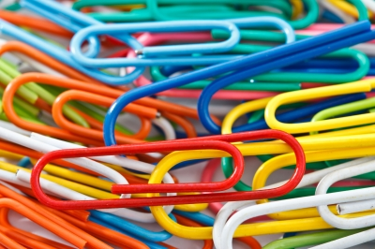

* Usually steel but sometimes plastic.
* Steel is made from iron ore which is extracted from the ground by mining.
* There are environmental consequences of mining.
* Iron ore is not renewable.

**Q2** How are they made? What energy is used to make them?

Image: Sura Nualpradid / FreeDigitalPhotos.net

* Have to be manufactured from raw materials.
* How energy intensive is it, also how water intensive?
* What about pollution?

**Q3** Once made, how do the paper clips get to the distributors that sell them?

* Transport at all stages produces GHG emissions, from extraction to processing, distribution and then consumer transporting.

**Q4** How long are they used for?

* They should last a long time.
* Using them does not produce any GHG emissions.

**Q5** What happens to paper clips once their useful life is over?

* Would you recycle it or put it in the bin?
* If you wanted to recycle would you know where to put a paper clip to recycle it?
* Even if recycled, because of the laws of thermodynamics, less than 100% of the material is recoverable.

**Q6** Can you think of other environmental impacts of a paper clip?

* What about the paper clips made from coloured metals or with the coloured plastic coatings? This introduces other material such as dyes and plastics.

# 3. Carbon Footprints

In the previous section the environmental impact of making things was considered. In our everyday lives we use hundreds of different products, all of which have an environmental impact throughout their lifetime. Producers of goods and services are increasingly becoming aware of these impacts and are starting to think of measures they can use to limit the amount of environmental damage their product is responsible for. One method of measuring this impact is carbon foot printing. A carbon footprint is the total set of greenhouse gas (GHG) emissions caused by an organisation, event or product (UK Carbon Trust, 2009). To make it easier to report, it is often expressed in terms of the amount of [carbon dioxide](http://en.wikipedia.org/wiki/Carbon_dioxide), or the amount of carbon dioxide equivalent of any other GHGs emitted.

A product’s carbon footprint is the total amount of GHGs produced across its life cycle from extraction to recycling or disposal. To measure a product footprint there is a ‘basket of six’ GHGs that are measured, these are:-

* Carbon dioxide (CO₂)
* Nitrous oxide (N₂O)
* Methane (CH₄)
* Hydrofluorocarbons (HFCs)
* Perfluorocarbons (PFCs)
* Sulphur hexafluoride (SF₆)

Many producers are now starting to measure the carbon footprint of the goods they produce. If a producer or manufacturer wants to reduce the carbon footprint of a product or services it needs to know how big it is first. Boots the Chemist, with help from the Carbon Trust, measured the carbon footprint of their Botanics shampoo range and as a result they determined where they could make reductions in the footprint of the products.

It is not just hairdressing products that manufacturers are looking at, below is an example of carbon footprint information for a brand of washing powder.

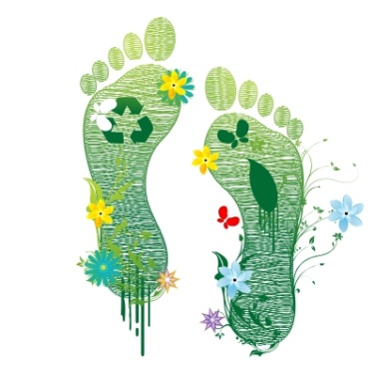

When measuring a carbon footprint, it is important to explain what the amount of carbon measured relates to, or to provide a meaningful unit. In this example the carbon footprint of 850g CO₂ is the amount per washing machine load.

The carbon footprint of this product is 850g per wash.

This can be reduced by washing at a lower temperature. Washing at 30°C instead of 40°C saves 160g CO₂ per wash.

850g CO₂ per wash

Image: digitalart / FreeDigitalPhotos.net



Image: By permission from Innocent Smoothies

This example refers to the amount of CO₂, 294g, per bottle of mangoes and passion fruits smoothie.

The main benefits of calculating a product footprint are to identify savings both in terms of money and for reducing carbon emissions. Also as customer demand grows for more ‘eco-friendly’ products it can be used to advertise your green credentials. If customer demand is sufficient this puts pressure on producers and suppliers to think about the environmental impact of their products.

The internet is a useful tool for finding information on the carbon footprint of products and events. A good place to start is the Carbon Trust website at [www.carbontrust.co.uk](http://www.carbontrust.co.uk)

The Carbon Trust website also has a range of tools, guides and reports which provide examples of how businesses and public sector organisations can address climate change and begin the journey to a low carbon economy. Available at <https://www.carbontrust.com/resources/?id=CTS053>, there are also case studies available at <https://www.carbontrust.com/our-clients/>.

## 3.1 Your Carbon Footprint

It is not only organisations, products and events that have carbon footprints. Activities in our daily lives cause GHG emissions and we can measure the amount to determine our own individual carbon footprint, just like we considered product carbon footprints previously.

The areas of our lives that generate most of our individual GHG emissions are as a result of:

* Electricity use
* Travel and transport
* Food production
* Buildings we use
* Waste

Carbon footprints are a sub-section of ecological footprints. Ecological footprints look to measure one person’s impact upon the world, or the amount of resources or space that are required for an individual to live their life. Go to the following website, <http://footprint.wwf.org.uk/> and enter the data to reflect your lifestyle, it will only take a few minutes to do so. Based on the information you provide regarding the way you live, the calculator will estimate how much of your share you are using to support your lifestyle. This is based on the amount of land required to produce the quantity of resources that you consume.

Record here how much of your share your lifestyle requires _________%

Record here your carbon footprint _________ tonnes per annum

***You may be surprised by the results! Remember we only have one Earth!***

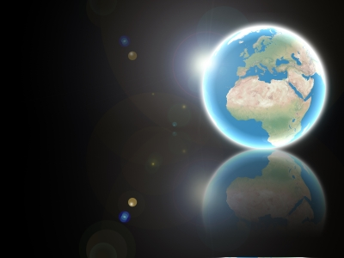

**Available Resource**

**=**

**1 Planet Only!**

Image: Salvatore Vuono / FreeDigitalPhotos.net

**Guidance for 3.1 Your Carbon Footprint**

The share that your lifestyle requires, or your ‘ecological footprint’ will be calculated based on your lifestyle, so your answer will be different to that of your colleagues or students. This also applies to the number of tonnes of carbon your lifestyle generates.

This exercise can be used to generate discussion as to why your lifestyle produces different figures from someone else’s. Does one of you fly more than the other, does someone use more public transport instead of a personal car, and maybe someone grows their own food and only buys organic, seasonal produce wherever possible, whereas someone else buys all pre-packaged processed food. The amount of ‘stuff’ you consume will also affect the numbers, as will the size of house you live in and how you use energy in it.

This exercise is a good way to compare and contrast lifestyles of different people around the world, looking at those who live within the confines of one planet and those who don’t. It can be used to debate the social injustice of those who have and those that don’t. This would also be a good opportunity to look at the United Nations Sustainable Development Goals.

**3.2 Carbon Footprints around the World**

Not everyone in the world lives in the same way as many of us in Scotland and other industrialised countries do. Some people are more environmentally aware and try to limit their impact upon the Earth and its resources wherever possible, whilst others don’t. Also, not everyone has access to the same amount of the Earth’s resources or the means to live as we do in the western world. The diagram below shows the average carbon footprint of the average North American in tonnes of carbon dioxide equivalent, (this is the total GHG emissions from the ‘basket of 6’ GHGs) which is compared against the average carbon footprint of someone who lives in Dumfries.

**Reminder, ‘basket of six’ greenhouse gases:**

* Carbon dioxide (CO₂)
* Nitrous oxide (N₂O)
* Methane (CH₄)
* Hydrofluorocarbons (HFCs)
* Perfluorocarbons (PFCs)
* Sulphur hexafluoride (SF₆)

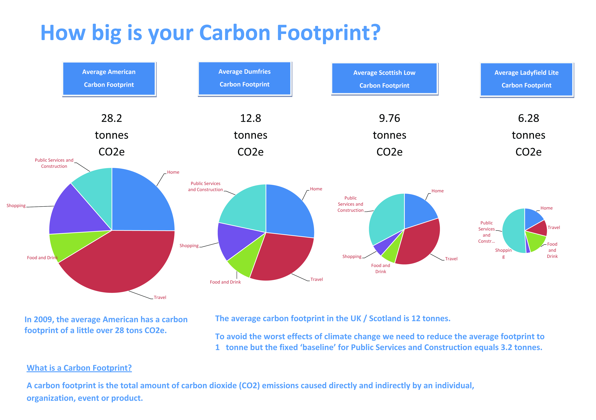

Source: Carbon footprint tool developed by the Crichton Carbon Centre

In 2009 the average North American had a carbon footprint of just over 28 tonnes of carbon dioxide equivalent and the average carbon footprint in Dumfries was nearly 13 tonnes of carbon dioxide equivalent. Whist the carbon footprint of the average person in Dumfries is significantly lower than the average North American; we are still not living within the available resources on the Earth if everyone were to have the same share. Ecological footprints measure the amount of hectares of land that are required to provide all of the goods and services a person consumes. To put this into perspective, the average North American person needs 8 hectares of land to support their lifestyle, the average British person needs 4.9 and the average Indian person only uses 0.9 hectares of land (Global Footprint Network, 2010). This highlights the social injustice that exists between different lifestyles around the world.

Put simply if everyone in the world lived like the average North American we would need another four planets in addition to the one we already have! Unfortunately we do not have five Earths!

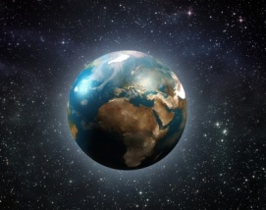

Image: Idea go / FreeDigitalPhotos.net

At the other end of the scale, the average person in China has a carbon footprint of 5 tonnes of carbon dioxide equivalent and in Bangladesh the average is as low as 1 tonne of carbon dioxide equivalent (Clark *et al*, 2009).

We will now move on to look at the areas of our lives that generate the majority of our GHG emissions.

# 4. Calculating Energy Consumption

## 4.1 Electricity – Understanding Watts and Kilowatt Hours

We calculate electricity in units of kilowatt hours (kWh). In the same way that 1 kilometre = 1000 metres; 1 kilowatt hour = 1000 watt hours.

When we look at anything that runs on electricity, such as a hairdryer or a television, there is usually a label that tells us how energy hungry it is - this is the number of watts (W) the piece of equipment uses – or its ‘wattage’. See the example below:

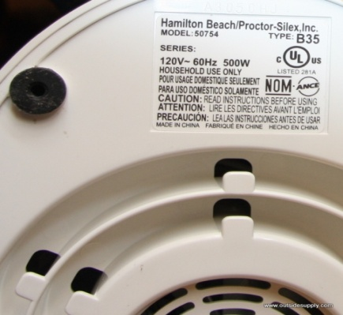

The picture to the left shows a household food blender with the panel you are looking for. The panel states the wattage of the blender is 500 watts.

Before calculating how much energy is used by electrical appliances in our home, we will look at a simple example of electricity consumption using light bulbs in a college classroom.

**Stage 1**

If there are 8 light bulbs in a classroom and each light bulb is 100 W, then to find out the total wattage of the lights you need to multiply the number of bulbs by the wattage:

**Total wattage (8 bulbs) = 8 x 100 W = 800 W**

**Stage 2**

To work out the ‘watt hours’ (Wh), how many hours it is used for, that a piece of equipment uses, we need to know the wattage **and** the number of hours it is turned on for.

**Watts x hours = watt hours**

**Stage 3**

Then to find out how many kilowatt hours this is, we divide the number of watt hours by 1000:

**Watt hours ÷ 1000 = kilowatt hours**

For example, if the eight 100 watt bulbs in the classroom are turned on for 5 hours, then:

**800 watts x 5 hours = 4000 watt hours**

**4000 watt hours ÷ 1000 = 4 kilowatt hours**

To calculate how much energy the classroom uses for lighting in a year, we need to estimate how many hours the lights are turned on for in a year. To do this we need to estimate the number of hours they are on per day, the number of days they are on per week, and the number of weeks per year.

The classroom lights are usually on for 8 hours per day, there are 5 days in the college week, and 40 college weeks per year, so the classroom lights are on for:

**[8 hours/day x 5 days/week x 40 weeks/year = 1600 hours/year]**

And the energy they use in a year is:

**800 watts x 1600 hours/year = 1,280,000 watt hours/year**

**1,280,000 watt hours/year ÷ 1000 = 1280 kilowatt hours/year (kWh/yr)**

**Based on an average electricity unit price of £0.10, 1 kWh costs £0.10**

**Therefore 1280 kWh/yr costs 1280 x £0.10 = £128.00**

## 4.2 Changing Light Bulbs

The previous example used 100 watt bulbs in the classrooms; however the college uses low energy fluorescent lighting in the classrooms. Each light fitting contains two 35 watt bulbs, and there are 11 fluorescent lights in the classroom. Prior to moving into the new college building, we will assume the old college building used light fittings with 100 watt bulbs, and there were 15 of these bulbs in a classroom. Using this information we can calculate how much energy and money the college saved when they moved to the new building by using lower wattage bulbs in the classrooms. Complete the following table to finish this calculation.

**Hint:** Estimate how many hours the lights are on each day based on an eight hour day. Remember there are 5 college days in a week, and 40 college weeks in a year, so there are 200 college days in a year.

**Remember:** (watts x hours per year) ÷ 1000 = kilowatt hours per year

**(Answers are provided in red)**

|  |  |  |  |  |  |  |
| --- | --- | --- | --- | --- | --- | --- |
|  | **Wattage of 1 bulb [W]** | **Number of bulbs** | **Total watts of all bulbs [W]** | **Hours on per day [hours / day]** | **Hours on per year [hours / year]** | **Kilowatt hours of energy per year [kWh / year]** |
| **Old bulbs** | 100 | 15 | 100w x 15 bulbs =  **1500 watts** | 8 | 8 hours x 200 days =  **1600 hours** | 1500 watts x 1600 hours = 2,400,000watt hours ÷ 1000 = **2400 kWh / year** |
| **New bulbs** | 35 | 22 | 35w x 22 bulbs =  **770 watts** | 8 | 8 hours x 200 days =  **1600 hours** | 770 watts x 1600 hours = 1,232,000watt hours ÷ 1000 = **1232 kWh / year** |
|  | | **Savings** | 1500 – 770 =  **730 watts** |  | **Savings** | 2400 – 1232 =  **1168 kWh / year** |

**Q1** Therefore how many kWh of electricity have been saved in a year in classroom by changing the bulbs? = **1168 kWh / year**

**Remember:** the average cost of 1 unit of electricity costs the college £0.10

1kWh of electricity costs **£0.10**

Therefore a reduction in use of **1168kWh** saves **1168 x £0.10 = £116.80 year**

**Q2** The new college building has many classrooms, therefore how much electricity and money has the college saved by changing the light bulbs in 20 classrooms?

One classroom means a reduction of **1168 kWh / year**, so 20 classrooms means a reduction of **1168 x 20 = 23,360 kWh / year**

One classroom saved **£116.80 a year**, so 20 classrooms saves **£116.80 x 20 = £2336.00 a year**

## 4.3 Energy Use at Home

The calculations used for the light bulbs in the college classrooms, can be applied to the electrical equipment we use in our homes. Look around your home and choose five pieces of electrical equipment you can find the wattage easily for. Remember, this can be found for many items on a little panel on it, failing that you can find the wattage in the manufacturer’s guide, if you still have it, or by searching on the internet (a good site is [www.sust-it.net](http://www.sust-it.net) ).

The items can be anything electrical, for example, a television, kettle, microwave, or even something you only use occasionally such as an electric lawnmower.

**Hint:** Once you have selected your electrical equipment, make an estimate of how many hours a day on average it is switched on and then complete the following table. The first line has been completed as an example.

**Remember:** there are 365 days in a year

|  |  |  |  |  |  |
| --- | --- | --- | --- | --- | --- |
| **Type of equipment** | **Make and model** | **Wattage [W]** | **Hours of use per day [hours / day]** | **Hours of use per year [hours / year]** | **Kilowatt hours of energy per year [kWh/year]** |
| **Television** | **Sony KDL 32EX603 32"** | **80** | **5** | **5 x 365 = 1825 hours / year** | **80W x 1825 hours = 146,000 watt hours ÷ 1000 = 146 kWh/year** |
|  |  |  |  |  |  |
|  |  |  |  |  |  |
|  |  |  |  |  |  |
|  |  |  |  |  |  |
|  |  |  |  |  |  |

**Q1** What is the most energy intensive piece of equipment you found? Remember this is the piece of equipment with the highest wattage per hour.

**Q2** Which piece of equipment you looked at in your household consumes the most electricity per year?

**Q3** Were you surprised by any particular result? If so, for what piece of equipment and why were the results surprising?

**Q4** Can you think of an example of an electrical item that you could substitute manpower for and still achieve the same result?

**Q5** What room in your house do you think is the most energy intensive in terms of electricity? Why do you think this is?

**Q6** Take the piece of equipment with the highest wattage per hour and search the internet for a less energy intensive alternative. Record your findings.

**Guidance for 4.3 Energy Use at Home**

There are no right or wrong answers for this exercise. The aim of this exercise is to raise awareness of energy use in the home; following on from looking at light bulbs in the college and the money that could be saved from making small changes such as switching to a lower wattage bulb. This can help you consider if there are changes you can make to the equipment you use at home to be more energy efficient. This doesn’t mean replacing equipment in perfectly good working order for more energy efficient models, if the equipment you are replacing ends up in landfill, but when the item does need replaced, consider replacing it with a model that uses less energy.

Being aware of how much energy a piece of equipment uses and how much it costs to use it will hopefully make you think about your energy use. Consider if you really need to switch it on and if so, don’t leave it on standby, wasting energy and money when not in use.

# C:\Documents and Settings\crawforde\Local Settings\Temporary Internet Files\Content.IE5\ZKTVDTJZ\25218wxlw8d7a6o[1].jpg5. Travel and Transport

Transport and travel make up a large part of our carbon footprints. Much of this can be attributed to the use of the motor car as this has become the most popular and convenient way for many of us to travel. The car is often seen as a ‘status symbol’ and for many 17 year olds, obtaining a driving licence and owning a car is considered a natural part of becoming an adult.

Image: xedos4 / FreeDigitalPhotos.net

Below are details of the emissions for different car sizes, petrol and diesel, for a **10 mile journey.**

|  |  |
| --- | --- |
| Size of car and fuel used | Total GHG emissions (kg CO₂eq) / 10 mile journey |
| Small petrol car, up to 1.4 litre engine | 2.9 kg CO₂eq |
| Medium petrol car, from 1.4 – 2.0 litre engine | 3.5 kg CO₂eq |
| Large petrol car, above 2.0 litres | 4.8 kg CO₂eq |
|  |  |
| Small diesel car, up to 1.7 litre engine | 2.5 kg CO₂eq |
| Medium diesel car, from 1.7 – 2.0 litre engine | 3.0 kg CO₂eq |
| Large diesel car, above 2.0 litres | 4.1 kg CO₂eq |

Total greenhouse gas emissions are advised in kg of carbon dioxide equivalent (kg CO₂eq); this includes all emissions from the ‘basket of six’ greenhouse gases that were introduced earlier.

**Reminder, ‘basket of six’ greenhouse gases:**

* Carbon dioxide (CO₂)
* Nitrous oxide (N₂O)
* Methane (CH₄)
* Hydrofluorocarbons (HFCs)
* Perfluorocarbons (PFCs)
* Sulphur hexafluoride (SF₆)

If you travel 100 miles a week in your car, from the table above it is easy to see how the emissions start to add up throughout the year. Let’s compare the annual emissions from a small petrol car against a large diesel car that drives on average 100 miles a week.

**SMALL PETROL CAR** up to 1.4 litre engine – **2.9 kg CO₂eq** for 10 miles

2.9 x 10 = **29 kg CO₂eq** for 100 miles in a week

29 x 52 = **1,508 kg CO₂eq** for 5,200 miles in a year

**LARGE PETROL CAR** above 2.0 litres – **4.1 kg CO₂eq** for 10 miles

4.1 x 10 = **41 kg CO₂eq** for 100 miles in a week

41 x 52 = **2,132 kg CO₂eq** for 5,200 miles in a year

So the difference between driving a small petrol car 100 miles a week over a year and a large diesel car 100 miles a week over a year is **624 kg CO₂eq**

**To put this into perspective this is roughly equivalent to a long haul economy flight to India.**

## 5.1 Lifestyle Changes Relating to Travel

Think of your lifestyle and look at the following table advising where you could make changes to reduce the GHGs you generate from travel. Also think about the barriers which may make it difficult for you to implement these changes and try to think of solutions to overcome the barriers. Some examples have been provided for you, these examples are not exhaustive and you will be able to think of many more.

|  |  |
| --- | --- |
| Lifestyle Change | Barrier/Solution |
| I will use public transport to travel to work instead of my car. | Barrier – the bus timetable does not get me to work on time.  Solution – my employer has agreed that twice a week I can start and finish earlier, fitting my hours in with the bus timetable. |
| I will not fly abroad on holiday any more. | Barrier – I want a holiday in the sunshine and it rains all the time in Scotland.  Solution – take the ferry to the South of France instead, or consider Cornwall which is sunnier than Scotland. It is easy to travel to France and Cornwall by other means of transport rather than flying. |
| I will buy a car with a smaller engine that has lower greenhouse gas emissions. | Barrier – I can’t afford to replace my car.  Solution – thinking sustainably should not mean replacing perfectly good equipment. However, when you do need to and can afford to replace your car, consider a lower emission alternative. |

It may not always be possible to implement a positive solution to the barrier, for example your employer may not allow you to work different hours two days a week. However, until you consider the barrier and look for a solution you will never know if a lifestyle change could be possible.

# 6. Food

It should already be evident to you from calculating your carbon footprint that one of the major contributors to our ecological and carbon footprint is the food we consume, but why is this? The easiest way to explain it is to look at an example of an everyday snack or lunch we may enjoy.

Taking a bacon, lettuce and tomato sandwich as an example, where do all of the ingredients come from?

Bacon – 2 slices from an industrial piggery in Denmark causing massive amounts of slurry which pollutes waterways

Iceberg lettuce – 2 large lettuce leaves produced in a Dutch greenhouse in the middle of winter and then transported by ship and road to British supermarkets

Bread – 2 slices from wheat grown on arable land in England where hedgerows have been removed and wildlife sprayed with toxic chemicals

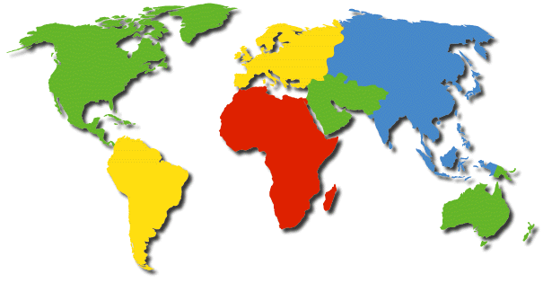

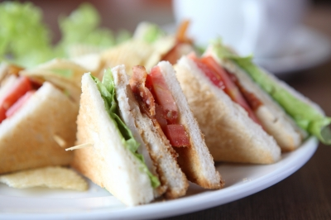

Tomatoes – grown in factory sized greenhouses in southern Spain where the rivers have been sucked dry for irrigation

Mayonnaise – produced from vegetable oils extracted from soya grown in cleared Amazon rainforests

Source: Adapted from the Teachers pack School Global Footprints (WWF Scotland, 2006).

Image: piyato / FreeDigitalPhotos.net

We can see from the example above, just how far our food often travels before it ends up on our plate. In the last section on transport, we calculated the amount of greenhouse gas emissions that resulted from different forms of travel. Therefore, it should be evident that if we were to consume less food grown in other countries and transported to the UK, and eat more food produced in the UK, this would reduce our carbon footprint in relation to food consumption. However, it is not always this straightforward. What would we do if we wanted fresh strawberries in January or pineapple at any time? Should we only eat seasonal fruit and vegetables that can be grown in the UK without the need for energy intensive hot houses?

## 6.1 Environmental Impact of Food

As we have seen, everything we eat has an impact upon the environment however there are steps we can take to help reduce the environmental impact of food, including the following:

* Shop locally and if possible, leave the car at home.
* Plan one big trip if using a large supermarket instead of going two or more times per week.
* Buy locally grown produce when it is in season.
* Avoid food which is over packaged whenever possible.
* Buy organic produce.
* Buy fair-trade goods which support third world communities and are usually transported by sea.

## 6.2 Fairtrade

Fairtrade has gained in popularity over recent years in our shops and supermarkets, especially with items such as tea, coffee, cocoa, chocolate and bananas. The purpose of Fairtrade is to provide justice and equality for small independent producers and the workers on plantations. The plantations are located in developing countries where workers are often exploited. In the past many of these farmers and workers were paid low wages and forced to work in poor conditions meaning they had to live in poverty. All of this meant they had little opportunity to improve their situation. Fairtrade aims to reverse this trend by ensuring there are standards in place for working conditions, and by implementing prices for traders and consumers. This means the farmers and workers are paid a fair wage. Fairtrade also ensures that the welfare conditions for the workers are acceptable, that children are not employed who should be in school and that farming practices are sustainable.

When we think of Fairtrade products, some of the first things that spring to mind include tea and coffee, or chocolate and bananas, none of which grow in the UK. Therefore, sometimes we need to think about compromising one belief or value we have, to support another. In this case the carbon emissions to transport these goods around the world, versus the need to help communities in developing countries support themselves and receive a fair income.

There may be other areas apart from Fairtrade where you may choose to compromise; especially in terms of the money you have available to spend, in order to support an environmental belief. For example, it is more expensive to buy free range chicken than battery farmed, which means you may choose to eat the more expensive free range chicken once a week instead of the cheaper alternative more often. Another example is looking for tuna that is pole and line caught which is more expensive than standard tins of tuna which have been caught by a process called purse seining. This involves huge nets which catch everything in the marine environment, including sharks and turtles (and sometimes even dolphins, although they state on the tin they are ‘dolphin friendly’). These other species are then discarded as by-catch and thrown back into the sea dead.

## 6.3 Environmental Impacts of Food Production

Decide what your favourite meal is, whether this is a burger, a curry, or fish and chips, and think about what the environmental implications could be of producing that meal. Use the internet to search for the implications of the ingredients within the meal. Think about where and how the ingredients are grown and how they reach the supplier you have purchased them from.



My favourite meal is _______________________

The ingredients include:

Image: savit keawtavee / FreeDigitalPhotos.net

# 

Record here what you think some of the environmental impacts of your meal could be

## Guidance for 6.3 Environmental Impacts of Food Production

There are many different environmental impacts that could be highlighted in this exercise; here are just a few examples:

* Has the food been sourced sustainably, such as fish, is it from a sustainable fishery?
* Have any of the ingredients been flown to the UK, if so why. Are they ingredients not grown in the UK, or are they not in season in the UK?
* Are any of the ingredients Fair Trade?
* Are the ingredients organic?
* Are there are any animal welfare issues, such as free range or battery chicken or eggs? Are there any animal ingredients from countries outside the UK where animal welfare rules are different?

# C:\Documents and Settings\crawforde\Local Settings\Temporary Internet Files\Content.IE5\Y3UK4JC7\507019xxcnt95ls[1].jpg7. Buildings

**Sydney at Night**

Around half of all global GHG emissions are generated from buildings. During the useful life of a building, this includes emissions during construction, the electricity consumed within them and the energy required to heat them. Once we are finished with the building there are emissions associated with its demolition, with materials either being recycled, which uses energy, or sent to landfill, which has other environmental impacts also. As we have seen earlier this is emissions from the ‘cradle to the grave’ of the building. There is huge potential for energy reduction in buildings as they are responsible for 40% of energy consumption and 36% of European Union CO2 emissions (European Commission, 2010).

Image savit keawtavee / FreeDigitalPhotos.net

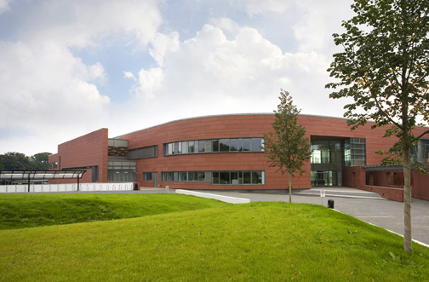Dumfries and Galloway College is a new building and has been designed and built to be energy efficient. However, this does not mean that improvements in energy reduction cannot be made because a building can be as energy efficient as possible, but if it is not used correctly then it will not be effective. For example, in the college a great number of the students use the disabled access doors at the main entrance instead of the revolving door. Constantly opening these doors makes the energy used for heating in this area inefficient. A campaign to educate the students why to use the revolving door could help to overcome this. This is why it is important not just to use the most energy efficient type of electrical equipment available, but also to ensure it is not left switched on unnecessarily. In a building such as a college, equipment like computers and printers are often left on standby consuming energy and costing money which could easily be saved. A simple measure such as placing stickers beside equipment reminding staff and students to switch it off once they have finished with it could help reduce this.

Out with the college, in our homes and workplaces there are simple and inexpensive measures that can be implemented such as:

* Replacing light bulbs with lower wattage versions where possible.
* Switching appliances off at the plug socket to ensure they are not accidentally left on standby.
* Draught proofing doors and windows by using secondary glazing or fitting heavy lined curtains in the winter months.
* Placing special foil panels behind radiators to reflect more heat into the room.
* Redecorating with insulating paint.

**Blacklaw Wind Farm**

**Lanark, Scotland**

There are other measures which require more time, effort and money such as:

* 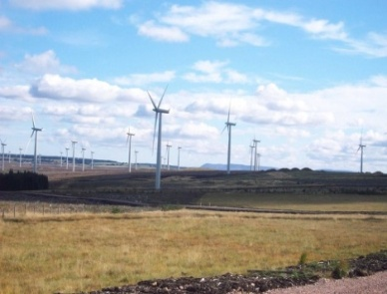Replacing doors and windows with double or triple glazing.
* Ensuring there is adequate wall and roof insulation.
* Upgrading the boiler and heating system when they need replaced.
* Replacing electrical appliances with energy efficient rated models.
* Switching electricity suppliers to one that utilises renewable energy sources to generate electricity.

A lot of the inexpensive measures can help to save money in the long run by reducing your energy bills. Some of the more expensive measures such as fitting adequate insulation in your home may be eligible for a government grant to help with the cost, even where you own your own home, are under 70 and are not in receipt of any income related benefits. For details of eligibility check the Governments Grant website at <http://www.government-grants.co.uk/>

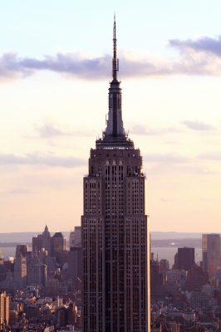

**7.1 Case Study – The Empire State Building**

Whilst moving forward, new buildings can be designed and built to be energy efficient, however existing buildings also need to be considered. The Empire State Building in New York is in the process of a major refurbishment which aims to reduce the energy usage of the building by up to 38% by 2013. Using computer modelling, the building’s energy efficiency was analysed to identify areas where the overall energy efficiency could be improved. The project team then decided to focus on eight economically viable measures which are expected to save around $4.4 million a year in energy costs. These measures include:

* Refurbishment of the building’s 6500 windows to create triple-glazed insulated panels
* Fitting insulation behind radiators to reduce heat loss
* Improved lighting and controls to reduce electricity usage
* Replacement of the building’s air handling units to increase operational efficiency
* Introduction of demand control ventilation

(Energy Efficiency News, 2009)

Image: Paul Martin Eldrige / FreeDigitalPhotos.net

Commercial and residential buildings account for the majority of the carbon footprint of major cities around the world, over 70% in New York. Therefore, finding a viable solution to retrofit existing major buildings to reduce their energy consumption and make cities cleaner and more energy efficient is vitally important.

# 8. Waste

# headerBg.gif

There is a limit to the amount of waste the Earth can absorb. When we look at a product and the waste it generates, we need to look at it from the ‘cradle to grave’. This is why we have looked at products so far starting with the raw materials they are made from and ending with the disposal of the item. In order to reduce the amount of waste we produce, we need to reduce the number of products we consume. We have more money to buy more ‘stuff’ and as we like new ‘stuff’ we are always buying more. Also, products are not made to last like they were in the past. Our grandparents would ‘make do and mend’ whilst we just throwaway and replace. Economies of countries are driven by producing and selling more materials, so to make products that last longer does not make economic sense.

Packaging is a major source of waste. The minute we remove it from a product waste is produced. One way to reduce the amount of packaging is by consumers putting pressure on suppliers to not over package their goods. This may be difficult for an individual, however if you are responsible for purchasing products on a large scale for an employer or your own business, this may then become possible. It is also worth investigating if a supplier has an environmental policy and, if so, what it consists of, before deciding to use that supplier. As was established in the section on the life cycle analysis of a product, we should consider waste impacts from ‘cradle to grave’ for a product. If we produce and use less packaging, this means there are less raw materials required to make the packaging and less energy being used also. Less packaging also means less waste to recycle, which also uses energy, or less waste to send to landfill.

Some of the waste produced in the college, for example in the hair and beauty salons or the workshops, is not only a concern due to the disposal of packaging but also due to disposal of the chemicals used in the products. Chemical waste causes pollution, which can be either point source or non-point source. Point source pollution is usually defined as pollution where the origin can be defined from one source, such as at the end of a pipe. Non-point source pollution is caused indirectly by chemicals leaking into groundwater. If disposed of incorrectly, chemicals can cause pollution to our environment by leaching into our groundwater from landfill sites. This can have a negative long-term effect on human health and also impacts upon plants and animals.

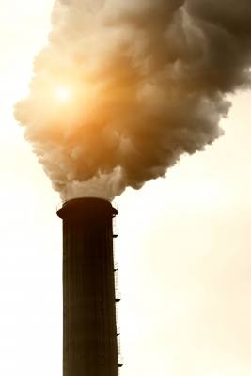

Here is an example of **point source pollution** or end of pipe pollution. It is generally easy to see and recognise point source pollution, which can make it easier to address.

Image: dan / FreeDigitalPhotos.net

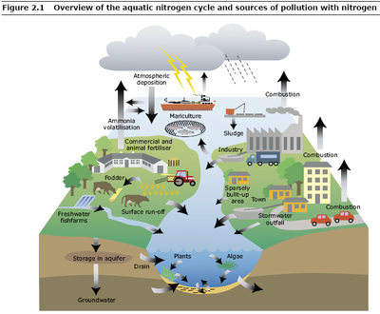

Source: http://www.eea.europa.eu/themes/water/water-pollution

**Non-point source pollution** can be more difficult to identify as it can originate from many sources. In the picture above chemicals are leaching into groundwater from many different sources including farming, industry and towns.

However, attitudes towards waste in our society are slowly changing. The best way to minimise the amount of waste we produce is to reduce the amount we produce in the first place. Failing this the next best option is to re-use it wherever possible and if this is not possible then recycle it. Most of you will probably be familiar with this concept already:

Reduce the amount of waste we produce

(For example by manufacturers using less packaging on products or by consumers buying re-fill packs which use less packaging. Consumers can also put pressure on manufacturers and retailers to use less packaging.)

Reuse packaging or waste wherever possible, either for the same purpose or find a new use for it

(For example, save last year’s Christmas cards and wrapping paper. Wrapping paper can be used again and Christmas cards can be cut up and used as name tags or decorations. Old magazines and newspapers can be used as wrapping paper with some pretty ribbon or bows added).

Recycle break your rubbish down and reprocess it

(However, remember this uses further energy and some items cannot be recycled because of toxic chemicals in them or because they may have manufactured from different materials squashed together).

So most of us are familiar with the message reduce, re-use, recycle. However, this can also be added to:

Repair broken items instead of discarding them and buying new ones

(For example, with our clothing, skills such as sewing are not so prevalent nowadays as they were in the past when clothing items would be mended instead of discarded. Also have shoes re-heeled or re-soled where possible instead of throwing them away).

Refill empty containers

For all non-renewable resources such as metals, glass and plastics, we need to remember, as they say in the supermarkets for special offers **‘when it’s gone, it’s gone’.**

The Earth is a closed system and once these materials have been used up the Earth can’t make any more of them within human timescales.

## 8.1 Waste Generated in the Household or College

Think of the products and materials that are used in an everyday household or college and make a list of the waste you think is generated within a normal week. If possible think of how this waste could be eliminated or reduced, or if this is not possible, how would you dispose of it with as little environmental impact as possible? Some examples are provided in the table below to start you thinking. Use the internet to search for recycling or waste disposal methods, a good site to start with is <https://www.recyclenow.com/>

|  |  |  |
| --- | --- | --- |
| Waste Produced |  | Method to Eliminate, Reduce or Dispose |
| Food waste |  | Only buy what you will use, avoid 2 for 1 offers in the supermarket unless you know you will eat both  Disposal – compost where possible |
| Used batteries |  | Use re-chargeable batteries wherever possible  Disposal – do not put in your household trash, where they can end up in landfill. Contact the council for disposal facilities in your area. If your college does not already do it, consider battery recycling collection points. |
| Unwanted furniture/household items |  | Consider selling at a car boot sale or place unwanted items on recycling websites where someone else can then get use of it. Also charity shops will often take large items away for free that they can sell in their shops.  Disposal - contact your council to see if they have any recycling facilities for what you are looking to get rid of |
| Paper coffee cups |  | Consider offering cash savings at your college coffee bar for those who use their own reusable mug. Dumfries and Galloway College offer 20 pence off your coffee if you ‘lug your own mug’.  Disposal – if you must dispose of paper cups in college ensure you have appropriate recycling methods in place |

# 9. Water Use

Water is essential for all living things on Earth, however it is a resource we take very much for granted in Scotland where we rarely have water shortages. Due to this, we do not always consider water as a finite resource and that not everyone in the world has access to readily available clean water, as we do. In 2007 the average Scottish person used 146 litres of water per day, which is 6% more water per person per day than we used 20 years ago.

## 9.1 Water Conservation

It is difficult to appreciate the need for water conservation when it rains so often in Dumfries and Galloway. However, even in Dumfries we are increasingly experiencing periods with little or no rainfall which means we may soon be facing water shortages. This will become more common in summer months in the future due to climate change. This is already a reality in many places around the world, and as global average temperatures rise, this will only get worse. By 2025, it is estimated that 5.5 billion people around the world, 67% of the population, will live in areas where drought, as a result of climate change, will make water scarce (WWF Scotland, 2006). There are already conflicts over water in some areas of the world, for example in some countries some communities’ water supplies are disrupted due to water being required for golf courses for wealthy tourists.

As a result of this we should be conserving water wherever possible. There are a number of easy ways to conserve water around the home and garden. Here are just a few examples:

* Only use your washing machine and dishwasher when they are full.

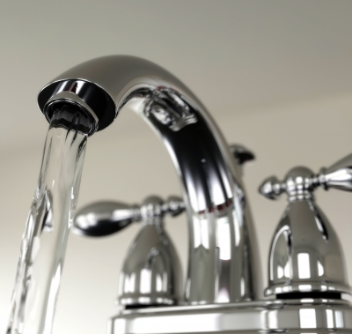

* Keep a pitcher of water in the fridge for cold drinks instead of running the tap.
* Water your garden in the morning and evening when temperatures are cooler to minimise evaporation.
* Wash fruit and vegetables in a pan of water instead of running the tap and then reuse the water on houseplants.

Image: Idea go / Free DigitalPhotos.net

* Wash dark clothing with cold water on a short cycle which reduces water and energy used and also helps your clothes keep their colour.
* Take showers instead of baths and reduce the time spent in the shower.
* Install a water butt in the garden to collect rainwater for watering the garden.
* Fix any dripping taps.
* Don’t wash your car yourself instead use a commercial car wash that recycles water.

Some other changes are not so straightforward and inexpensive to implement, however they can save money in the long run. Technology can be used for water conservation, for example there are taps available which reduce the amount of water that flows from them and there are washing machines which use a lot less water per load than standard ones. If you need to replace such equipment it may be worth considering alternatives that use less water, especially if this leads to reduced water bills if your water is metered, or reduces business costs.

## 9.2 Water Calculator

It is possible to calculate your water footprint, just like earlier in the workbook when you calculated your carbon footprint. Calculate your water footprint at:

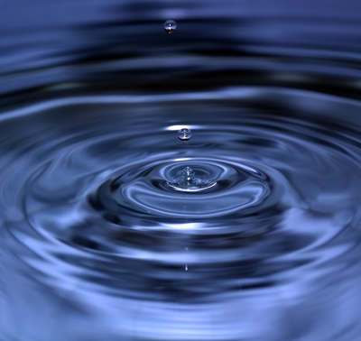<http://www.energysavingtrust.org.uk/resources/tools-calculators/water-energy>

Record here the amount of water you consume

Image: seaskylab / FreeDigitalPhotos.net

_________________

Q1. Where do you consume the most water?

Q2. What changes would you be happy to make to reduce the amount of water you use?

Q3. What do you think could make it difficult for you to reduce your water consumption?

## Guidance for 9.2 Water Calculator

Just like when you calculated your carbon and ecological footprints, the amount of water you consume will be different from what other people consume. Again, this exercise is about raising awareness of water issues, especially when we live in Scotland and don’t often have to consider water conservation. However, this is not the case in the whole of the UK; the south of England in particular often has drought worries.

This exercise can be used to look at how our attitude towards water is different to the attitudes of those who live in areas of the world that don’t have instant clean water on tap. Also consider how our water consumption is much higher than those who place a greater value on their water, especially if they have had to walk miles to collect it. This is also another opportunity to look at the United Nations Sustainable Development Goals.

## 9.3 Water Resources and Climate Change

Climate change will affect global water resources. Whilst an increase in global precipitation is expected, the regional patterns of rainfall will vary, meaning some areas will have more rainfall, while others will have less. There are high levels of uncertainty about how the pattern of precipitation will change but areas where agriculture is dependent on seasonal rainfall, like the Indian and West African monsoons, are particularly vulnerable. If monsoon patterns change or the monsoons weaken, millions of people could face food shortages.

Changes in climate and increases in some extreme weather events, such as floods and droughts, will disrupt the stability of the food supply, as well as people's livelihoods, making it more difficult for them to earn a stable income to purchase food. Some areas may face droughts with changing rainfall patterns, for example, in the Himalayas people are dependent upon seasonal melt water from glaciers which provides drinking water during the dry season. Climate change is causing glaciers to retreat which will endanger their fresh water supply as well as increase flood risks during the rainy season. Other problems associated with decreased water availability and quality in some areas, are increased health and sanitation problems, such as diarrhoeal disease and changes in the patterns of vector-borne disease, which can result in increased levels of malnutrition.

Unfortunately, many of the regions which are likely to be affected are in developing countries where the cost of climate change will be borne most by the poor. People in developing countries are highly dependent on rain fed agriculture for food security so they are particularly vulnerable to changes in annual precipitation levels. Also, because the poor have very limited resources they do not have the ability to adapt to climate change impacts like we can in wealthier industrialised nations.

There are also other indirect impacts of climate change upon water resources. Climate change is not only causing melting ice, but an increase to global temperatures means thermal expansion of the oceans causing sea levels to rise. Rising sea levels leads to salt water intrusion into groundwater supplies, which threatens the quality and quantity of freshwater which will impact large percentages of the population globally.

# 10. Reference List

Baker, S. (2006). *Sustainable Development*. London: Routledge.

Barry, J. (2007). Spires, plateaus and the infertile landscape of Education for Sustainable Development: re-invigorating the university through integrating community, campus and curriculum. *International Journal of Innovation and Sustainable Development*. **2**(3/4), pp 433-452.

Bonnett, M. (1999). Education for sustainable development: a coherent philosophy for environmental education? *Cambridge Journal of Education*. **29**(3), pp 313-324.

Carbon Trust (2009). Carbon foot printing – the next step to reducing your emissions. London: The Carbon Trust.

Energy Efficiency News. (2009). *Empire State Building Goes Green*. Available online at: <http://www.energyefficiencynews.com/refurbishment/i/2002/> [Accessed 23 August 2011].

European Commission (2010). *Energy Efficiency*. Available online at: <http://ec.europa.eu/energy/efficiency/buildings/buildings_en.htm> [Accessed 3 August 2010]

Global Footprint Network. (2010). *2010 Data Tables*. Available online at: <http://www.footprintnetwork.org/en/index.php/GFN/page/footprint_for_nations/> [Accessed 31 August 2011].

Intergovernmental Panel on Climate Change (IPCC) (2007). *Climate Change 2007: Synthesis Report 2007*. Cambridge: Cambridge University Press.

International Union for Conservation of Nature, United Nations Environment Programme & World Wide Fund for Nature. (IUCN, UNEP & WWF) (1980). *World Conservation Strategy: Living Resource Conservation for Sustainable Development*. Gland: IUCN.

International Union for Conservation of Nature (IUCN) (2006). *The Future of Sustainability: Re-thinking Environment and Development in the Twenty-first Century.* Report of the IUCN Renowned Thinkers Meeting, 29–31 January 2006. Available online at: <http://cmsdata.iucn.org/downloads/iucn_future_of_sustanability.pdf> [Accessed 20 January 2011].

Jones, P., Trier, C.J. & Richards, J.P. (2008). Embedding Education for Sustainable Development in higher education: A case study examining common challenges and opportunities for undergraduate programmes. *International Journal of Educational Research*. **47** pp 341-350.

Met Office. (2009). UK Climate Projections 2009 (UKCP09). Available online at: <http://www.metoffice.gov.uk/climatechange/guide/ukcp> [Accessed 31 August 2011].

Schumacher, F. (1973). *Small is beautiful: Economics as if people really mattered*. London: Abacus.

Scottish Executive. (2006). *Learning for our Future*. Edinburgh: The Scottish Executive.

Sustainable Development Education (SDE). (2008). *Embedding Sustainable Development in the Curriculum.*  Available online at: <http://www.eauc.org.uk/sorted/embedding_sustainable_development_in_the_curric> [Accessed 29 July 2010].

Stern, N. H. (2007). *The Economics of Climate Change: The Stern Review*. Cambridge: Cambridge University Press.

United Nations Department of Economic and Social Affairs, Division for Sustainable Development. (UNDESA). (1992). *Agenda 21, Chapter 36: Promoting education, public awareness and training*. Available online at: <http://www.un.org/esa/dsd/agenda21/res_agenda21_36.shtml> [Accessed 7 August 2010].

United Nations Educational Scientific and Cultural Organisation (UNESCO). (2004). *United Nations Decade of Education for Sustainable Development 2005-2004 Draft International Implementation Scheme*. Paris: UNESCO.

World Commission on Environment and Development (WCED). (1987). *Our Common Future*. Oxford: Oxford University Press.

World Wide Fund for Nature (WWF) Scotland (2006). *Schools Global Footprint*. Godalming: WWF-UK.