# About this Workbook

The author of this workbook is Mrs Elaine Crawford who is the Sustainable Development Adviser at Dumfries and Galloway College. Elaine has a MA in Environmental Sustainability and an MSc in Carbon Management, both from the University of Glasgow. The project to produce this range of workbooks began during a work placement with the Crichton Carbon Centre as part of the MSc in Carbon Management, when the first workbook was produced. As a result of this, a range of workbooks is now being developed to highlight Dumfries and Galloway College’s commitment to raising awareness of global issues that will affect us all and to ensure education for sustainable development is fully embedded within all aspects of the curriculum at the college. In places this workbook uses examples that are particular to Dumfries and Galloway College; however the information it contains can easily be applied to any college.

# Copyright Statement

**© Dumfries and Galloway College 2012**

### All rights reserved

This work is designed to be adaptable for different curriculum levels and to be stored in retrieval system form for uploading to a Virtual Learning Environment, which is acceptable to Dumfries and Galloway College. However, no part of this work may be reproduced, transmitted or forwarded to any other organisation, in any form or by any means, without the prior written permission of Dumfries and Galloway College.

Any enquiries regarding reproduction or distribution of all or any part of the work must be made in writing to Dumfries and Galloway College.

### Contract of sale

* Dumfries and Galloway College (the rights holder) reserves all rights in the work of this range of workbooks about Education for Sustainable Development.
* The work is offered for sale on the following basis.
* The purchaser will not reproduce these materials, other than to adapt it for different curriculum levels, or transmit these materials in any form, or by any means, any or all of the work without the express written permission of the rights holder.
* The rights holder does understand that the work may lend itself to adaptation by the purchaser to put the work in context for the purchaser’s requirement – for uploading to a Virtual Learning Environment, for example.
* The permission given by the rights holder to adapt and upload is given on the understanding that these rights will only be exercised by the purchaser.
* Any rights allowed to the purchaser are strictly non-transferable.
* At all times, the copyright of the work remains with Dumfries and Galloway College.
* Any reproduction or adaptation must still provide full acknowledgement to the rights holder on the work and any derivative work. The rights holder will agree a form of words to be used in the acknowledgement.
* Where reproduction or adaption rights allowed to the purchaser entails the work being stored on an intranet, for example, the purchaser must ensure that access to that intranet is secure.
* No rights are granted to permit uploading all, or any part of the work, to the public internet.

Dumfries and Galloway College indemnifies the purchaser against any third party charges of infringement in the work.

Table of Contents

About this Workbook 3

Copyright Statement 4

All rights reserved 4

Contract of sale 4

1 Introduction 7

1.1 Climate Change 7

2 The Life Cycle of Everyday Objects 10

2.1 Activity 1 - The Life Cycle of a Claw Hammer 11

3 Carbon Footprints 13

3.1 Activity 2 - Your Carbon Footprint 15

3.2 Carbon Footprints around the World 16

4 Sustainability 18

4.1 Sustainable Buildings 19

4.2 Activity 3 - Poster Competition 22

4.3 Activity 4 - Existing Buildings 22

4.4 Case Study – The Empire State Building 23

5 Building Materials, Insulation and Heat Loss 24

5.1 Code for Sustainable Homes 24

5.2 The Building Envelope 25

5.3 Building Materials 26

5.4 Activity 5 – Sustainable or Not Sustainable? 26

5.5 Heat Loss and Insulation 27

5.6 Activity 6 – Environmental Impact of an Insulation Material 28

5.7 Building Materials and Health 29

5.8 Activity 7 – Building Materials and Health Wordsearch 30

5.9 Embodied Energy 31

5.10 Activity 8 – Using the ICE Database 31

6 Construction Methods 34

6.1 Activity 9 - Off-site Construction 34

6.2 Activity 10 – Designing a New Build 36

7 Calculating Energy Consumption 37

7.1 Electricity – Understanding Watts and Kilowatt Hours 37

7.2 Activity 11 - Changing Light Bulbs 39

7.3 Activity 12 - Energy Use at Home 41

8 Waste 43

8.1 Activity 13 – Waste Generated on a Construction Site 47

9 Water Use 49

9.1 Water Conservation 49

9.2 Activity 14 - Water Calculator 50

9.3 Water Resources and Climate Change 51

10 Travel and Transport 52

10.1 Activity 15 - Lifestyle Changes Relating to Travel 53

11 Food 55

11.1 Environmental Impact of Food 56

11.2 Fair Trade 56

11.3 Activity 16 – Environmental Impacts of Food Production 57

12 And Finally …… 58

12.1 Activity 17 – Poster Competition 58

13 Reference List 60

# 1 Introduction



The purpose of this workbook is to introduce the topics of sustainability and sustainable development. There are a number of reasons why sustainability and sustainable development have become increasingly important in recent years, including the issue of climate change caused by human actions. However, sustainability does not mean only looking at climate change and the problems associated with it, but also considers other issues such as population growth, the use of limited resources and social justice. This workbook begins by explaining why we should be concerned about climate change and then moves on to provide information about other areas of our lives we could consider changing in order to live a more sustainable life within the confines of the one planet we call home – the planet Earth.

## 1.1 Climate Change

The Earth’s climate has varied naturally throughout its history, with periods when it was much warmer than today and ‘ice ages’, when Scotland was under glaciers a kilometre deep. However, during these times the Earth was much less densely populated than it is today. As you are probably aware, the Earth is now going through another period of warming – but this is different from those that have happened in the past. Over the last century global temperatures have been rising and scientists have concluded that this recent warming cannot simply be explained as natural variability. Human activities, mainly the emission of greenhouse gases (GHGs), are playing a major part. The main causes are the burning of fossil fuels (such as oil, coal and gas), and changes in land use, such as deforestation. As we increase emissions, the GHGs in the atmosphere also increase. This is resulting in an increase in global average temperatures, average sea level is rising, and snow and ice are melting at an alarming rate (IPCC, 2007). The Intergovernmental Panel on Climate Change has also concluded that most of the warming that has occurred since the mid 20th century is very likely due to man-made GHG emissions.

These GHG emissions are ‘enhancing’ the natural greenhouse effect. The greenhouse effect is a process which keeps the planet warm due to GHGs in the atmosphere trapping radiation from the sun – without it, the Earth would be much colder, around -18°C. The best known GHG is carbon dioxide (CO2), but there are a number of others, including methane (CH₄), nitrous oxide (N₂O) and water vapour (H₂O). Put simply, adding GHGs to the atmosphere enhances the greenhouse effect and results in global warming. Diagram 1 – The Greenhouse Effect shows the natural greenhouse effect without man made interference, however the addition of extra GHGs in the atmosphere causes more of the sun’s solar radiation to be trapped causing the temperature on earth to increase.

Diagram 1 - The Greenhouse Effect

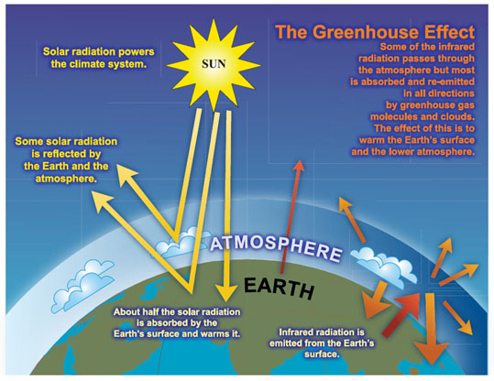

Source: Intergovernmental Panel on Climate Change Assessment Report 4 (2007)

The latest research conducted by experts at the Met Office suggests that if we (and others around the world) continue to operate on a ‘business as usual’ basis, then we could see an increase in the global average temperature of around 4°C before the end of the 21st century. In addition to the changes already mentioned, this increase in global temperature will bring with it major changes to weather patterns and an increasing frequency and intensity of extreme weather events such as hurricanes, heavy rainfall events and heat waves. Such a large and fast change in climate is dangerous and will have severe and costly impacts (Stern, 2007). For example, our ability to produce food around the world will decrease significantly, hundreds of millions of people will face water stress while millions of others will face flooding, and around a third of all species are likely to become extinct (IPCC, 2007).

Scotland, and the rest of the UK, will not be immune from the effects of climate change. Unless we seriously change our lifestyles to cut CO2 emissions, average temperature increases of up to 3°C in the winter and 4°C in the summer are likely to be experienced by our grandchildren and great-grandchildren (Met Office, 2009). The related weather changes are likely to mean floods, droughts and dangerous heat waves, with a rise in heat-related deaths. In 2003, 37,000 people died as a result of a heat wave in Europe, over 2,000 of which were in the UK (Met Office, 2009). Winters will be significantly wetter, with more intense rainfall. This would mean more flash floods, with rivers bursting their banks more often. Other impacts include an increasing incidence of severe gales and sea level rise, affecting coastal areas causing flooding of coastal homes and businesses and coastal erosion.

Action now needs to be taken to reduce GHG emissions to ensure that global temperatures do not rise by more than 2°C; this will help to limit the most severe impacts of climate change. This challenge has been accepted by the UK and Scottish governments with the passing of The Climate Change Act 2008 and The Climate Change (Scotland) Act 2009, both of which set a legally binding target to reduce emissions by 80% from 1990 levels by 2050. In Scotland, the first interim target is a reduction of 42% below 1990 levels by 2020. As a result, we will see an increasing regulatory requirement to reduce emissions in both the workplace and the home. Everyone has to play their part in the drive to a more resource efficient, low carbon system if we are to meet these targets and avoid catastrophic interference with the climate system.

Due to the global recession, it is likely that global emissions have fallen due to a reduction in fossil fuel use. The Earth’s climate is also going through a natural cooling period, hiding the true extent of climate change for a short period. This may make it seem like we have turned a corner and that the problem has been solved. This will not be the case. Tackling the global climate will be a major project for the whole of humanity and throughout the lives of everyone at the college. We need to do all we can to reduce our GHG emissions by using fewer fossil fuels, more renewable energy and changing our lifestyles to reflect this. Climate change is coming, but with your help, we can reduce its impacts for ourselves and the generations which follow us.

# 2 The Life Cycle of Everyday Objects

Life Cycle Analysis (LCA) is a process used to measure the environmental impact of a product or process, from the beginning of its life to the end, or from the ‘cradle to grave’. As we can see from the diagram below, to make any product we need to start with the raw materials and then determine how they are processed to make the product, how the product is then used, before it is either discarded or recycled.

**MANUFACTURE**

**USE**

**RECYCLING/DISPOSAL**

**EXTRACTION**

**PROCESSING**



*Source: Adapted from the Swedish Environmental Management Council*

**TRANSPORT**

**TRANSPORT**

**TRANSPORT**

**TRANSPORT**

**Standards**

Think about what everyday objects are made of, the resources and energy used to make them, how long they can be used for, and what happens to them at the end of their useful life. You may also need to consider the following:-

* Different types of products and services have their most significant climate impact at different stages in their life cycles.
* For products with a long life and high energy consumption, the use phase typically accounts for the most significant climate impact, for example a washing machine.
* Other products will have their greatest impact during the production phase – this is usually the case for food production.
* Some products may not be recyclable and may need to go to landfill.

This is just a small snapshot of the impacts of the life cycle of an object. To see more of the environmental impacts of the products we consume, go to <https://storyofstuff.org/movies/story-of-stuff/> and watch the Story of Stuff.

## 2.1 Activity 1 - The Life Cycle of a Claw Hammer



Image: FreeDigitalPhotos.net

Look at the picture of a typical pair of salon style hairdressing scissors.   
Have a good think about the scissors and answer the following questions. You may find the internet helpful with your answers.

**Q1** How are the materials produced to make the hammer?   
Where do the materials come from?

* A claw hammer is normally a wooden handle and steel head.
* Wood is renewable if managed correctly.
* Steel is made from iron ore and this is not a renewable resource, once we have used it all no more will be created.

**Q2** How are the hammers made?

What energy do you think has been used to make them?

* Energy expended to cut down the trees and to mine the iron ore.
* Energy is also required to form the hammer handles. Steel is created by hot forging with temperatures up to 1300°C, therefore extremely energy intensive.

**Q3** Once made, how do the hammers get to the distributors that sell them?

* They have to be transported either by road, air or sea. Therefore the energy requirements will be dependent on where they have been made and where they are being sold.
* If made in the UK this should be lower, however they may have been made on the other side of the world.

**Q4** How long are the hammers used for?

* They should last a long time.

**Q5** What happens to hammers once their useful life is over?

* Would they be put in the bin and end up in a landfill site, or would they be recycled?
* Remember steel is not a renewable resource.

**Q6** Can you think of other environmental impacts of a hammer not already considered? (For example, what about different materials, such as a rubber grip on the handle or water resources used during manufacture)?

* Look at other materials such as rubber grips, where does the rubber comes from and is it renewable?
* Strip mining the iron ore has environmental consequences.
* The transport of raw materials before the hammer is made.

Guidance for 2.1 – The Life Cycle of a Claw Hammer

For this exercise, remember to refer back to the 6 stages of the Life Cycle Analysis diagram at the beginning of Section 2. These are:

* Raw materials
* Manufacturing
* Distribution
* Retail
* Use
* Disposal

It is not important that the manufacturing process is investigated and understood in any great detail. The main point of consideration here is that everything we produce has an impact upon the Earth and we do not have access to unlimited resources. Also, this exercise could be used to generate discussion on the amount of the world’s resources that are consumed in westernised countries compared to developing countries and the social injustice and difference between those that have and those that do not.

# 3 Carbon Footprints

In the previous section the environmental impact of making things was considered. In our everyday lives we use hundreds of different products, all of which have an environmental impact throughout their lifetime. Producers of goods and services are increasingly becoming aware of these impacts and are starting to think of measures they can use to limit the amount of environmental damage their product is responsible for. One method of measuring this impact is carbon footprinting. A carbon footprint is the total set of greenhouse gas (GHG) emissions caused by an organisation, event or product (UK Carbon Trust, 2009). To make it easier to report, it is often expressed in terms of the amount of carbon dioxide (CO₂), or the amount of carbon dioxide equivalent of any other GHGs emitted.

A product’s carbon footprint is the total amount of GHGs produced across its life cycle from extraction to recycling or disposal. To measure a product footprint there is a **‘basket of six’** GHGs that are measured, these are:-

* Carbon dioxide (CO₂)
* Nitrous oxide (N₂O)
* Methane (CH₄)
* Hydrofluorocarbons (HFCs)
* Perfluorocarbons (PFCs)
* Sulphur hexafluoride (SF₆)

Many producers are now starting to measure the carbon footprint of the goods they produce. If a producer or manufacturer wants to reduce the carbon footprint of a product or service it needs to know how big it is first.

Walkers Crisps, with help from the Carbon Trust, measured the carbon footprint of their range of crisps and as a result they determined where they could make reductions in the footprint of the products. One way they achieved this was by only using British potatoes therefore reducing food miles as the potatoes did not need to be flown in from another country.

Image: Free DigitalPhotos.net

For more information on how the Carbon Trust are working with businesses to measure and reduce their carbon footprints look at the following link on the Carbon Trust website.

[**http://www.carbontrust.com/our-clients**](http://www.carbontrust.com/our-clients)

It is not just food products that manufacturers are looking at, below is an example of carbon footprint information for a brand of washing powder.

|  |
| --- |
| C:\Documents and Settings\crawforde\Local Settings\Temporary Internet Files\Content.IE5\Y3UK4JC7\56292mnbbzto4nu[1].jpg  **When measuring a carbon footprint, it is important to explain what the amount of carbon measured relates to, or to provide a meaningful unit. In this example the carbon footprint of 850g CO₂ is the amount per washing machine load.**  **The carbon footprint of this product is 850g CO₂ per wash.**  **This can be reduced by  washing at a lower temperature.**  **Washing at 30°C instead  of 40°C saves 160g CO₂  per wash.**  Image:  digitalart / FreeDigitalPhotos.net |
|  |



***This example refers to the amount of CO₂, 294g, per bottle of mangoes and passion fruits smoothie.***

Image: By permission from Innocent Smoothies

The main benefits of calculating a product footprint are to identify savings both in terms of money and for reducing carbon emissions. Also as customer demand grows for more ‘eco-friendly’ products it can be used to advertise your green credentials. If customer demand is sufficient this puts pressure on producers and suppliers to think about the environmental impact of their products.

The internet is a useful tool for finding information on the carbon footprint of products. A good place to start is the Carbon Trust website at <https://www.carbontrust.com/home> and then search for product footprint information. Carbon footprinting can also be used to measure the GHG emissions from an event such as a conference or a festival.

## 3.1 Activity 2 - Your Carbon Footprint

It is not only organisations, products and events that have carbon footprints. Activities in our daily lives cause GHG emissions and we can measure the amount to determine our own individual carbon footprint, just like we considered product carbon footprints previously.

The areas of our lives that generate most of our individual GHG emissions are as a result of:

* Electricity use
* Travel and transport
* Food production
* Buildings we use
* Waste

Carbon footprints are a sub-section of ecological footprints. Ecological footprints look to measure one person’s impact upon the world, or the amount of resources or space that are required for an individual to live their life. Go to the following website, <http://footprint.wwf.org.uk/> and enter the data to reflect your lifestyle, it will only take a few minutes to do so. Based on the information you provide regarding the way you live, the calculator will estimate how many planets would be required to support your lifestyle should every person in the world live as you do. This is based on the amount of land required to produce the quantity of resources that you consume.

* *Record here how may planets your lifestyle requires _____________*
* *Record here your carbon footprint _____________ tonnes per annum*

***You may be surprised by the results!  
Remember we only have one Earth!***

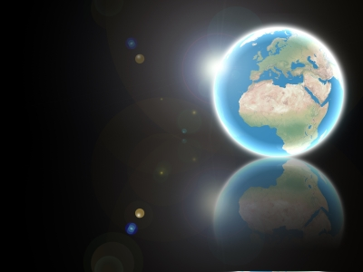

**Available Resource = 1 Planet Only!**

Image: Salvatore Vuono / FreeDigitalPhotos.net

## 

Guidance for 3.1 - Your Carbon Footprint

The number of planets your lifestyle requires, or your ‘ecological footprint’ will be calculated based on your lifestyle, so your answer will be different to that of your colleagues or other students. This also applies to the number of tonnes of carbon your lifestyle generates.

This exercise can be used to generate discussion as to why your lifestyle produces different figures from someone else’s. Does one of you fly more than the other, does someone use more public transport instead of a personal car, and maybe someone grows their own food and only buys organic, seasonal produce wherever possible, whereas someone else buys all pre-packaged processed food. The amount of ‘stuff’ you consume will also affect the numbers, as will the size of house you live in and how you use energy in it.

This exercise is a good way to compare and contrast lifestyles of different people around the world, looking at those who live within the confines of one planet and those who don’t. It can be used to debate the social injustice of those who have and those who don’t. This would also be a good opportunity to look at the United Nations Sustainable Development Goals.

## 3.2 Carbon Footprints around the World

Not everyone in the world lives in the same way as many of us in Scotland and other industrialised countries do. Some people are more environmentally aware and try to limit their impact upon the Earth and its resources wherever possible, whilst others don’t. Also, not everyone has access to the same amount of the Earth’s resources or the means to live as we do in the Western world. The diagram below shows the average carbon footprint of the average North American in tonnes of carbon dioxide equivalent, (this is the total amount of GHG emissions from the **‘basket of 6’** GHGs), compared against the average carbon footprint of someone who lives in Dumfries.

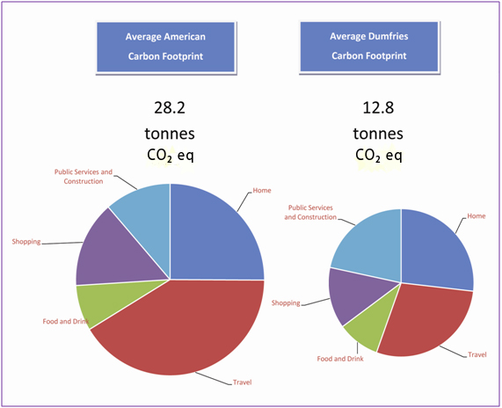

Source: Carbon footprint tool developed by the Crichton Carbon Centre

In 2009 the average North American had a carbon footprint of just over 28 tonnes of carbon dioxide equivalent and the average carbon footprint in Dumfries was nearly 13 tonnes of carbon dioxide equivalent. Whilst the carbon footprint of the average person in Dumfries is significantly lower than the average North American, we are still not living within the available resources on the Earth if everyone were to have the same share. At the other end of the scale, the average person in China has a carbon footprint of 5 tonnes of carbon dioxide equivalent and in Bangladesh the average is as low as 1 tonne of carbon dioxide equivalent (Clark *et al*., 2009).

Ecological footprints measure the amount of hectares of land that are required to provide all of the goods and services a person consumes. To put this into perspective, the average North American person needs 8 hectares of land to support their lifestyle, the average British person needs 4.9 and the average Indian person only uses 0.9 hectares of land (Global Footprint Network, 2010). This highlights the social injustice that exists between different lifestyles around the world.

**Put simply, if everyone in the world lived like the average American we would need five planets, that’s four more in addition to the one we already have!**

***Unfortunately we do not have five Earths!***

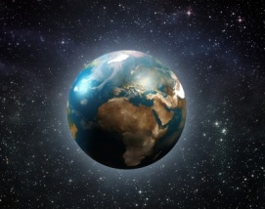

Image: Idea go / FreeDigitalPhotos.net

Now that we have seen how unsustainably most people live in the Western world, we will move on to look at some aspects of sustainability and how we could make changes in our lives if we wanted to live more sustainably.

# 4 Sustainability

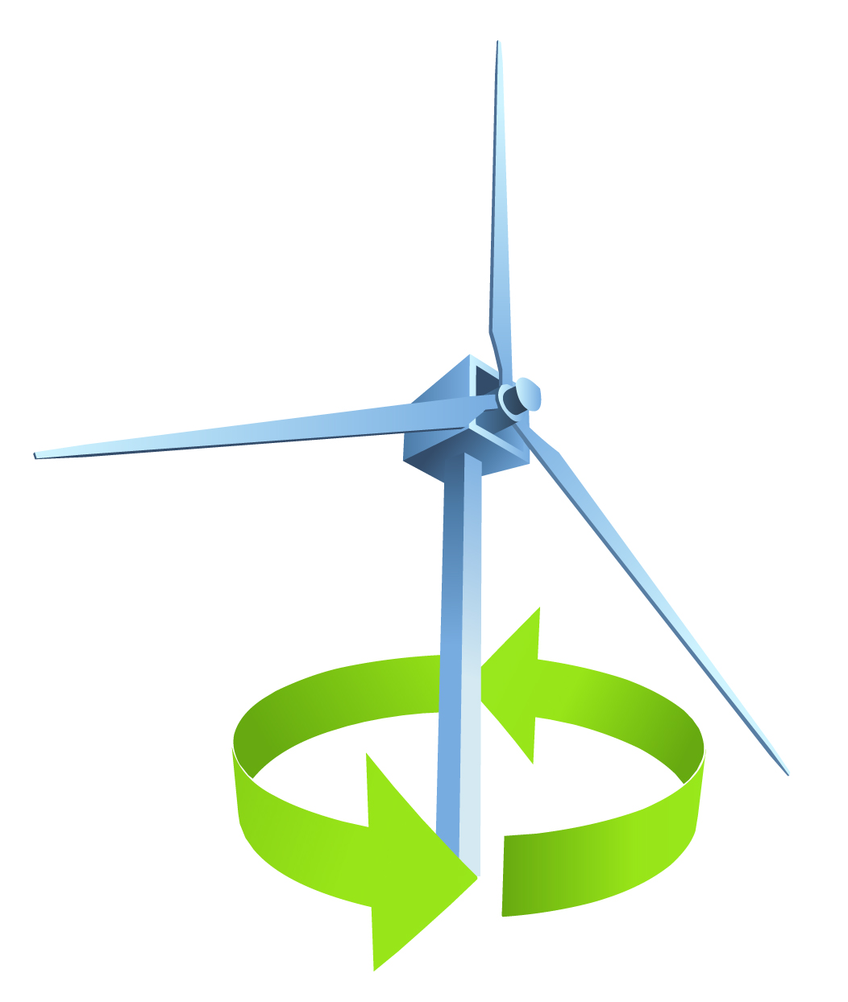

Before we look at the concept of sustainability in construction or ‘sustainable buildings’, we need to know what sustainability and sustainable development mean. One of the original descriptions and arguably the most famous was coined by the Brundtland Commission and states that,

***‘Sustainable development is development that meets the needs of the present without compromising the ability of future generations to meet their own needs’***

***(WCED, 1987)***

However, what does that actually mean? One person’s needs are very different from another’s and how do we know what needs future generations will have?

Taking all of these points into consideration some of the elements of sustainability include:

* Conservation and preservation (natural environment, built environment, resources)
* Care (people, other species, ecosystems and biodiversity)
* Culture (protecting different cultures around the world but also looking at how cultures change as attitudes change)
* Communities (local, national and global)

However, all of these elements can be   
incorporated into 3 components which are:

* **SOCIAL**

**HUMAN   
WELL-BEING**

* **ECONOMIC**
* **ENVIRONMENT**

Often when we think of or refer to development, we are meaning economic growth or economic development, however with sustainable development the economy is not considered in isolation but is interlinked with society and the environment and all three aspects are just as important. If the three aspects of sustainable development are considered as three circles of the same size, the overlap in the centre is where human well-being is achieved. As the three elements of society, environment and economy become more aligned, the area of overlap will increase and so will human well-being.

You might be thinking, well what does any of this have to do with me? I want to be a builder, or a painter and decorator, so why do I need to know about sustainability? Thinking of sustainability in buildings terms is important as it allows us to understand and develop knowledge of sustainability methods that can be used in construction to help protect the environment. The construction industry has an important part to play in terms of sustainable development due to the following reasons:

* Sustainable construction can help to protect the Earth’s resources for future generations.
* Sustainable technologies can help reduce the reliance on fossil fuels to heat and power our buildings.
* Using sustainable insulation materials can reduce the environmental impact of construction upon the Earth.
* Sustainable buildings use less energy and therefore produce lower GHG emission levels helping to combat man-made climate change.
* Sustainable construction practices produce less waste which reduces the environmental impact upon the Earth.
* Sustainable buildings are better for our health and well-being.

## 4.1 Sustainable Buildings

Now that we have an idea what sustainability means, we can start to apply this concept to what a sustainable building could be.

***‘A sustainable building, or green building is an outcome of design philosophy which focuses in increasing the efficiency of resource use – energy, water and materials – while reducing building impacts on human health and the environment during the building’s lifecycle, through better siting, design, construction, operation, maintenance and removal ‘***

*(Frej, 2005)*

We can start by considering a number of questions:

* What is the role or function of the building?
* What is the building’s design?
* What materials are being used, are they renewable?
* How are the materials sourced and how energy intensive is it to obtain them?
* What is the energy use to manufacture the raw materials?
* How will the building be constructed?
* How will the building be used?
* What are the requirements of the building, such as heating, lighting and water?
* What is the estimated lifespan of the building?
* How will it be demolished at the end of its life and will any of the materials be recycled?
* If the materials are not recycled, how will they be disposed of?

These are just a few of the considerations that need to be taken into account when considering the life cycle analysis of any building, all of which relate to the sustainability or otherwise of the building. All of these points are significant in terms of climate change largely due to energy use generated by fossil fuels.

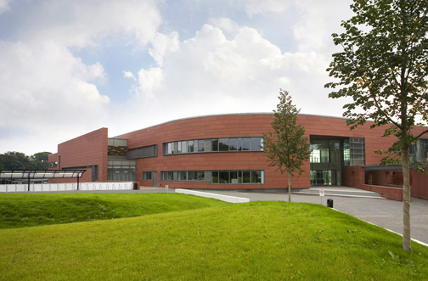 Around half of all global GHG emissions are generated from buildings. During the useful life of a building, this includes emissions during construction, the electricity consumed within them and the energy required to heat them. Once we are finished with the building there are emissions associated with its demolition, with materials either being recycled, which uses energy, or sent to landfill, which has other environmental impacts also. As we have seen earlier this is emissions from the ‘cradle to grave’ of the building. There is huge potential for energy reduction in buildings as they are responsible for 40% of energy consumption and 36% of European Union CO2 emissions (European Commission, 2010).



Dumfries and Galloway College’s building is new and has been designed and built to be energy efficient. However, this does not mean that improvements in energy reduction cannot be made, because a building can be as energy efficient as possible, but if it is not used correctly then it will not be effective. For example, in the college a great number of staff and students use the disabled access doors at the main entrance instead of the revolving door. Constantly opening these doors makes the energy used for heating in this area inefficient. A campaign to educate staff and students why to use the revolving door could help to overcome this. This is also why it is important not just to have the most energy efficient type of electrical equipment available but also to use it properly, for example to ensure it is not left switched on unnecessarily.

In a building such as a college, equipment like computers and printers are often left on standby consuming energy and costing money which could easily be saved. A simple measure such as placing stickers beside equipment reminding staff and students to switch it off once they have finished with it could help reduce this.

Outwith the college, in our homes and workplaces there are simple and inexpensive measures that can be implemented such as:

* Replacing light bulbs with lower wattage versions where possible.
* Switching appliances off at the plug socket to ensure they are not accidentally left on standby.
* Draught proofing doors and windows by using secondary glazing or fitting heavy lined curtains in the winter months.
* Placing special foil panels behind radiators to reflect more heat into the room.
* Redecorating with insulating paint.

There are other measures which require more time, effort and money such as:

* Replacing doors and windows with double or triple glazing.
* Ensuring there is adequate wall and roof insulation.
* Upgrading the boiler and heating system when they need replaced.
* Replacing electrical appliances with energy efficient rated models.
* Switching electricity suppliers to one that utilises renewable energy sources to generate electricity.

A lot of these measures can help to save money in the long run by reducing your energy bills. Some of the more expensive measures such as fitting adequate insulation in your home may be eligible for a government grant to help with the cost, even where you own your own home, are under 70 and are not in receipt of any income related benefits.

Check the Government’s Grant website at:

* <http://www.government-grants.co.uk>

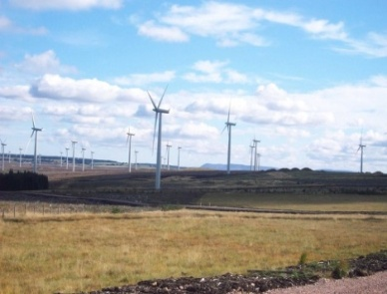

Blacklaw Wind Farm, Lanark, Scotland - Image by: Author

## F:\DCIM\101SSCAM\SDC10628.JPG4.2 Activity 3 - Poster Competition

Think about your college building, is there a door that is used unnecessarily or left open when it shouldn’t be?

* Design a poster to be displayed on that door to discourage students from using it or leaving it open when they don’t need to.

Some of the information you may want to include could be:

* Why this door should not be used unless necessary
* The energy and money that is being wasted
* That fossil fuels being used to generate the wasted energy will run out
* How adding extra greenhouse gases to the atmosphere changes the climate
* The poster should be colourful, eye-catching and to the point.
* The best design will be made into a full size poster to display on the door.
* You can design your poster either by hand or on a computer.

## 4.3 Activity 4 - Existing Buildings

Before we look at some examples of refurbishing existing buildings, think about some of the barriers against refurbishing an existing building and also consider the reasons or drivers for doing it. For example, cost can be a barrier if it is too expensive, however cost can be a driver also if the building is being heated inefficiently and this is wasting money. Think of other barriers to and drivers of why we should consider refurbishing existing buildings wherever possible and then complete the table below.

|  |  |  |
| --- | --- | --- |
| Barriers to Refurbishing |  | Drivers for Refurbishing |
| *Cost – too expensive* |  | ***Cost – wastes money by being energy inefficient*** |
| *Technical difficulties* |  | ***Legislation demands it – reduce carbon emissions*** |
| *Lack of skilled workforce* |  | ***Government incentives – grants may be available*** |
| *Lack of motivation* |  | ***To advertise your ‘green’ credentials or corporate social responsibility*** |
| *Legislation and guidance is unclear* |  | ***Easier and more cost effective than building new*** |

## 4.4 Case Study – The Empire State Building

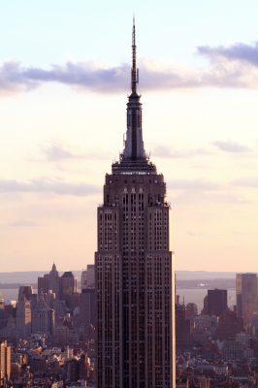Image: FreeDigitalPhotos.net

Moving forward, new buildings can be designed and built to be energy efficient; however as we have seen, existing buildings also need to be considered. Around 60% of the buildings that will be standing in 2050 have already been built today, so it is vital to maximise the carbon saving opportunities of renovations and retrofits (Carbon Trust, 2011).

The Empire State Building in New York is in the process of a major refurbishment which aims to reduce the energy usage of the building by up to 38% by 2013. Using computer modelling, the building’s energy efficiency was analysed to identify areas where the overall energy efficiency could be improved. The project team then decided to focus on eight economically viable measures which are expected to save around $4.4 million a year in energy costs.

These measures include:

* Refurbishment of the building’s 6500 windows to create triple-glazed insulated panels
* Fitting insulation behind radiators to reduce heat loss
* Improved lighting and controls to reduce electricity usage
* Replacement of the building’s air handling units to increase operational efficiency
* Introduction of demand control ventilation

(Energy Efficiency News, 2009)

Commercial and residential buildings account for the majority of the carbon footprint of major cities around the world, over 70% in New York. Therefore, finding a viable solution to retrofit existing major buildings to reduce their energy consumption and make cities cleaner and more energy efficient is vitally important.

To look at examples of how the Carbon Trust has worked with companies to help them refurbish their buildings and consider and implement renewable energy technologies, look at some of the case studies and resources available in the links below.

* <https://www.carbontrust.com/our-clients/>
* <http://www.carbontrust.com/resources/reports/advice/delivering-the-future-today>

# 5 Building Materials, Insulation and Heat Loss



Whether refurbishing an existing building or constructing a new build, the materials that are used will all contribute to the overall energy performance and efficiency of the building. There are regulations to follow on improving the sustainability of new buildings. In Scotland, guidance on the standards set by the Building (Scotland) Regulations 2004 is found in two volumes, Domestic Buildings and Non-domestic Buildings; Section 3 in both covers the Environment. The Code for Sustainable Homes is a government initiative for new homes built in England and Wales. All new homes are assessed for their overall sustainability and then graded accordingly from levels 1 to 6, with 6 representing a zero carbon home. The Code for Sustainable Homes does not cover non-domestic buildings.

The following link contains all of the Technical Handbooks relating to the Building (Scotland) Regulations 2017, for new Domestic and Non-domestic dwellings as well as guidance for the conversion of traditional buildings published by Historic Scotland.

* <http://www.scotland.gov.uk/Topics/Built-Environment/Building/Building-standards/publications/pubtech>

## 5.1 Code for Sustainable Homes

Studies have shown that on average more than a quarter of the UK’s yearly carbon dioxide (CO₂) emissions are caused by the energy we use to heat, light and run our homes. Due to this it is vital that our homes are built in a way that limits energy use and therefore reduces CO₂ emissions. However, CO₂ emissions are not the only environmental impact of our homes. Construction and use of our homes has a range of other negative environmental impacts, created for example through water use, waste generation and the use of polluting materials. These impacts can be significantly reduced by integrating higher sustainability performance standards within the design and construction of the home. More sustainable homes can also improve our overall wellbeing and quality of life. Full details of the Code can be found at:

* *energy use and co₂   
  emissions from the dwelling*
* *water use*
* *materials*
* *surface water run-off*
* *waste*
* *pollution*
* *health and wellbeing*
* *management*
* *ecology*
* <https://www.planningportal.co.uk/info/200140/greener_homes>

The Code for Sustainable Homes is part of the UK Government’s zero carbon initiative and all homes built in England and Wales from 2016 onwards are expected to be zero carbon.

The categories that each new home is assessed under are as opposite.

## 5.2 The Building Envelope

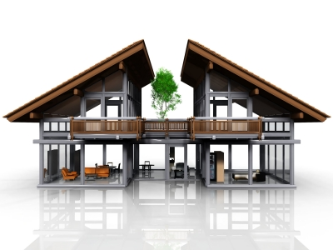

Image: FreeDigitalPhotos.net

The building envelope put simply is the barrier between what part of the building is heated and cooled and the part of the building that is not. There are 5 performance characteristics of a building that the building envelope governs.

1. STRUCTURE
2. TEMPERATURE
3. FABRIC
4. MOISTURE
5. AIR REGULATION

It is important that none of these elements are considered in isolation as they all interact with each other.

## 5.3 Building Materials

It is important to consider the materials used within our buildings as they contribute to the overall GHG emissions for the UK of around 5-6%. Most of this is associated with the manufacture, around 70%, but transport also is a major factor at 15%. It is also estimated that around a third of our buildings suffer from sick building syndrome (SBS), due to the materials used to construct them.

Below are some points we need to consider when thinking if a material is sustainable or low impact.

* Origin (where has it come from)
* Extraction effort (energy)
* Fabrication (manufacture – energy, water)
* Transportation
* Construction
* Waste

## 5.4 Activity 5 – Sustainable or Not Sustainable?

Research the materials below and decide whether they are sustainable or not sustainable.   
 Give the reasons for your decision for each material.

|  |  |  |
| --- | --- | --- |
| Material | Sustainable /   Not Sustainable | Reasons Why |
| TIMBER | Sustainable | Needs to be managed correctly, forestry can be re-grown  after harvesting |
| SHEEPSWOOL INSULATION | Sustainable | A natural material that will be renewed when the sheep  grows another fleece |
| CONCRETE | Not sustainable (due to overall environmental impact) | In its raw form of earth and rock it could be argued it is a sustainable material, however it has other negative environmental impacts to consider such as pollution, water use and disposal. Also need to consider cement use as limestone is not renewable. |
| STEEL | Not sustainable | Made from iron ore which is not renewable |

## 5.5 Heat Loss and Insulation

To provide the highest level of thermal efficiency possible in a building heat loss should be kept to a minimum. This can be achieved by high levels of insulation.

Heat loss from a house or building occurs in all directions. The house pictured shows typical heat losses from different sources. Loft insulation and cavity wall insulation are simple and efficient ways to prevent heat loss through the roof and walls. Energy savings could be as great as 40% depending on the type of insulation used and the thickness of it.

In countries where the climate means there is a significant temperature difference between the outside and the inside of a building, thermal insulation of the building envelope becomes the most important way of ensuring it is warm inside the building.



25%

**Up to 25% heat loss through the roof**

15%

10%

**Up to 35% heat loss through un-insulated walls**

35%

15%

Image: FreeDigitalPhotos.net

## 5.6 Activity 6 – Environmental Impact of an Insulation Material

Your job is to design and market an insulation material aimed at the environmentally aware consumer. Research your material and design a campaign to promote this material’s ‘**green credentials**’. You will need to consider how you would design and advertise your product to appeal to your target market. Bear in mind whoever your market is they are environmentally conscious and want a product that has as little impact upon the environment as possible.

Your marketing campaign can take a number of different forms as long as the information in the box below is included. Remember, it will need to be colourful and imaginative if it is to appeal to your target audience. A poster or PowerPoint presentation may be a good way to present your campaign.

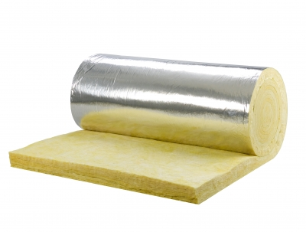

Image: FreeDigitalPhotos.net

Below are some types of insulation materials you could consider, however you do not need to choose one of these:

* Natural fibre insulators
* Fibreglass
* Spray foam insulators
* Poured concrete

***Remember***: The Internet is a good resource to utilise for information.

*You will need to consider all of the stages in the life cycle of a product which are:*

* *Extraction of raw materials*
* *Processing and manufacturing*
* *Transport and distribution*
* *Retail and consumer use*
* *Disposal*

*Taking account of each of these points, consider how your product could be classed as ‘eco-friendly’ and how you would market it as such.*

## 5.7 Building Materials and Health

Many different chemicals are widely used in the construction of modern buildings however few of them have been thoroughly tested together to determine the impact they have upon human health. There is evidence to show that the use of toxic chemicals has a negative impact upon health. Different materials will have toxicity issues at different stages of their lifecycles, from extraction to disposal. For example, PVC is toxic during manufacturing, timber treatment spray is toxic during installation and composite panels have toxicity issues during disposal. Many building materials can also off-gas a range of chemicals which are dangerous for the builder and building user.

***Example of the toxicity levels of a construction material – PVC***

|  |  |  |  |  |  |
| --- | --- | --- | --- | --- | --- |
| H:\photos hair\file000487877504.jpgID-10075784.jpg | |  | | --- | | Risks: | | * During manufacture:  **ingredients within the PVC such as vinyl chloride monomer emit dioxides which can cause both acute and chronic health hazards.** * During use: **PVC can off-gas toxic chemicals, for example off-gassing from flooring can trigger asthma, cause hormone disruption and cancer.** * In disposal: **leaches toxic additives when disposed of to landfill.** * In fire: **emits hydrogen chloride gas.** | | Possible PVC alternatives: | | * **Stainless steel conduits** * **Copper water pipes** * **Linoleum or rubber instead of vinyl floor coverings** * **Cast iron rainwater goods** | |

Image freedigitalphotos.net

## 5.8 Activity 7 – Building Materials and Health Wordsearch

|  |  |  |  |  |  |  |  |  |  |  |  |  |  |  |  |  |
| --- | --- | --- | --- | --- | --- | --- | --- | --- | --- | --- | --- | --- | --- | --- | --- | --- |
| V | R | H | N | G | | N | E | T | L | O | | X | S | Y | I | L |
| E | I | U | U | U | | N | H | W | F | X | | I | C | A | G | O |
| Y | U | N | I | M | | G | I | F | Y | C | | W | H | S | I | M |
| A | T | E | Y | E | | A | G | H | K | P | | N | T | F | B | L |
| L | I | S | E | L | | A | N | B | C | T | | I | U | L | L | W |
| A | R | X | I | S | | C | U | H | I | A | | N | I | U | A | D |
| R | E | E | S | H | | I | H | S | E | G | | E | G | H | S | O |
| H | I | I | N | L | | S | O | L | A | A | | L | L | R | T | E |
| A | N | O | D | U | | H | S | L | O | E | | L | P | I | H | R |
| G | G | I | E | M | | A | S | H | E | R | | U | T | S | M | T |
| C | N | I | W | S | | P | T | D | L | T | | I | V | H | A | T |
| G | D | D | I | O | | X | I | D | E | S | | C | D | S | R | N |
| H | Y | D | R | O | | G | E | N | S | T | | E | Y | E | S | N |
| U | N | E | Y | T | | I | L | A | U | Q | | R | E | T | A | W |
| M | S | T | O | X | | I | C | I | T | Y | | T | A | T | C | G |
|  | | | | | | | | | | | | | | | | |
| **Words to find:** | | | | | | | | | | | | | | | | |
| * ASTHMA * DIOXIDES * FUNGAL SPORES * HUMAN HEALTH | | | | | * HYDROGEN * LEACHING * OFFGASSING | | | | | | * SICK BUILDING * VINYL CHLORIDE * WATER QUALITY | | | | | |

*Once you have found all of the words, search the internet to ensure you are familiar with the meaning of them all and any negative health and safety implications that are associated with them.*

## 5.9 Embodied Energy

Embodied energy is the total amount of energy used by a product throughout its life cycle. From earlier in the workbook, we know that the life cycle of a product is from the beginning of its life when raw materials are extracted, until the end of its life when it is disposed of or recycled, or from the ‘***cradle to grave’*** of a product. However, you may also see embodied energy in the form of from *‘****cradle to site’***, which is the primary energy consumed until the product reaches the point of use, i.e., the building site, or embodied energy may also be expressed as ‘***cradle to gate’***, which is the primary energy consumed until the product leaves the factory gate.

## 5.10 Activity 8 – Using the ICE Database

The Inventory of Carbon and Energy (ICE) database is a database advising the embodied energy and carbon of a large number of building materials. It was produced by staff from the Department of Mechanical Engineering at the University of Bath and is available as a free download (see the separate ICE database file provided with this workbook).

The boundaries used within the ICE database are normally ‘***cradle to gate’***, unless otherwise stated. As well as providing embodied energy information, the ICE database also provides details of embodied carbon.

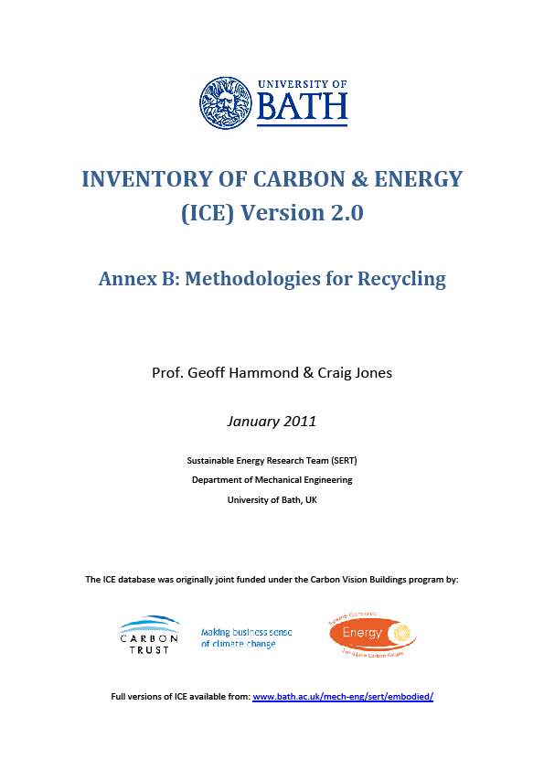

* Complete the table using the ICE database available at

<http://www.organicexplorer.co.nz/site/organicexplore/files/ICE%20Version%201.6a.pdf>

|  |  |  |
| --- | --- | --- |
| **Material** | **Embodied Energy** | **Embodied Carbon** |
| * FIBREGLASS (GLASS WOOL) |  |  |
| * POLYSTYRENE  *(state which type you have chosen – some examples)*   Expanded Polystyrene  High Impact Polystyrene  Thermoformed Expanded  Polystyrene |  |  |
| * WOOL (RECYCLED) |  |  |
| * CELLULOSE |  |  |
| * CORK |  |  |
| * FLAX |  |  |

**Q1** Which material has the highest embodied energy, why do you think this is?

The polystyrenes – not natural materials, far more processes/manufacturing involved

**Q2** Which material has the lowest embodied energy, why do you think this is?

Cellulose – it is a natural plant material, not much processing required

**Q3** What is the difference between embodied energy and embodied carbon?

Embodied energy includes all energy inputs such as raw materials, fuel use, and human input

etc., whereas embodied carbon only states the amount of carbon dioxide emitted per kilogram

**Q4** What is the difference between the embodied carbon per kilogram (kgCO2/kg) and embodied carbon equivalent per kilogram (kgCO2eq/kg)?

kgCO2/kg = the amount of carbon dioxide emitted per kilogram

kgCO2eq/kg = the amount of carbon dioxide equivalent of all greenhouse gases emitted from the ‘basket of six’

# 6 Construction Methods

There are various different construction methods, each with their own advantages and disadvantages. Traditional masonry is the most popular method in the UK for new homes and refers to buildings that are constructed in block or brick. However timber framed homes, which is the second most popular technique throughout the UK for new build homes, is now the fastest growing method of construction in the UK and the most popular build choice for new builds in Scotland.

Due to advances in technology, there is a range of relatively new construction techniques that offer many advantages over the traditional methods. Referred to as ‘modern methods of construction’, some of these techniques have been around for a while, but have become increasingly popular for a number of reasons, including the increased demand for more sustainable homes and because of reduced construction time on site as the majority of manufacture takes place in a factory.

## 6.1 Activity 9 - Off-site Construction

**ADVANTAGES** of off-site construction include the following:

* Fewer materials deliveries so lower fuel consumption
* Reduced construction times
* Higher quality
* Reduced energy use

However, there are **DISADVANTAGES** also, such as:

* Early decision making required
* Reduced flexibility in design
* Greater levels of co-ordination required
* Transportation can be expensive if the site is remote

These are just a few of the advantages and disadvantages of off-site construction. Use the following table to record any others you can think of.

|  |  |
| --- | --- |
| **ADVANTAGES** | **DISADVANTAGES** |
| Improved health and safety | Size limitations on transporting pre-  constructed modules |
| Easier quality control through standardisation | Overall can prove to be more expensive |
| Reduces the effect that bad weather has on  production | Can be more difficult to implement  workarounds if required |
| Reduces waste | Lack of experienced managers to co-ordinate  procedures between on-site and off-site |
| Shorter build times | Untrained labour may be used for simple  installations which may create problems |

## 6.2 Activity 10 – Designing a New Build

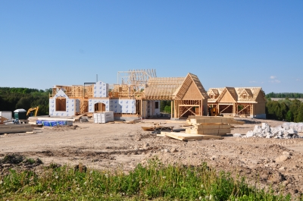

Image: FreeDigitalPhotos.net

You are the architect designing a family house to be built in Scotland. Put together a presentation which considers the following points:

* building materials used
* insulation materials used
* siting to consider natural daylighting
* on/off-site construction
* Give the reasons for your choices
* Also refer back to Section 5.2 and remember to consider the ‘building envelope’ when making your choices.
* Another good website with information about sustainable construction methods is
  + <http://www.sustainablebuild.co.uk/ConstructionMethodsCategory.html>
* Some designs that might inspire you include the Huf House, Passivhaus and the Earthship house. Details of the types of build and images of what they look like are available at the following websites:
  + <https://www.huf-haus.com/uk/>
  + <http://www.passivhaus.org.uk/>
  + <http://earthship.com/>

# 7 Calculating Energy Consumption



Now that we know what embodied energy is, we will move on to look at how energy consumption is measured and calculated.

## 7.1 Electricity – Understanding Watts and Kilowatt Hours

We calculate electricity in units of kilowatt hours (kWh). In the same way that ***1 kilometre = 1000 metres; 1 kilowatt hour = 1000 watt hours.***

When we look at anything that runs on electricity, such as a hairdryer or a television, there is usually a label that tells us how energy hungry it is - this is the number of watts (W) the piece of equipment uses – or its ‘**wattage’**. See the example below:

* *The picture to the right shows a household food blender with the panel you are looking for.*
* *The panel states the wattage of the blender is 500W watts.*

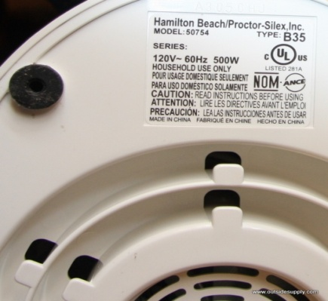

Before calculating how much energy is used by electrical appliances in our home, we will look at a simple example of electricity consumption using light bulbs in a college classroom.

For example, if the eight 100 watt bulbs in the classroom are turned on for 5 hours, then:

***800 watts x 5 hours = 4000 watt hours (Wh)***

***4000 watt hours (Wh) ÷ 1000 = 4 kilowatt hours (kWh)***

To calculate how much energy the classroom uses for lighting in a year, we need to estimate how many hours the lights are turned on for in a year. To do this we need to estimate the number of hours they are on per day, the number of days they are on per week, and the number of weeks per year.

The classroom lights are usually on for 8 hours per day, there are 5 days in the college week, and 40 college weeks per year, so the classroom lights are on for:

***[8 hours/day x 5 days/week x 40 weeks/year = 1600 hours/year]***

**And the energy they use in a year is:**

***800 watts x 1600 hours/year = 1,280,000 watt hours/year***

***1,280,000 watt hours/year ÷ 1000 = 1280 kilowatt hours/year (kWh/yr)***

**Based on an average electricity unit price of £0.10, 1 kWh costs £0.10**

***Therefore 1280 kWh/yr costs 1280 x £0.10 = £128.00***

## 7.2 Activity 11 - Changing Light Bulbs

The previous example used 100 watt bulbs in the classrooms; however the college uses low energy fluorescent lighting in the classrooms. Each light fitting contains two 35 watt bulbs, and there are 11 fluorescent lights in the classroom. Prior to moving into the new college building, we will assume the old college building used light fittings with 100 watt bulbs, and there were 15 of these bulbs in a classroom. Using this information we can calculate how much energy and money the college saved when they moved to the new building by using lower wattage bulbs in the classrooms. Complete the following table to finish this calculation.

***HINT:*** *Estimate how many hours the lights are on each day based on an eight hour day.   
Remember there are 5 college days in a week, and 40 college weeks in a year, so there are 200 college days in a year.*

***REMEMBER*: *(watts x hours per year) ÷ 1000 = kilowatt hours per year***

|  |  |  |  |  |  |  |
| --- | --- | --- | --- | --- | --- | --- |
|  | **Wattage of 1 bulb [W]** | **Number of bulbs** | **Total watts of all bulbs [W]** | **Hours on per day [hours / day]** | **Hours on per year  [hours / year]** | **Kilowatt hours of energy per year [kWh / year]** |
| **OLD BULBS** | 100 | 15 | ***100w  x  15 bulbs  = 1500 watts*** | **8** | ***8 hours  x  200 days  = 1600 hours*** | ***1500 watts  x  1600 hours  = 2,400,000watt hours  ÷  1000  = 2400 kWh / year*** |
| **NEW BULBS** | 35 | 22 |  |  |  |  |
|  | | ***SAVINGS*** |  |  | ***SAVINGS*** |  |

**Q1** Therefore how many kWh of electricity have been saved in a year in one classroom by changing the bulbs?

= ________________ kWh / year

***REMEMBER:*** *the average cost of 1 unit of electricity costs the college £0.10*

* 1kWh of electricity costs £ _________________
* Therefore a reduction in use of _____________ kWh
* saves £ **_________________________________** a year

**Q2** The new college building has many classrooms, therefore how much electricity and money has the college saved by changing the light bulbs in 20 classrooms?

* **1** classroom means a **reduction** of  
    
   ________________ kWh / year,

So **20** classrooms means a **reduction** of  
  
 ______________ kWh / year

* **1** classroom saved £________________ a year

So **20** classrooms saves £ ________________ a year

## 7.3 Activity 12 - Energy Use at Home

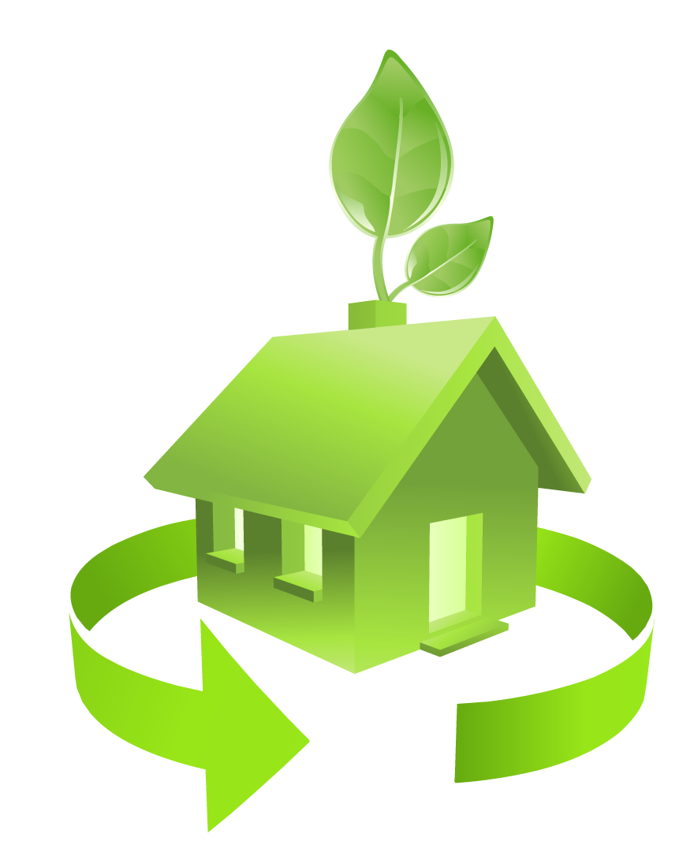

The calculations used for the light bulbs in the college classrooms, can be applied to the electrical equipment we use in our homes. Look around your home and choose five pieces of electrical equipment you can find the wattage easily for. Remember, this can be found for many items on a little panel on it, failing that you can find the wattage in the manufacturer’s guide, if you still have it, or by searching on the internet (a good site is [www.sust-it.net](http://www.sust-it.net) ). The items can be anything electrical, for example, a television, kettle, microwave, or even something you only use occasionally such as an electric lawnmower.

***HINT:*** *Once you have selected your electrical equipment, make an estimate of how many hours a day on average it is switched on and then complete the following table.   
The first line has been completed as an example.*

***REMEMBER:*** *there are 365 days in a year*

|  |  |  |  |  |  |
| --- | --- | --- | --- | --- | --- |
| **Type of equipment** | **Make and model** | **Wattage [W]** | **Hours of use per day [hours / day]** | **Hours of use per year   [hours / year]** | **Kilowatt hours of energy per year [kWh/year]** |
| **TELEVISION** | **Sony KDL 32EX603 32"** | **80** | **4** | **4 x 365  =  1460 hours / year** | **80W x 1460 hours  = 116800 Wh  ÷ 1000  = 116.8 kWh/year** |
| 1 |  |  |  |  |  |
| 2 |  |  |  |  |  |
| 3 |  |  |  |  |  |
| 4 |  |  |  |  |  |
| 5 |  |  |  |  |  |

**Q1** What is the most energy intensive piece of equipment you found?   
Remember this is the piece of equipment with the highest wattage.

**Q2** Which piece of equipment in your home consumes the most electricity per year?

**Q3** Were you surprised by any particular result?   
If so, for what piece of equipment and why did you find the results surprising?

**Q4** Can you think of an example of an electrical item that you could substitute manpower for and still achieve the same result?

**Q5** What room in your house do you think is the most energy intensive in terms of electricity? Why do you think this is?

**Q6** Take the piece of equipment with the highest wattage per hour and search the internet for a less energy intensive alternative. What did you find?

**Q7** Electricity aside, can you think of any other ways energy is consumed by your household?

# 8 Waste





There is a limit to the amount of waste the Earth can absorb. When we look at a product and the waste it generates, we need to look at it from the ‘cradle to grave’. This is why we have looked at products so far starting with the raw materials they are made from and ending with the disposal of the item. In order to reduce the amount of waste we produce, we need to reduce the number of products we consume. We have more money to buy more ‘stuff’ and as we like new ‘stuff’ we are always buying more. Also, products are not made to last like they were in the past. Our grandparents would ‘make do and mend’ whilst we just throwaway and replace. Economies of countries are driven by producing and selling more materials, so to make products that last longer does not make economic sense. (If you have not already done so, now is a good time to watch ‘The Story of Stuff’ at <https://storyofstuff.org/movies/story-of-stuff/> ).

Packaging is a major source of waste. The minute we remove it from a product waste is produced. One way to reduce the amount of packaging is by consumers putting pressure on suppliers to not over package their goods. This may be difficult for an individual, however if you are responsible for purchasing products on a large scale for an employer or your own business, this may then become possible. It is also worth investigating if a supplier has an environmental policy and, if so, what it consists of, before deciding to use that supplier. As was established in Section 2 when we looked at the life cycle analysis of products, we should consider waste impacts from ‘cradle to grave’ for a product. If we produce and use less packaging, this means there are less raw materials required to make the packaging and less energy being used also. Less packaging also means less waste to recycle, which also uses energy, or less waste to send to landfill.

Some of the waste produced in the college, for example in the workshops or the hair and beauty salons, is not only a concern due to the disposal of packaging but also due to the disposal of the chemicals used in the products. Chemical waste causes pollution, which can be either point source or non-point source. Point source pollution is usually defined as pollution where the origin can be defined from one source, such as at the end of a pipe.

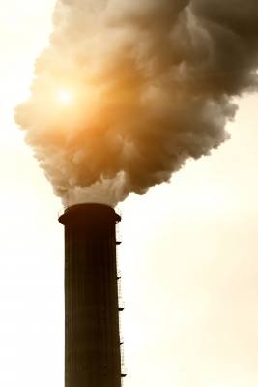

*Image: dan / FreeDigitalPhotos.net*

*Here is an example of* ***point source pollution*** *or end of pipe pollution. It is generally easy to see and recognise point source pollution, which can make it easier to address.*

Non-point source pollution is caused indirectly by chemicals leaking into groundwater. If disposed of incorrectly, chemicals can cause pollution to our environment by leaching into our groundwater from landfill sites. This can have a negative long-term effect on human health and also impacts upon plants and animals.

NON-POINT SOURCE POLLUTION

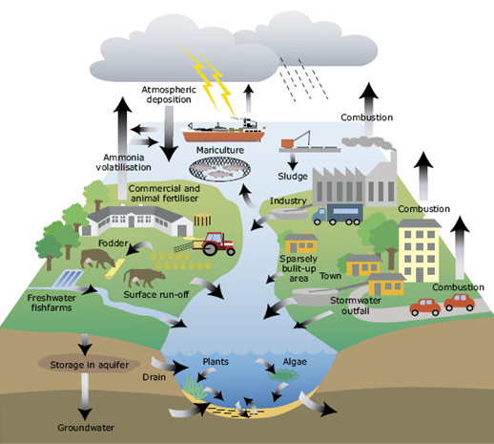

*Source: http://www.eea.europa.eu/themes/water/water-pollution*

***Non-point source pollution*** *can be more difficult to identify as it can originate from many sources. In the picture above chemicals are leaching into groundwater from many different sources including farming, industry and towns.*

However, attitudes towards waste in our society are slowly changing. The best way to minimise the amount of waste we produce is to reduce the amount we produce in the first place. Failing this the next best option is to re-use it wherever possible and if this is not possible then recycle it.

Most of you will probably be familiar with this concept already:

*(For example by manufacturers using less packaging on products or by consumers buying re-fill packs which use less packaging. Consumers can also put pressure on manufacturers and retailers to use less packaging)*

*(For example, save last year’s Christmas cards and wrapping paper. Wrapping paper can be used again and Christmas cards can be cut up and used as name tags or decorations. Old magazines and newspapers can be used as wrapping paper with some pretty ribbon or bows added)*

*(However, remember this uses further energy and some items cannot be recycled because of toxic chemicals in them or because they may have been manufactured from different materials squashed together).*

***So most of us are familiar with the message REDUCE, RE-USE, RECYCLE,   
however, this can also be added to with:***

*(For example, with our clothing, skills such as sewing are not so prevalent nowadays as they were in the past when clothing items would be mended instead of discarded. Also have shoes re-heeled or re-soled where possible instead of throwing them away).*

*For all non-renewable resources such as metals, glass and plastic, we need to be aware of the following:*

*We need to remember,   
as they say in the supermarkets for special offers*

***‘When it’s gone, it’s gone!’***

*The Earth is a closed system and once these   
materials have been used up the Earth can’t make any more of them within human timescales*

## 8.1 Activity 13 – Waste Generated on a Construction Site

Some of the main sources of waste in construction projects are:

* Over-ordering of materials due to inaccurate estimates of the materials required
* Damage to materials during transportation and on site
* Excessive off-cuts
* Design changes which mean reworking and wasted materials
* Temporary work materials such as formworks and hoardings
* Packaging

This is just a small part of the picture. Think of the products and materials that are used every day on a construction site and complete the table to make a list of the waste you think is generated within a building project, from beginning to end, some ideas have been provided to start with. If possible think of how this waste could be eliminated or reduced, or if this is not possible, how would you dispose of it with as little environmental impact as possible?

Some examples have been provided to start the table. Use the internet to search for recycling or waste disposal methods.

|  |  |  |
| --- | --- | --- |
| WASTE PRODUCED |  | METHOD TO ELIMINATE, REDUCE OR DISPOSE |
| * Pre-build |  | *Excavated materials could be suitable for landscaping either at this site or another (one college new build provided top soil to landscape a rugby field nearby)* |
| * Clearing existing buildings |  | *Building materials can be crushed on site to be re-used*  *Need to dispose of hazardous materials correctly (asbestos must be disposed of following the Scottish Environment Protection Agency regulations)* |
| * Building site |  | Have segregated skips on-site to separate waste and  recycle wherever possible  Off-site construction can help to reduce on-site waste  and recycling is often greater |
| * Building site |  | Look at procurement to avoid over ordering materials.  Handle off cuts with care so they can be re-used.  PRIORITISE RE-USE BEFORE RECYCLING (landfill  should be the last option) |
| * Other   Impact on Water |  | Need to consider pollution impacts and carefully control  chemical use  Minimise land disturbance to prevent erosion and run-  off which can pollute groundwater  Think about Sustainable Urban Drainage System  (SUDS)  Cover and protect drains on site  Waste water generated on-site needs to be treated and  disposed of correctly |
| * Other   Any chemical waste, leftover  chemical products such as  paint/varnish etc.  Vehicle diesel and petrol |  | Look at procurement and impose better control on what is  purchased and ensure re-used wherever possible  Consider non-toxic or natural paints with lower levels of  Volatile Organic Compounds (VOCs)    Use low sulphur diesel oil in vehicles and equipment  engines where possible to reduce impact if fuel is leaked |

# 9 Water Use

Water is essential for all living things on Earth, however it is a resource we take very much for granted in Scotland where we rarely have water shortages. Due to this, we do not always consider water as a finite resource and that not everyone in the world has access to readily available clean water, as we do. In 2007 the average Scottish person used 146 litres of water per day, which is 6% more water per person per day than we used 20 years ago.

## 9.1 Water Conservation

It is difficult to appreciate the need for water conservation when it rains so often in Scotland. However, even in some areas of Scotland we are increasingly experiencing periods of little or no rainfall which means we may soon be facing water shortages, as experienced more regularly in other areas of the UK. This is already a reality in many places around the world, and as global average temperatures rise, this will only get worse. By 2025, it is estimated that 5.5 billion people around the world, 67% of the population, will live in areas where drought, as a result of climate change, will make water scarce (WWF Scotland, 2009). There are already conflicts over water in some areas of the world, for example in some countries communities’ water supplies are disrupted due to water being required for golf courses for wealthy tourists.

As a result we should be conserving water wherever possible.   
There are a number of easy ways to conserve water around the home and garden. Here are just a few examples:

* Only use your washing machine and dishwasher when they are full.
* Keep a pitcher of water in the fridge for cold drinks instead of running the tap until it is cold.
* Water your garden in the morning and evening when temperatures are cooler to minimise evaporation.
* Wash fruit and vegetables in a pan of water instead of running the tap and then reuse the water on houseplants.
* Wash dark clothing with cold water on a short cycle which reduces water and energy used and also helps your clothes keep their colour longer.
* Take showers instead of baths and reduce the time spent in the shower.
* Install a water butt in the garden to collect rainwater for watering the garden.
* Fix any dripping taps.
* Don’t wash your car yourself instead use a commercial car wash that recycles water.

Some other changes are not so straightforward and inexpensive to implement, however they can save money in the long run. Technology can be used for water conservation, for example there are taps available which reduce the amount of water that flows from them and there are washing machines which use a lot less water per load than standard ones. If you need to replace such equipment it may be worth considering alternatives that use less water, especially if this leads to reduced water bills if your water is metered, or reduces business costs.



*Image: Ideago / Free Digital Photos.net*

## 9.2 Activity 14 - Water Calculator

It is possible to calculate your water footprint, just like earlier in the workbook when you calculated your carbon footprint. Calculate your water footprint at: <http://www.energysavingtrust.org.uk/resources/tools-calculators/water-energy>

|  |  |
| --- | --- |
| ***Q1*** *How many litres of water per day are used in your household?* | *litres/day* |
| ***Q2*** *How many buckets of water does this equate to?* | *buckets* |
| ***Q3*** *How many litres of water a day do you use personally?* | *litres/day* |
| ***Q4*** *Do you use more or less water than the average person in the UK?* |  |
| ***Q5*** *What are the most water intensive activities in your life?* |  |
| ***Q6*** *What could you do personally to reduce your water consumption?* |  |

## 9.3 Water Resources and Climate Change

Climate change will affect global water resources. Whilst an increase in global precipitation is expected, the regional patterns of rainfall will vary, meaning some areas will have more rainfall, while others will have less. There are high levels of uncertainty about how the pattern of precipitation will change but areas where agriculture is dependent on seasonal rainfall, like the Indian and West African monsoons, are particularly vulnerable. If monsoon patterns change or the monsoons weaken, millions of people could face food shortages.

Changes in climate and increases in some extreme weather events, such as floods and droughts, will disrupt the stability of the food supply, as well as people's livelihoods, making it more difficult for them to earn a stable income to purchase food. Some areas may face droughts with changing rainfall patterns, for example, in the Himalayas people are dependent upon seasonal melt water from glaciers which provides drinking water during the dry season. Climate change is causing glaciers to retreat which will endanger their fresh water supply as well as increase flood risks during the rainy season. Other problems associated with decreased water availability and quality in some areas, are increased health and sanitation problems, such as diarrhoeal disease and changes in the patterns of vector-borne disease, which can result in increased levels of malnutrition.

Unfortunately, many of the regions which are likely to be affected are in developing countries where the cost of climate change will be borne most by the poor. People in developing countries are highly dependent on rain fed agriculture for food security so they are particularly vulnerable to changes in annual precipitation levels. Also, because the poor have very limited resources they do not have the ability to adapt to climate change impacts like we can in wealthier industrialised nations.

There are also other indirect impacts of climate change upon water resources. Climate change is not only causing melting ice, but an increase to global temperatures means thermal expansion of the oceans causing sea levels to rise. Rising sea levels leads to salt water intrusion into groundwater supplies, which threatens the quality and quantity of freshwater for drinking which will impact large percentages of the population globally.

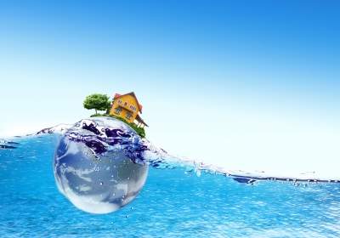

***Image: FreeDigitalPhotos.net***

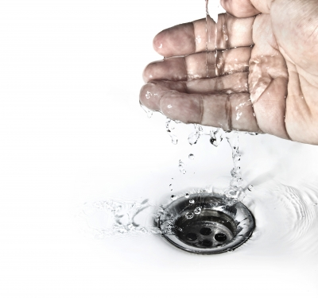

# 10 Travel and Transport



Transport and travel make up a large part of our ecological and carbon footprints. Much of this can be attributed to the use of the motor car as this has become the most popular and convenient way for many of us to travel. The car is often seen as a ‘status symbol’ and for many 17 year olds, obtaining a driving licence and owning a car is considered a natural part of becoming an adult.

Below are details of the emissions for different car sizes, petrol and diesel, for a **10 mile journey.**

|  |  |
| --- | --- |
| Size of car and fuel used | Total GHG emissions (kg CO₂eq) / 10 mile journey |
| Small PETROL car, up to 1.4 litre engine | **2.9 kg CO₂eq** |
| Medium PETROL car, from 1.4 – 2.0 litre engine | **3.5 kg CO₂eq** |
| Large PETROL car, above 2.0 litres | **4.8 kg CO₂eq** |
|  |  |
| Small DIESEL car, up to 1.7 litre engine | **2.5 kg CO₂eq** |
| Medium DIESEL car, from 1.7 – 2.0 litre engine | **3.0 kg CO₂eq** |
| Large DIESEL car, above 2.0 litres | **4.1 kg CO₂eq** |

Total greenhouse gas emissions are advised in kg of carbon dioxide equivalent (kg CO₂eq); this includes all emissions from the ‘basket of six’ greenhouse gases that were introduced earlier.

***REMINDER* ‘basket of six’ greenhouse gases:**

* Carbon dioxide (CO₂)
* Nitrous oxide (N₂O)
* Methane (CH₄)
* Hydrofluorocarbons (HFCs)
* Perfluorocarbons (PFCs)
* Sulphur hexafluoride (SF₆)

If you travel 100 miles a week in your car, from the table above it is easy to see how the emissions start to add up throughout the year. Let’s compare the annual emissions from a small diesel car against a large petrol car that drives on average 100 miles a week.

**SMALL DIESEL CAR** up to 1.7 litre engine – **2.5 kg CO₂eq** for 10 mile

2.5 kg CO₂eq x 10 = **25 kg CO₂eq** for 100 miles in a week

25 kg CO₂eq x 52 weeks = **1,300 kg CO₂eq** for 5,200 miles in a year

**LARGE PETROL CAR** above 2.0 litres – **4.8 kg CO₂eq** for 10 miles

4.8 kg CO₂eq x 10 = **48 kg CO₂eq** for 100 miles in a week

48 kg CO₂eq x 52 weeks = **2,496 kg CO₂eq** for 5,200 miles in a year

*So the difference between driving a small diesel car 100 miles a week over a year and a large petrol car 100 miles a week*

*= 2,496 kg CO₂eq*

*Minus 1,300 kg CO₂eq*

*= 1,196 kg CO₂eq*

***To put this into perspective this is roughly   
equivalent to a long haul economy return flight From Glasgow to New York.***

## 

## 10.1 Activity 15 - Lifestyle Changes Relating to Travel

Think of your lifestyle and look at the following table advising where you could make changes to reduce the GHGs you generate from travel. Also think about the barriers which may make it difficult for you to implement these changes and try to think of solutions to overcome the barriers.

Some examples have been provided for you, these examples are not exhaustive and you will be able to think of many more.

|  |  |
| --- | --- |
| LIFESTYLE CHANGE | BARRIER/SOLUTION |
| ***I will use public transport to travel to work instead of my car.*** | ***BARRIER*** *– the bus timetable does not get me to work on time.*  ***SOLUTION*** *– my employer has agreed that twice a week I can start and finish earlier, fitting my hours in with the bus timetable. Or if public transport is not an option, think about car sharing.* |
| ***When changing your car, buy a car with a smaller engine and lower emissions. What about considering electric or hybrid cars instead.*** | ***BARRIER*** *– cost, energy efficient cars may prove to be more expensive.*  ***SOLUTION*** *– as demand increases then price should fall.* |
|  |  |
|  |  |
|  |  |
|  |  |

It may not always be possible to implement a positive solution to the barrier, for example your employer may not allow you to work different hours two days a week. However, until you consider the barrier and look for a solution you will never know if a lifestyle change could be possible.

# C:\Documents and Settings\crawforde\Local Settings\Temporary Internet Files\Content.IE5\IP67HK85\6117715wy0opc4s[1].jpg11 Food

It should already be evident to you, from calculating your carbon footprint, that one of the major contributors to ecological and carbon footprint is the food we consume, but why is this? The easiest way to explain it is to look at an example of an everyday snack or lunch we may enjoy. Taking a bacon, lettuce and tomato sandwich as an example, where do all of the ingredients come from?

***MAYONNAISE – produced from vegetable oils extracted from soya grown in cleared Amazon rainforests***

***TOMATOES – grown in factory sized greenhouses in southern Spain where the rivers have been sucked dry for irrigation***

***ICEBERG LETTUCE – 2 large lettuce leaves produced in a Dutch greenhouse in the middle of winter and then transported by ship and road to British supermarkets***

***BACON – 2 slices from an industrial piggery in Denmark causing massive amounts of slurry which pollutes waterways***

***BREAD – 2 slices from wheat grown on arable land in England where hedgerows have been removed and wildlife sprayed with toxic chemicals***

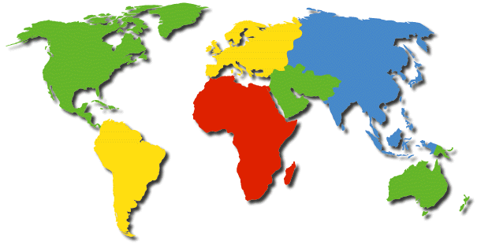

*Source: Adapted from the Teachers pack School Global Footprints (WWF Scotland, 2006). Image: piyato / FreeDigitalPhotos.net*

We can see from the example above, just how far our food often travels before it ends up on our plate. In the last section on transport, we calculated the amount of greenhouse gas emissions that resulted from different forms of travel. Therefore, it should be evident that if we were to consume less food grown in other countries and transported to the UK, and eat more food produced in the UK, this would reduce our carbon footprint in relation to food consumption. However, it is not always this straightforward. What would we do if we wanted fresh strawberries in January or pineapple at any time? Should we only eat seasonal fruit and vegetables that can be grown in the UK without the need for energy intensive hot houses?

## 11.1 Environmental Impact of Food

As we have seen, everything we eat has an impact upon the environment however there are steps we can take to help reduce the environmental impact of food, including the following:

* Shop locally and if possible, leave the car at home
* Plan one big trip if using a large supermarket instead of going two or more times per week
* Buy locally grown produce when it is in season
* Avoid food which is over packaged whenever possible
* Buy organic produce
* Buy fair-trade goods which support third world communities and are usually transported by sea

## 11.2 Fair Trade

Fair Trade has gained in popularity over recent years in our shops and supermarkets, especially with items such as tea, coffee, cocoa, chocolate and bananas. The purpose of Fair Trade is to provide justice and equality for small independent producers and the workers on plantations. The plantations are located in developing countries where workers are often exploited. In the past many of these farmers and workers were paid low wages and forced to work in poor conditions meaning they had to live in poverty. All of this meant they had little opportunity to improve their situation. Fair Trade aims to reverse this trend by ensuring there are standards in place for working conditions, and by implementing prices for traders and consumers. This means the farmers and workers are paid a fair wage. Fair Trade also ensures that the welfare conditions for the workers are acceptable, that children are not employed who should be in school and that farming practices are sustainable.

When we think of Fair Trade products, some of the first things that spring to mind include tea and coffee, or chocolate and bananas, none of which grow in the UK. Therefore, sometimes we need to think about compromising one belief or value we have, to support another. In this case the carbon emissions to transport these goods around the world, versus the need to help communities in developing countries support themselves and receive a fair income.

There may be other areas apart from Fair Trade where you may choose to compromise; especially in terms of the money you have available to spend, in order to support an environmental belief. For example, it is more expensive to buy free range chicken than battery farmed, which means you may choose to eat the more expensive free range chicken once a week instead of the cheaper alternative more often. Another example is looking for tuna that is pole and line caught which is more expensive than standard tins of tuna which have been caught by a process called purse seining. Purse seining uses huge nets which catch everything in the marine environment, including sharks and turtles (and sometimes even dolphins, although they state on the tin they are ‘dolphin friendly’). These other species are then discarded as by-catch and thrown back into the sea dead.

## 11.3 Activity 16 – Environmental Impacts of Food Production

Decide what your favourite meal is, whether this is a burger, a curry, or fish and chips, and think about what the environmental implications could be of producing that meal. Use the internet to search for the implications of the ingredients within the meal. Think about where and how the ingredients are grown and how they reach the supplier you have purchased them from.

|  |  |
| --- | --- |
| My favourite meal is: | Image: savit keawtavee / FreeDigitalPhotos.net  C:\Documents and Settings\crawforde\Local Settings\Temporary Internet Files\Content.IE5\6HRXJ5J0\24811ul2eeezbcr[1].jpg |
| The ingredients include: |  |



Record here what you think some of the environmental impacts of your meal could be:



# 12 And Finally ……

The last activity is to consolidate all of the information contained within the workbook. You can use the information you have learnt from any section of the workbook provided it relates to what is being done in your curriculum area to tackle sustainability issues.

## 12.1 Activity 17 – Poster Competition

Design a poster to advertise what is happening in the Construction area of the college to promote sustainability. The project can be related to any aspect of your college life, whether this is a class project, a Citizenship project or a cross college project your class is engaged in. The winning designs will be made into artwork and displayed around the college. The poster below may give you an idea of what is required. This poster was adapted in Dumfries and Galloway College from a campaign poster used at the University of Toronto to promote the use of reusable mugs. Using reusable mugs instead of paper ones stops paper ones ending up in landfill sites which is a waste of resources. This project has been successfully implemented within Dumfries and Galloway College.

To give you some ideas, here are some topics your poster could be about:

⯈ RECYCLING ⯈ RENEWABLE ENERGY

⯈ BIOFUELS ⯈ ECO-BUILDS

**⯈ Bring your own mug and save money and stop trash going to landfill.**

**⯈ Save 20p at Costa Coffee and 10p in the canteen.**

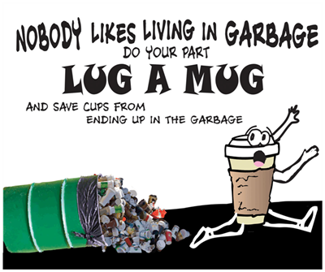

Source: www.ueat.utoronto.ca

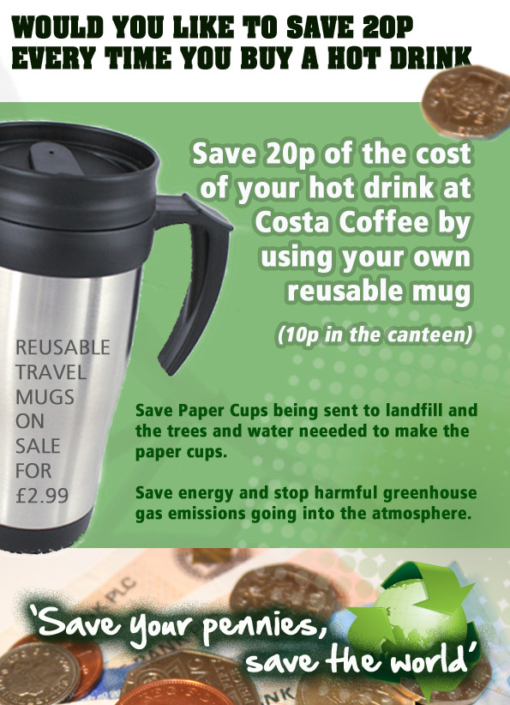

# 13 Reference List

Carbon Trust (2009). ***Carbon footprinting – the next step to reducing your emissions***.   
London: The Carbon Trust.

Energy Efficiency News. (2009). ***Empire State Building Goes Green*.** Available online at: [**http://www.energyefficiencynews.com/refurbishment/i/2002/**](http://www.energyefficiencynews.com/refurbishment/i/2002/) [Accessed 23 August 2011]

European Commission. (2010). *Energy Efficiency*. Available online at: [**http://ec.europa.eu/energy/efficiency/buildings/buildings_en.htm**](http://ec.europa.eu/energy/efficiency/buildings/buildings_en.htm) [Accessed 15 August 2011].

Frej, A.B. Ed. (2005). ***Green Office Buildings: A Practical Guide to Development***.   
ULI-The Urban Land Institute: Washington DC.

Global Footprint Network. (2010). ***2010 Data Tables***. Available online at: [**http://www.footprintnetwork.org/en/index.php/GFN/page/footprint_for_nations/**](http://www.footprintnetwork.org/en/index.php/GFN/page/footprint_for_nations/)   
[Accessed 26 August 2011].

Clark, D., Bangay, R., O’Connor M., & Roche, R. (2009).   
***The Guardian’s quick carbon calculator*.** Guardian online. Available online at: [**http://www.guardian.co.uk/environment/interactive/2009/oct/20/guardian-quick-carbon-calculator**](http://www.guardian.co.uk/environment/interactive/2009/oct/20/guardian-quick-carbon-calculator) [Accessed 26 August 2011].

Intergovernmental Panel on Climate Change (IPCC) (2007).   
***Climate Change 2007: Synthesis Report 2007*.** Cambridge: Cambridge University Press.

Met Office. (2009). ***UK Climate Projections 2009 (UKCP09).*** Available online at: [**http://www.metoffice.gov.uk/climatechange/guide/ukcp/map/**](http://www.metoffice.gov.uk/climatechange/guide/ukcp/map/) [Accessed 31 August 2011].

Stern, N. H. (2007). ***The Economics of Climate Change*:** The Stern Review.   
Cambridge: Cambridge University Press.

World Commission on Environment and Development (WCED). (1987).   
***Our Common Future*.** Oxford: Oxford University Press.

World Wide Fund for Nature (WWF) Scotland. (2006). ***Schools Global Footprint*.**Godalming: WWF-UK.

