**STUDENT**

**PACK**

# About this Workbook

The author of this workbook is Mrs Elaine Crawford who is the Sustainable Development Adviser at Dumfries and Galloway College. Elaine has a MA in Environmental Sustainability and an MSc in Carbon Management, both from the University of Glasgow. The project to produce this range of workbooks began during a work placement with the Crichton Carbon Centre as part of the MSc in Carbon Management, when the first workbook was produced. As a result of this, a range of workbooks is now being developed to highlight Dumfries and Galloway College’s commitment to raising awareness of global issues that will affect us all and to ensure education for sustainable development is fully embedded within all aspects of the curriculum at the college. In places this workbook uses examples that are particular to Dumfries and Galloway College; however the information it contains can easily be applied to any college.

# Copyright Statement

**© Dumfries and Galloway College 2012**

### All rights reserved

This work is designed to be adaptable for different curriculum levels and to be stored in retrieval system form for uploading to a Virtual Learning Environment, which is acceptable to Dumfries and Galloway College. However, no part of this work may be reproduced, transmitted or forwarded to any other organisation, in any form or by any means, without the prior written permission of Dumfries and Galloway College.

Any enquiries regarding reproduction or distribution of all or any part of the work must be made in writing to Dumfries and Galloway College.

### Contract of sale

1. Dumfries and Galloway College (the rights holder) reserves all rights in the work of this range of workbooks about Education for Sustainable Development.
2. The work is offered for sale on the following basis.
3. The purchaser will not reproduce these materials, other than to adapt it for different curriculum levels, or transmit these materials in any form, or by any means, any or all of the work without the express written permission of the rights holder.
4. The rights holder does understand that the work may lend itself to adaptation by the purchaser to put the work in context for the purchaser’s requirement – for uploading to a Virtual Learning Environment, for example.
5. The permission given by the rights holder to adapt and upload is given on the understanding that these rights will only be exercised by the purchaser.
6. Any rights allowed to the purchaser are strictly non-transferable.
7. At all times, the copyright of the work remains with Dumfries and Galloway College.
8. Any reproduction or adaptation must still provide full acknowledgement to the rights holder on the work and any derivative work. The rights holder will agree a form of words to be used in the acknowledgement.
9. Where reproduction or adaption rights allowed to the purchaser entails the work being stored on an intranet, for example, the purchaser must ensure that access to that intranet is secure.
10. No rights are granted to permit uploading all, or any part of the work, to the public internet.

Dumfries and Galloway College indemnifies the purchaser against any third party charges of infringement in the work.

Table of Contents

About this Workbook 2

Copyright Statement 3

All rights reserved 3

Contract of sale 3

1 Introduction 5

1.1 Climate Change 5

2 The Life Cycle of Everyday Objects 8

2.1 Activity 1 - The Life Cycle of a Pair of Hairdressing Scissors 9

3 Carbon Footprints 10

3.1 Activity 2 - Your Carbon Footprint 10

3.2 Carbon Footprints around the World 12

4 Hairdressing Products 14

4.1 Activity 3 - Product Design 16

5 Calculating Energy Consumption 17

5.1 Electricity - Understanding Watts and Kilowatt Hours 17

5.2 Activity 4 - Changing Light Bulbs 18

5.3 Activity 5 - Calculating Energy Use from Changing Hairdryers 20

5.4 Activity 6 - Calculating the Electricity Used by Hood Hair Dryers 21

5.5 Activity 7 - Energy Use of a Climazone versus Cling Film 23

5.6 Activity 8 - Energy Use at Home 24

6 Water Use 27

6.1 Water Conservation 27

6.2 Activity 9 - Water Conservation Calculations 28

6.3 Activity 10 - Poster Competition 30

7 Waste 32

7.1 Activity 11 - Waste Generated in the Salon 34

8 Buildings 37

9 Travel and Transport 39

9.1 Activity 12 - Changes to my Travel 39

10 Food 41

10.1 Environmental Impact of Food 42

10.2 Fairtrade 42

10.3 Activity 13 - Environmental Impacts of Food Production 43

11 Managing a Small Hairdressing Salon 44

11.1 Activity 14 – Environmental Impacts of a Small Hairdressing Salon 45

12 And Finally …… 48

12.1 Activity 15 - Poster Competition 48

13 Reference List 50

# 1 Introduction

The purpose of this workbook is to introduce the topics of sustainability and sustainable development. There are a number of reasons why sustainability and sustainable development have become increasingly important in recent years, including the issue of climate change caused by human actions. However, sustainability does not mean only looking at climate change and the problems associated with it, but also considers other issues such as population growth, the use of limited resources and social justice. This workbook begins by explaining why we should be concerned about climate change and then moves on to provide information about other areas of our lives we could consider changing in order to live a more sustainable life within the confines of the one planet we call home – the planet Earth.

## 1.1 Climate Change

The Earth’s climate has varied naturally throughout its history, with periods when it was much warmer than today and ‘ice ages’, when Scotland was under glaciers a kilometre deep. However, during these times the Earth was much less densely populated than it is today. As you are probably aware, the Earth is now going through another period of warming, but this is different from those that have happened in the past. Over the last century global temperatures have been rising and scientists have concluded that this recent warming cannot simply be explained as natural variability. Human activities, mainly the emission of greenhouse gases (GHGs), are playing a major part. The main causes are the burning of fossil fuels (such as oil, coal and gas), and changes in land use, such as deforestation. As we increase emissions, the GHGs in the atmosphere also increase. This is resulting in an increase in global average temperatures, average sea level is rising, and snow and ice are melting at an alarming rate (IPCC, 2007). The Intergovernmental Panel on Climate Change has also concluded that most of the warming that has occurred since the mid 20th century is very likely due to man-made GHG emissions.

These GHG emissions are ‘enhancing’ the natural greenhouse effect. The greenhouse effect is a process which keeps the planet warm due to GHGs in the atmosphere trapping radiation from the sun – without it, the Earth would be much colder, around -18°C. The best known GHG is carbon dioxide (CO2), but there are a number of others, including methane (CH₄), nitrous oxide (N₂O) and water vapour (H₂O). Put simply, adding GHGs to the atmosphere enhances the greenhouse effect and results in global warming. Diagram 1 – The Greenhouse Effect shows the natural greenhouse effect without man made interference, however the addition of extra GHGs in the atmosphere causes more of the sun’s solar radiation to be trapped causing the temperature on earth to increase.

Diagram 1 - The Greenhouse Effect

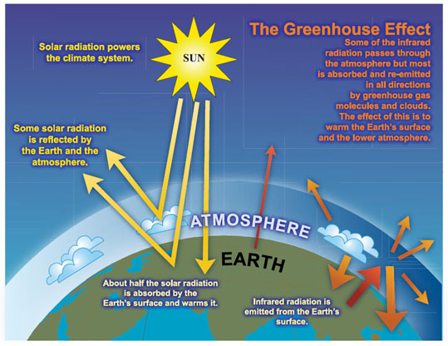

*Source: Intergovernmental Panel on Climate Change Assessment Report 4 (2007)*

The latest research conducted by experts at the Met Office suggests that if we (and others around the world) continue to operate on a ‘business as usual’ basis, then we could see an increase in the global average temperature of around 4°C before the end of the 21st century. In addition to the changes already mentioned, this increase in global temperature will bring with it major changes to weather patterns and an increasing frequency and intensity of extreme weather events such as hurricanes, heavy rainfall events and heat waves. Such a large and fast change in climate is dangerous and will have severe and costly impacts (Stern, 2007). For example, our ability to produce food around the world will decrease significantly, hundreds of millions of people will face water stress while millions of others will face flooding, and around a third of all species are likely to become extinct (IPCC, 2007).

Scotland, and the rest of the UK, will not be immune from the effects of climate change. Unless we seriously change our lifestyles to cut CO2 emissions, average temperature increases of up to 3°C in the winter and 4°C in the summer are likely to be experienced by our grandchildren and great-grandchildren (Met Office, 2009). The related weather changes are likely to mean floods, droughts and dangerous heat waves, with a rise in heat-related deaths. In 2003, 37,000 people died as a result of a heat wave in Europe, over 2,000 of which were in the UK (Met Office, 2009). Winters will be significantly wetter, with more intense rainfall. This would mean more flash floods, with rivers bursting their banks more often. Other impacts include an increasing incidence of severe gales and sea level rise, affecting coastal areas causing flooding of coastal homes and businesses, and coastal erosion.

Action now needs to be taken to reduce GHG emissions to ensure that global temperatures do not rise by more than 2°C; this will help to limit the most severe impacts of climate change. This challenge has been accepted by the UK and Scottish governments with the passing of The Climate Change Act 2008 and The Climate Change (Scotland) Act 2009, both of which set a legally binding target to reduce emissions by 80% from 1990 levels by 2050. In Scotland, the first interim target is a reduction of 42% below 1990 levels by 2020. As a result, we will see increasing regulatory requirements to reduce emissions in both the workplace and the home. Everyone has to play their part in the drive to a more resource efficient, low carbon system if we are to meet these targets and avoid catastrophic interference with the climate system.

Due to the global recession, it is likely that global emissions have fallen due to a reduction in fossil fuel use. The Earth’s climate is also going through a natural cooling period, hiding the true extent of climate change for a short period. This may make it seem like we have turned a corner and that the problem has been solved. This will not be the case. Tackling the global climate will be a major project for the whole of humanity and throughout the lives of everyone at the college. We need to do all we can to reduce our GHG emissions by using fewer fossil fuels, more renewable energy and changing our lifestyles to reflect this. Climate change is coming, but with your help, we can reduce its impacts for ourselves and the generations which follow us.

# 2 The Life Cycle of Everyday Objects

Life Cycle Analysis (LCA) is a process used to measure the environmental impact of a product or process, from the beginning of its life to the end, or from the ‘cradle to grave’. As we can see from the diagram below, to make any product we need to start with the raw materials and then determine how they are processed to make the product, how the product is then used, before it is either discarded or recycled

**MANUFACTURE**

**USE**

**RECYCLING/DISPOSAL**

**EXTRACTION**

**PROCESSING**



*Source: Adapted from the Swedish Environmental Management Council*

**TRANSPORT**

**TRANSPORT**

**TRANSPORT**

**TRANSPORT**

**Standards**

Think about what everyday objects are made of, the resources and energy used to make them, how long they can be used for, and what happens to them at the end of their useful life. You may also need to consider the following:-

* Different products and services have their most significant climate impact at different stages in their life cycles.
* For products with a long life and high energy consumption, the **Use Phase** typically accounts for the most significant climate impact, for example a washing machine.
* Other products will have their greatest impact during the **Production Phase** – this is usually the case for food production.
* Some products may not be recyclable and may need to go to landfill.

This is just a small snapshot of the impacts of the life cycle of an object. To see more of the environmental impacts of the products we consume, go to <http://www.storyofstuff.com/> and watch the Story of Stuff. (Available at <http://www.storyofstuff.org/movies-all/story-of-stuff/> ).

## 2.1 Activity 1 - The Life Cycle of a Pair of Hairdressing Scissors



*Image:   
Sura Nualpradid /FreeDigitalPhotos.net*

Look at the picture of a typical pair of salon style hairdressing scissors. Have a good think about the scissors and answer the following questions. You may find the internet helpful with your answers.

**Q1** What are they made from?

**Q2** How are they made? What energy is used to make them?

**Q3** How do the scissors get to the salon from where they are made?

**Q4** How long are they used for?

**Q5** What happens to paper scissors once their useful life is over?

# 3 Carbon Footprints

## 3.1 Activity 2 - Your Carbon Footprint

A carbon footprint is the total set of greenhouse gas (GHG) emissions caused by an organisation, event or product (Carbon Trust, 2009). To make it easier to report, it is often expressed in terms of the amount of [carbon dioxide](http://en.wikipedia.org/wiki/Carbon_dioxide) (CO₂), or the amount of carbon dioxide equivalent (CO₂eq) of any other GHGs emitted, such as methane or nitrous oxide. Activities in our daily lives cause GHG emissions and we can measure the amount to determine our own individual carbon footprint or a product’s carbon footprint.

The areas of our lives that generate most of our individual GHG emissions are as a result of:

* Electricity use
* Travel and transport
* Food production
* Buildings we use
* Waste

Carbon footprints are a sub-section of ecological footprints. Ecological footprints look to measure one person’s impact upon the world, or the amount of resources or space that are required for an individual to live their life. Go to the following website, <http://footprint.wwf.org.uk/> and enter the data to reflect your lifestyle, it will only take a few minutes to do so. Based on the information you provide regarding the way you live, the calculator will estimate how many planets would be required to support your lifestyle should every person in the world live as you do. This is based on the amount of land required to produce the quantity of resources that you consume.

* **Record here how may planets your lifestyle requires _________**
* **Record here your carbon footprint _________ tonnes per annum**

**You may be surprised by the results!**

**Remember we only have one Earth!**



**Available Resource = 1 Planet Only!**

*Image: Salvatore Vuono / FreeDigitalPhotos.net*

## 3.2 Carbon Footprints around the World

Not everyone in the world lives in the same way as many of us in Scotland and other industrialised countries do. Some people are more environmentally aware and try to limit their impact upon the Earth and its resources wherever possible, whilst others don’t. Also, not everyone has access to the same amount of the Earth’s resources or the means to live as we do in the Western world. The diagram below shows the average carbon footprint of an average North American in tonnes of carbon dioxide equivalent (the total of all their GHG emissions), compared against the average carbon footprint of someone who lives in Dumfries.

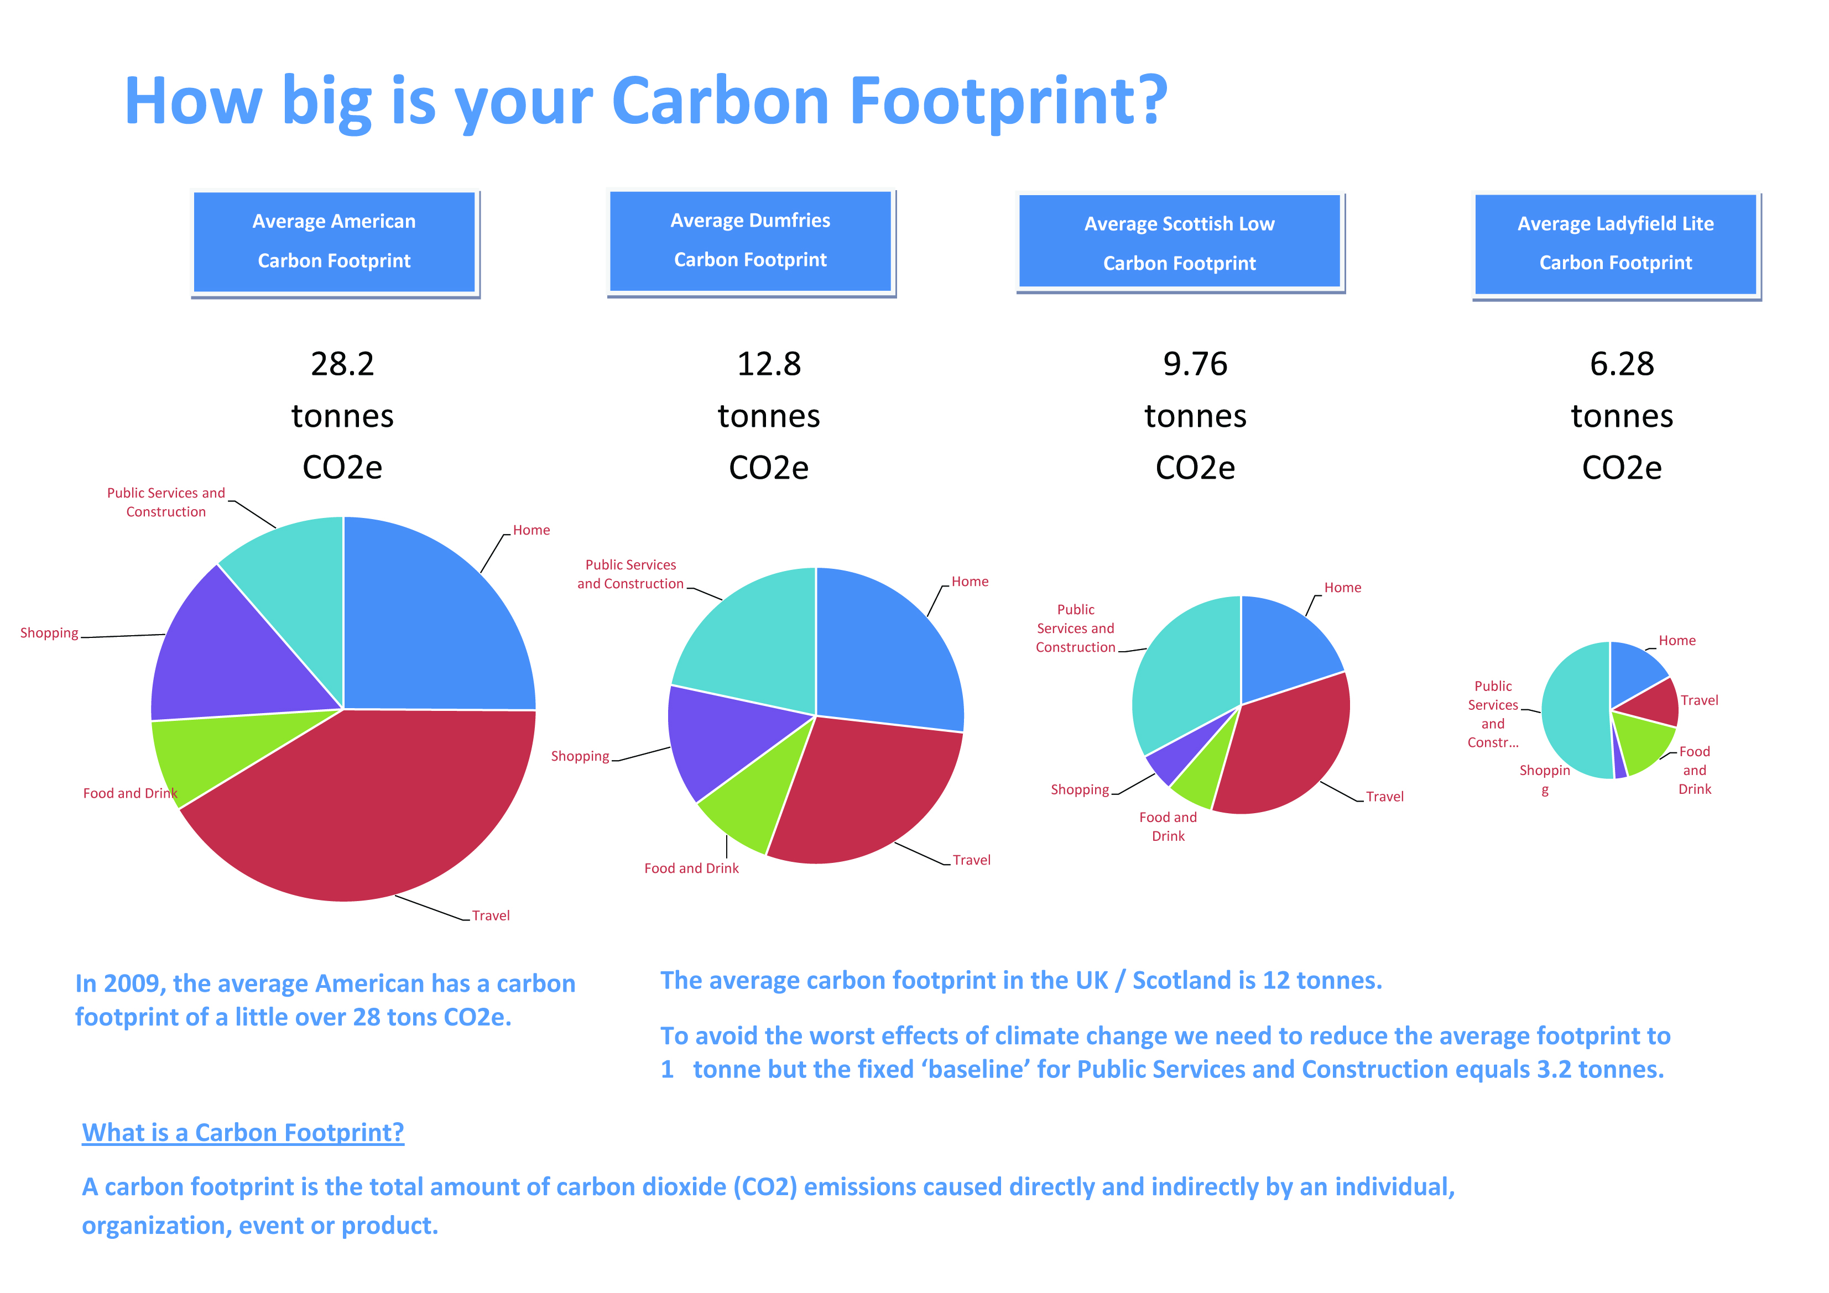

**28.2 tonnes CO₂ eq**

**12.8 tonnes CO₂ eq**

*Source: Carbon footprint tool developed by the Crichton Carbon Centre*

In 2009 the average North American had a carbon footprint of just over 28 tonnes of carbon dioxide equivalent and the average carbon footprint in Dumfries was nearly 13 tonnes of carbon dioxide equivalent. Whilst the carbon footprint of the average person in Dumfries is significantly lower than the average North American, we are still not living within the available resources on the Earth if everyone were to have the same share. At the other end of the scale, the average person in China has a carbon footprint of 5 tonnes of carbon dioxide equivalent and in Bangladesh the average is as low as 1 tonne (Clark *et al*., 2009).

Ecological footprints measure the number of hectares of land that are required to provide all of the goods and services a person consumes. To put this into perspective, the average North American person needs 8 hectares of land to support their lifestyle, the average British person needs 4.9 hectares and the average Indian person only 0.9 hectares (Global Footprint Network, 2010). This highlights the social injustice that exists between different lifestyles around the world. Put simply, if everyone in the world lived like the average American we would need five planets, that’s four more in addition to the one we already have!

**Unfortunately we do not have five Earths!**





*Image: Idea go / FreeDigitalPhotos.net*

# 4 Hairdressing Products

In Section 2 we considered the environmental impact of making everyday objects. In your career as a hairdresser, you will need to use different products, all of which have an environmental impact throughout their lifetime. Producers of goods and services are increasingly becoming aware of these impacts and are starting to think of measures they can take to limit the amount of environmental damage their product is responsible for. However, before measures can be taken to reduce a carbon footprint, they need to know how big it is.

Just like people, every good or service can be measured in terms of its carbon footprint. A product’s carbon footprint is the total amount of GHGs produced whilst making that product, during its lifetime and then to dispose of it.

To calculate a product footprint there is a ‘**basket of six’** greenhouse gases that need to be measured, these are:-

* Carbon dioxide (CO₂)
* Nitrous oxide (N₂O)
* Methane (CH₄)
* Hydrofluorocarbons (HFCs)
* Perfluorocarbons (PFCs)
* Sulphur hexafluoride (SF₆)

Boots the Chemist, with help from the Carbon Trust, has measured the carbon footprint of their Botanics shampoo range and as a result they determined where they could make reductions in the footprint of the products.

For more information on how the Carbon Trust work with their clients and help them reduce their carbon footprints and the carbon footprints of their products, please look at the link below.

* <http://www.carbontrust.com/our-clients>

It is not just hairdressing products that manufacturers are looking at, below is an example of carbon footprint information for a brand of washing powder.

|  |
| --- |
| C:\Documents and Settings\crawforde\Local Settings\Temporary Internet Files\Content.IE5\Y3UK4JC7\56292mnbbzto4nu[1].jpg  The carbon footprint of this product is 850g per wash.  This can be reduced by  washing at a lower temperature.  Washing at 30°C instead  of 40°C saves 160g CO₂  per wash.  When measuring a carbon footprint, it is important to explain what the amount of carbon measured relates to, or to provide a meaningful unit. In this example the carbon footprint of 850g CO₂ is the amount per washing machine load.  *Image:  digitalart / FreeDigitalPhotos.net* |



This example refers to the amount of CO₂, 294g, per bottle of mangoes and passion fruits smoothie.

*Image: By permission from Innocent Smoothies*

The main benefits of calculating product footprints are to identify both financial and carbon emission savings. Also as customer demand grows for more ‘eco-friendly’ products it can be used to advertise your green credentials. If customer demand is sufficient this puts pressure on producers and suppliers to think about the environmental impact of their products.

Use the internet to see if you can find more information on the carbon footprint of products. A good place to start is the Carbon Trust website at [www.carbontrust.co.uk](http://www.carbontrust.co.uk) and then search for product footprint information.

## 4.1 Activity 3 - Product Design

Your job is to design and market a hairdressing product aimed at the environmentally aware consumer. This can be any type of product you want such as a hairdryer or a hairdressing product. You will need to decide the type of product and give it a name. You will also need to consider who your market is, for example are you designing a new hairdryer to sell to salons, or a hair gel aimed at the youth market.

How would you design and advertise your product to appeal to your target market? Bear in mind whoever your market is they are environmentally conscious and want a product that has as little impact upon the environment as possible. Your marketing campaign can take a number of different forms as long as the information in the box below is included. Remember, it will need to be colourful and imaginative if it is to appeal to your target audience. A poster or a PowerPoint presentation may be a good way to present your campaign.

*Remember: The Internet is a good resource to utilise for information*

You will need to consider all of the stages in the life cycle of a product which are:

* Extraction of raw materials
* Processing and manufacturing
* Transport and distribution
* Retail and consumer use
* Disposal

Taking account of each of these points, consider how your product could be classed as ‘eco-friendly’ and how you market it as such.

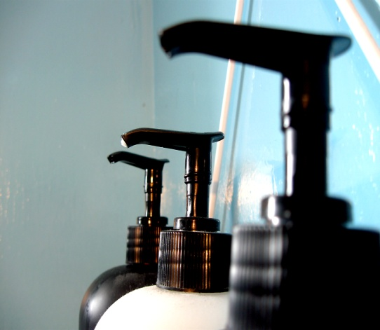

If you need some inspiration before you start this activity, **The Story of Stuff** website has a good video, ‘**The Story of Cosmetics’** available at;

* <http://www.storyofstuff.org/movies-all/story-of-cosmetics/>
* *The picture to the left shows a household food blender with the panel you are looking for.   
  The panel states the wattage of the blender is 500 watts.*

# 5 Calculating Energy Consumption

## 5.1 Electricity - Understanding Watts and Kilowatt Hours

We calculate electricity in units of **kilowatt hours (kWh**). A kWh is the number of watts used in one hour.

When we look at anything that runs on electricity, such as a hairdryer or a climazone, there is usually a label that tells us how energy hungry it is - this is the number of **watts (W)** the piece of equipment uses – or its ‘wattage’. For example, look at the hairdryers in the salons and you will see on the silver label on the handle, the Turbodryer 2000 uses 1400/1500 watts (W).

Before calculating how much energy is used by electrical appliances in our home, we will look at a simple example of electricity consumption using light bulbs in a college classroom.

|  |  |
| --- | --- |
| STAGE 1 | If there are 8 light bulbs in a salon and each light bulb is 100W, then to find out the total wattage of the lights you need to multiply the number of bulbs by the wattage:   * *Total wattage (8 bulbs) = 8 x 100 W = 800 W* |
| STAGE 2 | **To work out the ‘watt hours’ (Wh), we need to know the wattage and the number of hours it is turned on for.**   * ***Watts x hours = watt hours*** |
| STAGE 3 | **Then to find out how many kilowatt hours this is, we divide the number of watt hours by 1000:**   * ***Watt hours ÷ 1000 = kilowatt hours*** |

For example, if the eight 100 watt bulbs in the salon are turned on for 5 hours, then:

***800 watts x 5 hours = 4000 watt hours***

***4000 watt hours ÷ 1000 = 4 kilowatt hours***

To calculate how much energy the salon uses for lighting in a year, we need to estimate how many hours the lights are turned on for in a year. To do this we need to estimate the number of hours they are on per day, the number of days they are on per week, and the number of weeks per year.

The salon lights are usually on for 8 hours per day, there are 5 days in the college week, and 40 college weeks per year, so the salon lights are on for:

***[8 hours/day x 5 days/week x 40 weeks/year = 1600 hours/year]***

*And the energy they use in a year is:*

***800 watts x 1600 hours/year = 1,280,000 watt hours/year***

***1,280,000 watt hours/year ÷ 1000 = 1280 kilowatt hours/year (kWh/yr)***

*Based on an average electricity unit price of £0.10, 1 kWh costs £0.10*

***Therefore 1280 kWh/yr costs 1280 x £0.10 = £128.00***

*This means to light the salon during working hours for one year,   
using 8 100 W bulbs costs the salon £128.00*

## 

## 5.2 Activity 4 - Changing Light Bulbs

The college has low energy fluorescent lighting in the hairdressing salons. Each light fitting contains two 35 W bulbs, and there are 11 fittings in the salon. Prior to moving into the new college building, the salons at the old building used light fittings with 100 W bulbs, with 15 of these bulbs in a salon.

Therefore how much energy and money did the college save when they moved to the new building by changing the bulbs in the salons?

***HINT:*** *Estimate how many hours the lights are on each day based on an eight hour day.   
Remember there are 5 college days in a week, and 40 college weeks in a year, so there are 200 college days in a year.*

***REMEMBER*: *(watts x hours per year) ÷ 1000 = kilowatt hours per year***

|  |  |  |  |  |  |  |
| --- | --- | --- | --- | --- | --- | --- |
|  | **Wattage of 1 bulb [W]** | **Number of bulbs** | **Total watts of all bulbs [W]** | **Hours on per day [hours / day]** | **Hours on per year  [hours / year]** | **Kilowatt hours of energy per year [kWh / year]** |
| **OLD BULBS** | **100** | **15** | ***100w  x  15 bulbs  = 1500 watts*** | **8** | ***8 hours  x  200 days  = 1600 hours*** | ***1500 watts  x  1600 hours  = 2,400,000watt hours  ÷  1000  = 2400 kWh / year*** |
| **NEW BULBS** | **35** | **22** | ***35w  x  22 bulbs  = 770 watts*** | **8** |  |  |
|  | | ***SAVINGS*** |  |  | ***SAVINGS*** |  |

**Q1** Therefore how many kWh of electricity have been saved in a year in one salon classroom by changing the bulbs?

= ________________ **kWh / year**

***REMEMBER:*** *the average cost of 1 unit of electricity costs the college £0.10*

1kWh of electricity costs £ _________________

Therefore a reduction in use of ____________ **kWh**saves £ **________________________________ a year**

**Q2** The new college building has 3 hairdressing salon classrooms, therefore how much electricity and money has the college saved by changing the light bulbs in all 3 salons?

* One salon means a reduction of ________________  **kWh / year**,   
  so 3 salons means a reduction of ________________ **kWh / year**
* One salon saved £**________________ a year,**so 3 salons saves£ **________________________________ a year**

## 5.3 Activity 5 - Calculating Energy Use from Changing Hairdryers

Over the summer break, due to wear and tear, all of the hairdryers in the salon have been replaced ready for the new academic year. Instead of each hair station having a **Turbodryer 2000** which uses 1500 W of electricity, these have now been replaced by a **Babyliss Eco Dry** energy saving hairdryer which uses 1000 W of electricity. Complete the table below to estimate how much electricity in kilowatt hours (kWh) each salon will save in a year, and then how much will be saved from the electricity bill for the college in a year.

***HINT:*** *There are 14 stations in each salon and therefore there are 14 hairdryers being replaced in each salon. If on average each hairdryer is used for 2 hours per day, complete the following table to calculate the electricity used by the hairdryers in one salon in a year.*

***REMEMBER*: *there are 200 college days in a year***

|  |  |  |  |  |  |  |
| --- | --- | --- | --- | --- | --- | --- |
| **Hairdryer** | **Wattage of 1 hairdryer**  **[W]** | **Number of hairdryers in a salon** | **Total watts of all 14 hairdryers [W]** | **Hours on per day [hours/day]** | **Hours on per year [hours/year]** | **Kilowatt hours of energy per year [kWh/year]** |
| **Turbodryer 2000** | ***1500*** | ***14*** | ***1500 x 14***  ***=***  ***21,000 W*** | ***2*** | ***2 hours***  ***x***  ***200 days***  ***=***  ***400 hours*** | ***21,000 W***  ***x***  ***400 hours***  ***=***  ***8,400,000 Wh***  ***÷***  ***1000***  ***=***  ***8400 kWh / year*** |
| **Babyliss Eco Dry** | **1000** |  |  |  |  |  |
|  | | ***Savings*** |  |  | ***Savings*** |  |

Now we know how much electricity the hairdryers in one salon use in a year. We can calculate the amount of electricity used in total by all hairdryers in the college’s hairdressing salons.

|  |  |  |
| --- | --- | --- |
|  | **kWh/year for 1 salon** | **kWh/year for 3 salons** |
| * **Turbodryer 2000** |  |  |
| * **Babyliss Eco Dry** |  |  |
| * **Savings** |  |  |

***HINT:*** *1kWh of electricity costs £0.10*

* Therefore a reduction in energy use from the 3 salons of **____________ kWh**    
    
  saves £ **________________________________ a year**

## 5.4 Activity 6 - Calculating the Electricity Used by Hood Hair Dryers

The hairdressing salons have many different types of hood hair dryers. Calculate the electricity use of each hood hair dryer to see how they compare against each other in terms of energy efficiency.

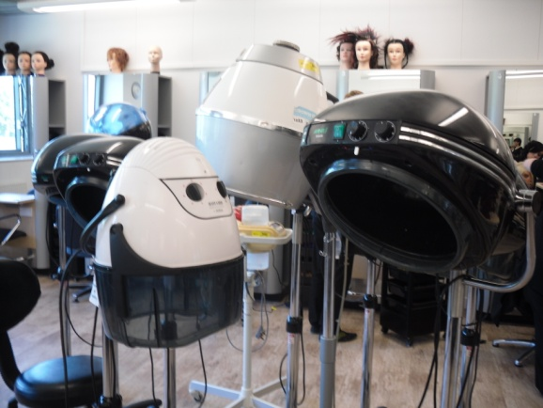

These are some of the hood hair dryers used in the salons.

* Is their performance all similar?
* Do they all take the same amount of time to dry a client’s hair?
* Do they all produce the same results?

If so, how much electricity could be saved by only using the most energy efficient model?

***REMEMBER*:** There are 40 weeks in a college year and for the purpose of this exercise it has been estimated the hood hair dryer is used for 8 hours per week.

***HINT*:** To find the wattage of electrical equipment look for a small information panel on it where you will find the wattage stated.

* *The picture to the left shows a household food blender with the panel you are looking for.   
  The panel states the wattage of the blender is 500W watts.*

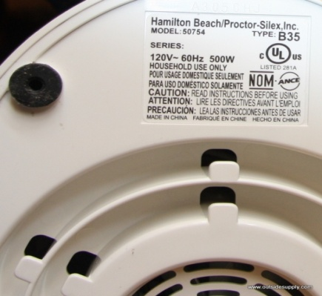

Complete the table below to compare the electricity consumption of hood hair dryers. Two examples have already been provided for you. For the remaining spaces, find two different types of hood hairdryer within your salon and find the wattage for them, either on the information panel on the machine or by searching the internet.

|  |  |  |  |  |
| --- | --- | --- | --- | --- |
|  | **Wattage of hood hair dryer [W]** | **Average hours used per week [hours/week]** | **Average hours used per year [hours/year]** | **Kilowatt hours of energy per year [kWh/year]** |
| * **Avant Garde** | **950** | **8** |  |  |
| * **Wellaportronic** | **720** | **8** |  |  |
|  |  | **8** |  |  |
|  |  | **8** |  |  |

**Q1** Which hood hair dryer uses the least amount of electricity?

**Q2** What is the difference in electricity consumption per year of the hood hair dryer that uses the greatest amount of electricity and the hood hair dryer that uses the least amount of electricity?

**Q3** By only using the hood hair dryers that use the least amount of electricity, how much would this reduce the college’s electricity bill by in a year for one hood hairdryer?

* 1kWh of electricity costs £________________
* Therefore a reduction in use of **____________ kWh**    
  saves £________________________________ **a year**

## E:\DCIM\101SSCAM\SDC10364.JPG5.5 Activity 7 - Energy Use of a Climazone versus Cling Film

A climazone reduces the amount of time that colour products needs to be left on the client’s hair by around 25%. However, if the colour needs to be on the client’s hair for 40 minutes, this is only a saving of 10 minutes. If the salon is not particularly busy, the client may not mind sitting a further 10 minutes, particularly if you explain to them why and offer them a coffee and a magazine.

Calculate how much electricity could be saved in one salon if the climazones were not used, either because the client sits a bit longer, or an alternative such as wrapping the head in cling film is used instead.

***HINT*:** *For this exercise assume the climazones are used for 4 hours per week per salon. You will also need to find the wattage of the climazone*

***REMEMBER*:** *there are 40 weeks in a college year*

|  |  |  |  |  |
| --- | --- | --- | --- | --- |
|  | **Wattage**  **[W]** | **Average hours used per week [hours/week]** | **Average hours used per year [hours/year]** | **Kilowatt hours of energy per year [kWh/year]** |
| * **Climazone** |  |  |  |  |
| * **Sitting Extra or  Cling Film** | **0** |  |  |  |
| * **Savings** |  |  |  |  |

**Q1** How much electricity is saved per year in one salon by using cling film, or by the client sitting longer, instead of using the climazone? _____________________**kWh** per year

**Q2** If the saving for one salon = ______________________________ **kWh**  per year,  
then the savings from 3 salons = __________________________ **kWh**

**Q3** If the number of hours the climazones were used throughout the year was reduced by half, how much electricity would be saved in one salon?   
Climazone use in one salon = **kWh**  per year,  
 therefore reducing this by half =  **kWh** per year

**Q4** By how much would this reduce the college’s electricity bill by?  
1kWh of electricity costs £____________  
Therefore reducing the use of the climazone in one salon by 50% saves £__________ *per year.*

**Q5** How much would this monetary saving increase by if the same practice was used in all 3 salons? £_______________ *per year*

## 5.6 Activity 8 - Energy Use at Home

Look around your home and choose five pieces of electrical equipment you can find the wattage easily for. Remember, for many items this can be found on a little panel, failing that you can find the wattage in the manufacturer’s guide, if you still have it, or by searching on the internet (a good site is [www.sust-it.net](http://www.sust-it.net) ). The items can be anything electrical, for example, a television, kettle, microwave, or something you only use occasionally such as an electric drill or electric lawn mower.

***HINT:*** *Once you have selected your electrical equipment, make an estimate of how many hours a day on average it is switched on and then complete the following table. The first line has been completed as an example.*

***REMEMBER:*** *there are 365 days in a year*

|  |  |  |  |  |  |
| --- | --- | --- | --- | --- | --- |
| **Type of equipment** | **Make and model** | **Wattage [W]** | **Hours of use per day [hours / day]** | **Hours of use per year   [hours / year]** | **Kilowatt hours of energy per year [kWh/year]** |
| **TELEVISION** | **Sony KDL 32EX603 32"** | **80** | **4** | **4 x 365  =  1460 hours / year** | **80W x 1460 hours  = 116800 Wh  ÷ 1000  = 116.8 kWh/year** |
|  |  |  |  |  |  |
|  |  |  |  |  |  |
|  |  |  |  |  |  |
|  |  |  |  |  |  |
|  |  |  |  |  |  |

**Q1** What is the most energy intensive piece of equipment you found?   
Remember this is the piece of equipment with the highest wattage.

**Q2** Which piece of equipment consumes the most electricity per year?

**Q3** Were you surprised by any particular result?   
If so, what is the piece of equipment and why were you surprised?

**Q4** Can you think of an example of an electrical item that you could substitute manpower for and still achieve the same result?

**Q5** What room in your house do you think is the most energy intensive in terms of electricity? Why do you think this is?

**Q6** Take the piece of equipment with the highest electricity consumption and search the internet for a less energy intensive alternative. What did you find?

**Q7** Electricity aside, can you think of any other ways energy is consumed in your household?

# 6 Water Use

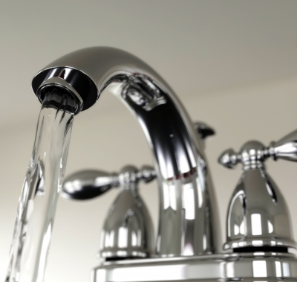

*Image: Ideago / Free Digital Photos.net*

## 6.1 Water Conservation

Water is essential for all living things on Earth, however it is a resource we take very much for granted in Scotland where we rarely have water shortages. Due to this, we do not always consider water as a finite resource and that not everyone in the world has access to readily available clean water, as we do. In 2007 the average Scottish person used 146 litres of water per day, which is 6% more water per person per day than we used 20 years ago.

It is difficult to appreciate the need for water conservation when it rains so often in Dumfries and Galloway. However, even in Dumfries we are increasingly experiencing periods of little or no rainfall, which means we may soon be facing water shortages, and this will become more common in summer months in the future due to climate change. This is already a reality in many places around the world, and as global average temperatures rise, this will only get worse. By 2025, it is estimated that 5.5 billion people around the world, 67% of the population, will live in areas where drought, as a result of climate change, will make water scarce (WWF Scotland, 2006). There are already conflicts over water in some areas of the world, for example in some countries communities’ water supplies are disrupted due to water being required for golf courses for wealthy tourists.

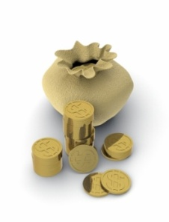

*Image:   
graur razvan ionut /  
FreeDigitalPhotos.net*

As a result we should be conserving water wherever possible.   
Hairdressing is a water intensive industry for a number of reasons such as:

* Shampooing client’s hair
* Cotton used for towels as growing cotton is water intensive
* The quantity of towels used generates a lot of washing.
* Water requirement in the production of hairdressing products.

In order to conserve water, we need to think how hairdressing practices in the salon could change to be less water intensive. The first step could be not to waste water wherever possible, which could mean only having the tap running when it is needed. This means when washing a client’s hair the tap should be switched off when the water is not being used to rinse products from the hair. This may seem obvious, however it is simple to implement and could mean a large reduction in water usage. Another simple measure is to ensure the washing machine always has a full load before switching it on. This may not be an issue in the college where there are always lots of towels to wash, but this may not be the case if you work in a small salon. This is also a simple measure to put into practice at home.

Some other changes are not so straightforward, such as technology being used for water conservation. There are taps available which reduce the amount of water that flows from them and there are washing machines which use a lot less water per load than standard ones. If you need to replace such equipment it may be worth considering alternatives that use less water, especially if this can lead to reduced water bills which could save your employer money.

## E:\DCIM\101SSCAM\SDC10364.JPG6.2 Activity 9 - Water Conservation Calculations

Standard taps use around 15 litres of water per minute. There are taps available that can reduce this to 3 litres per minute. If we assumed the taps in the salon were using 15 litres per minute, how much water could be saved if they were changed to those that use 3 litres per minute?

***HINT:*** *There are 4 sinks in each salon and there are 3 salons*

|  |  |  |  |
| --- | --- | --- | --- |
|  | **Tap flow per minute for 1 tap**  **[litres / minute]** | **Tap flow per minute for 4 taps**  **[litres / minute]** | **Tap flow per minute for 3 salons**  **[litres / minute]** |
| **Standard Tap** | ***15 litres*** |  |  |
| **Low Flow Tap** | ***3 litres*** |  |  |
| **Savings** |  |  |  |

**Q1** In total, how many litres of water per minute would be saved if the taps were changed in all 3 salons? ________________ **litres / minute**

Next, let’s look at how much water actually flows from the taps in the salons. This way we can calculate how much water is saved by not leaving the tap running when shampooing a client’s hair. To do this we will need a **bucket** and a **measuring jug** to measure the water flow from the tap.

* Tap flow in 10 seconds = **_________ litres**

Therefore tap flow for 1 minute = _____________ **litres x 6 =** ___________ **litres**

Next we need to estimate how long the taps are running each day. For the next 5 client’s hair you shampoo, record how long the tap is on from start to finish. A stopwatch will be required.

|  |  |  |  |  |  |
| --- | --- | --- | --- | --- | --- |
| **CLIENT** | Client 1 | Client 2 | Client 3 | Client 4 | Client 5 |
| **Time in minutes** |  |  |  |  |  |

To calculate the average time it takes to wash a client’s hair, add the time in minutes together of the 5 clients and divide by 5.

**STEP 1**

**STEP 2** (divide the total number of minutes by five to get the average time)

Now that we know the tap flow per minute of the salon taps and the average time it takes to wash a client’s hair, complete the following table to calculate the amount of water that could be saved per salon if the taps were changed to low flow water efficient ones.

***HINT:*** *For the purpose of this exercise we will assume each student washes 2 heads per day which adds up to 140 washes per salon per week.*

|  |  |  |  |  |  |
| --- | --- | --- | --- | --- | --- |
|  | **Tap flow per minute**  **[litres / minute]** | **Average time per client**  **[minutes]** | **Litres of water used per client**  **[litres / client]** | **Number of clients per week [clients / week]** | **Water use in one salon per week**  **[litres / week]** |
| **Salon Tap** |  |  |  |  |  |
| **Low Flow Tap** | 3 |  |  |  |  |
|  | | | | ***Savings*** |  |

**Q1** How much water is used in one salon per week to wash 140 heads?

litres/week

**Q2** How much water would be saved in one salon per week by changing to low flow taps?

litres/week

**Q3** How much would be saved in three salons per week by changing to low flow taps?

litres/week

**Q4** Based on a 40 week college year, how much water would be saved in a year by changing the taps in all 3 salons?

litres/ year

**Q5** If the college pays an average amount of £0.08 per litre.

Based on changing the taps in the 3 salons, how much money could the college save per year?

litres/ year x £ __________ = £ __________

## 6.3 Activity 10 - Poster Competition

Design a poster to be displayed either beside the washing machine or beside the salon sinks stating all of the important points to consider in this area for water conservation.

The poster needs to be colourful and eye-catching whilst clearly stating what is required and why.

The winning design will be made into a poster and displayed in the appropriate area within the college.

# 7 Waste



There is a limit to the amount of waste the Earth can absorb. When we look at a product and the waste it generates, we need to look at it from the ‘cradle to grave’. This is why we have looked at products so far starting with the raw materials they are made from and ending with the disposal of the item. In order to reduce the amount of waste we produce, we need to reduce the number of products we consume. We have more money to buy more ‘stuff’ and as we like new ‘stuff’ we are always buying more. Also, products are not made to last like they were in the past. Our grandparents would ‘make do and mend’ whilst we just throwaway and replace. Economies of countries are driven by producing and selling more materials, so to make products that last longer does not make economic sense. (If you have not already done so, now is a good time to watch ‘The Story of Stuff’ at <http://www.storyofstuff.org/movies-all/story-of-stuff/> ).

Packaging is a major source of waste. The minute we remove it from a product waste is produced. One way to reduce the amount of packaging is by consumers putting pressure on suppliers to not over package their goods. This may be difficult for an individual, however if you are responsible for purchasing hairdressing products on a large scale for an employer or your own business, this may then become possible. It is also worth investigating if a supplier has an environmental policy and, if so, what it consists of, before deciding to use that supplier. As was established in the section on the life cycle analysis of a product, we should consider waste impacts from ‘cradle to grave’ for a product. If we produce and use less packaging, this means there are less raw materials required to make the packaging and less energy being used also. Less packaging also means less waste to recycle, which also uses energy, or less waste sent to landfill.

The waste produced in the salons is not only a concern due to the disposal of packaging but also due to disposal of the chemicals used in the products. Chemical waste causes pollution, which can be either point source or non-point source. Point source pollution is usually defined as pollution where the origin can be defined from one source, such as at the end of a pipe. Non-point source pollution is caused indirectly by chemicals leaking into groundwater. If disposed of incorrectly, the chemicals used in the salon can cause pollution to our environment by leaching into our groundwater from landfill sites. This can have a negative long-term effect on human health and also impacts upon plants and animals.

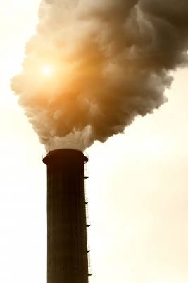

*Image: dan / FreeDigitalPhotos.net*

*Here is an example of* ***point source pollution*** *or end of pipe pollution. It is generally easy to see and recognise point source pollution, which can make it easier to address.*

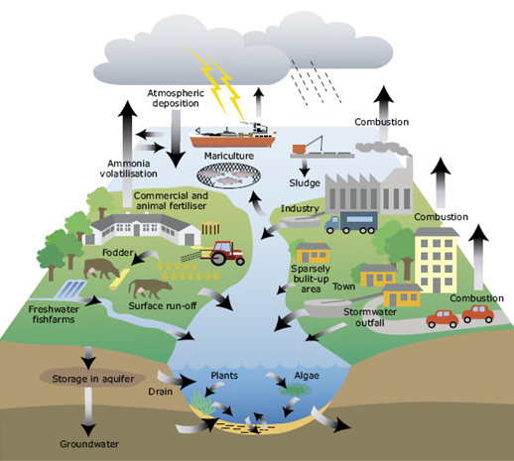

*Source: http://www.eea.europa.eu/themes/water/water-pollution*

***Non-point source pollution*** *can be more difficult to identify as it can originate from many sources.*

*In the picture above chemicals are leaching into groundwater from many different sources including farming, industry and towns.*

## 7.1 Activity 11 - Waste Generated in the Salon

Think of the products and materials that are used in the salon and make a list of the waste you think is generated within a normal week. If possible think of how this waste could be eliminated or reduced.

***HINT: include waste that could be generated as a result of lectures as well as hairdressing procedures and also think of canteen waste, i.e., tea and coffee for clients***

|  |  |  |
| --- | --- | --- |
| Waste Produced |  | Method to Eliminate, Reduce or Dispose |
|  |  |  |
|  |  |  |
|  |  |  |
|  |  |  |
|  |  |  |
|  |  |  |

Attitudes towards waste in our society are slowly changing. The best way to minimise the amount of waste we produce is to reduce the amount of ‘stuff’ we use. Failing this the next best option is to re-use wherever possible.

Most of you will probably be familiar with the concept of **‘Reduce, Reuse, Recycle’** already:

*(For example by manufacturers using less packaging on products or by consumers buying re-fill packs which use less packaging. Consumers can also put pressure on manufacturers and retailers to use less packaging.)*

*(For example, save last year’s Christmas cards and wrapping paper. Wrapping paper can be used again and Christmas cards can be cut up and used as name tags or decorations. Old magazines and newspapers can be used as wrapping paper with some pretty ribbon or bows added)*

*(However, remember this uses further energy and some items cannot be recycled because of toxic chemicals in them or because they may have been manufactured from different materials squashed together).*

***So most of us are familiar with the message REDUCE, RE-USE, RECYCLE.   
However, this can also be added to.***

*(For example, with our clothing, skills such as sewing are not so prevalent nowadays as they were in the past when clothing items would be mended instead of discarded. Also have shoes re-heeled or re-soled where possible instead of throwing them away).*

***We need to think for all non-renewable resources such as metals, glass and plastics***

*We need to remember,   
as they say in the supermarkets   
for special offers*

***‘when it’s gone, it’s gone’***

*The Earth is a closed system and once these   
materials have been used up the Earth can’t  
make any more of them within human timescales!*

# 8 Buildings



Around half of all global GHG emissions are generated as a result of buildings. During the useful life of a building, this includes emissions during construction, the electricity we consume within them and the energy required heating them. Once we are finished with the building there are emissions associated with its demolition, with materials either recycled, which uses energy, or sent to landfill, which has other environmental impacts also As we have seen earlier this is emissions from the ‘cradle to the grave’ of the building. There is huge potential for energy reduction in buildings as they are responsible for 40% of energy consumption and 36% of European Union CO2 emissions (European Commission, 2010).

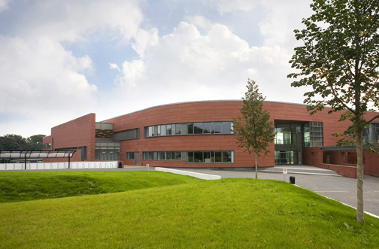Dumfries and Galloway College building is new and has been designed and built to be energy efficient. However, this does not mean that improvements in energy reduction cannot be made because a building can be as energy efficient as possible, but if it is not used correctly then it will not be effective. This is why it is important not just to use the most energy efficient type of electrical equipment available, but also to ensure it is not left switched on unnecessarily.

In a building such as a college, equipment like computers and printers are often left on standby consuming energy and costing money which could be easily saved. A simple measure such as placing stickers beside equipment reminding staff and students to switch off once finished with could help reduce this.

When you leave college and enter into employment there are simple and inexpensive measures concerning the salon building you could suggest to your employer such as:

* Replacing light bulbs with lower wattage versions where possible.
* Draught proofing doors and windows.
* Placing special foil panels behind radiators to reflect more heat into the room.
* Redecorating with insulating paint.

There are other measures which require more time, effort and money such as:

* Replacing doors and windows with double or triple glazing.
* Ensuring there is adequate wall and roof insulation.
* Changing the boiler and heating system.
* Switching electricity suppliers to one that utilises renewable energy sources to generate electricity.

These measures can also be implemented within your home. Inexpensive measures such as using draught excluders along the bottom of doors and fitting heavy lined curtains in front of draughty windows, especially in the winter, are easy to do. It is also easy to turn appliances off at the wall when not in use ensuring they are not accidentally left on standby. Whilst some of the other measures are more expensive, there may be instances where grants are available to help with the costs of procedures such as cavity wall and roof insulation.

Check the Government’s Grant website at <http://www.government-grants.co.uk>

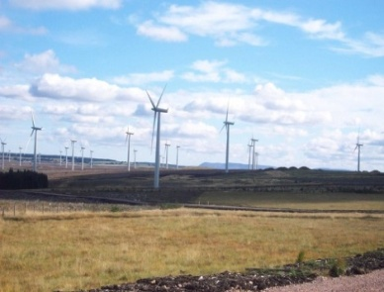

*Blacklaw Wind Farm, Lanark, Scotland - Image by: Author*

# 9 Travel and Transport

*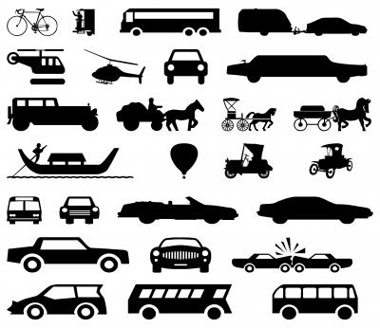Image: xedos4 / FreeDigitalPhotos.net*

Transport and travel make up a large part of our carbon footprints. Much of this can be attributed to the use of the motor car as this has become the most popular and convenient way for many of us to travel.

The car is often seen as a ‘**status symbol’** and for many 17 year olds, obtaining a driving licence and owning a car is considered a natural part of becoming an adult.

Different forms of transport are responsible for varying levels of GHG emissions, starting with walking or cycling which do not generate any, to air travel which generates more emissions than any other form of transport. In terms of our everyday lives, we can choose whether to use public transport, instead of sitting on our own in a car, or decide not to fly on holiday but stay in the UK instead. However, sometimes it is difficult or inconvenient for us to make changes, especially if running a business, such as a hairdressing salon where you need to encourage people to travel to your salon.

## 9.1 Activity 12 - Changes to my Travel

Think of your lifestyle and complete the following table advising where you could make changes to reduce the GHGs you generate from travel. Also think about the barriers which may make it difficult for you to implement these changes, for example, I will use my car less and take public transport to college; however the bus times may not get you to college in time.

|  |  |
| --- | --- |
| LIFESTYLE CHANGE | BARRIER/SOLUTION |
| *I will use public transport to travel to work instead of my car.* | ***Barrier*** *– the bus timetable does not get me to work on time.*  ***Solution*** *– my employer has agreed that twice a week I can start and finish earlier, fitting my hours in with the bus timetable.* |
|  |  |
|  |  |
|  |  |
|  |  |
|  |  |
|  |  |

# C:\Documents and Settings\crawforde\Local Settings\Temporary Internet Files\Content.IE5\IP67HK85\6117715wy0opc4s[1].jpg10 Food

It should already be evident to you from calculating your carbon footprint that one of the major contributors to our ecological and carbon footprint is the food we consume, but why is this? The easiest way to explain it is to look at an example of an everyday snack or lunch we may enjoy.

Taking a bacon, lettuce and tomato sandwich as an example, where do all of the ingredients come from?

***BREAD*** *2 slices from wheat grown on arable land in England where hedgerows have been removed and wildlife sprayed with toxic chemicals.*

***BACON*** *2 slices from an industrial piggery in Denmark causing massive amounts of slurry which pollutes waterways.*



***ICEBERG LETTUCE*** *2 large lettuce leaves produced in a Dutch greenhouse in the middle of winter and then transported by ship and road to British supermarkets.*

***TOMATOES*** *grown in factory sized greenhouses in southern Spain where the rivers have been sucked dry for irrigation.*

***MAYONNAISE*** *produced from vegetable oils extracted from soya grown in cleared Amazon rainforests.*

*Source: Adapted from the Teachers pack School Global Footprints (WWF Scotland, 2006). Image: piyato / FreeDigitalPhotos.net*

We can see from the example above, just how far our food often travels before it ends up on our plate. Therefore, it should be evident that if we were to consume less food grown in other countries and transported to the UK, and eat more food produced in the UK, this would reduce our carbon footprint in relation to our food consumption. However, it is not always this straightforward. What would we do if we wanted fresh strawberries in January or pineapple at any time? Should we only eat seasonal fruit and vegetables that can be grown in the UK without the need for energy intensive hot houses?

## 10.1 Environmental Impact of Food

As we have seen, everything we eat has an impact upon the environment however there are steps we can take to help reduce the environmental impact of food, including the following:

* Shop locally and if possible, leave the car at home.
* Plan one big trip if using a large supermarket instead of going two or more times per week.
* Buy locally grown produce when it is in season.
* Avoid food which is over packaged whenever possible.
* Buy organic produce.
* Buy fair-trade goods which support third world communities and are usually transported by sea.

## 10.2 Fair Trade

Fair Trade has gained in popularity over recent years in our shops and supermarkets, especially with items such as tea, coffee, cocoa, chocolate and bananas. The purpose of Fair Trade is to provide justice and equality for small independent producers and the workers on plantations. The plantations are located in developing countries where workers are often exploited. In the past many of these farmers and workers were paid low wages and forced to work in poor conditions meaning they had to live in poverty. All of this meant they had little opportunity to improve their situation. Fair Trade aims to reverse this trend by ensuring there are standards in place for working conditions, and by implementing prices for traders and consumers. This means the farmers and workers are paid a fair wage. Fair Trade also ensures that the welfare conditions for the workers are acceptable, that children are not employed who should be in school and that farming practices are sustainable.

When we think of Fair Trade products, some of the first things that spring to mind include tea and coffee, or chocolate and bananas, none of which grow in the UK. Therefore, sometimes we need to think about compromising one belief or value we have, to support another. In this case the carbon emissions to transport these goods around the world, versus the need to help communities in developing countries support themselves and receive a fair income.

It is customary to offer your client’s a cup of tea or coffee whilst they are in the salon, so if you are going to buy these products anyway then this may be an area where you wish to consider using Fair Trade products.

## 10.3 Activity 13 - Environmental Impacts of Food Production

Decide what your favourite meal is, whether this is a burger, a curry, or fish and chips. Think about what the environmental impacts could be of producing that meal. Use the internet to search for the effects that producing the individual ingredients in your meal has upon the environment. Think about where and how the ingredients are grown and how they reach the supplier you have purchased them from.

|  |  |
| --- | --- |
| My favourite meal is: | *Image: savit keawtavee / FreeDigitalPhotos.net*  C:\Documents and Settings\crawforde\Local Settings\Temporary Internet Files\Content.IE5\6HRXJ5J0\24811ul2eeezbcr[1].jpg |
| The ingredients include: |  |



Record here what you think some of the environmental impacts of your meal could be:



# 11 Managing a Small Hairdressing Salon

***You are the manager of a small independent hair salon.***

|  |  |  |  |  |  |  |  |
| --- | --- | --- | --- | --- | --- | --- | --- |
| H:\photos hair\file000487877504.jpg | |  | | --- | | **The salon includes:** | | * **a reception area** * **4 hairdressing stations** * **2 hair washing basins** | | **The salon employs:** | | * **you, as the manager and senior stylist** * **two further stylists** * **a hairdressing trainee** * **a receptionist** * **a salon junior for late night openings and Saturdays** | | **Salon equipment consists of:** | | * **4 x Parlux 3000 hairdryer** * **4 x GHD hair straighteners** * **4 x Hairtools hair tongs** * **2 x Wella Climazone** * **1 x Avante Garde hood hairdryer** * **1 x Wellaportronic hood hairdryer** | |

|  |  |
| --- | --- |
| **Equipment (Make and Model)** | **Wattage [W]** |
| * **Parlux 3000 hairdryer** | 1810 |
| * **GHD hair straighteners** | 120 |
| * **Hairtools hair tongs** | 15 |
| * **Avante Garde by REM hood hairdryer** | 950 |
| * **Wellaportronic hood hairdryer** | 720 |

|  |  |  |  |
| --- | --- | --- | --- |
| **Procedure** | **Number per week** | **Average time taken**  **[minutes]** | **Average water consumption [litres]** |
| * **Cut and blow dry** | 25 | 90 | 60 |
| * **Colour** | 15 | 180 | 90 |
| * **Perm** | 12 | 150 | 90 |

## 11.1 Activity 14 – Environmental Impacts of a Small Hairdressing Salon

***Energy Calculations***

* Based on the information provided above, complete the following calculations.

***Example 1***

A cut and blow dry on average takes 90 minutes. If a third of this time is spent drying the hair, how much electricity is used each year on cut and blow dries?

***30 minutes x 25 clients = 750 minutes/week***

***= 750 ÷ 60 = 12.5 hours/week***

***= 12.5 x 52 weeks/year = 650 hours/year***

***= 650 hours x 1810 W = 1,176,500 Wh/year ÷ 1000***

***= 1176.5 kWh/year***

**Q1** Following this example, if the Parlux 3000 hairdryer (1810 W) was changed to a BarBar ECO-8000 hair dryer (1000 W), how much electricity would be saved?

|  |
| --- |
| ***Fifteen customers a week have their hair permed. Each customer on average sits under a hood hairdryer for 20 minutes.*** |

**Q2** Calculate the amount of electricity that would be saved in a week if the Wellaportronic hood hairdryer (720 watts) was used for each customer instead of the Avante Garde by REM hood hairdryer (950 watts).

**Q3** How much electricity would be saved in a year if the salon then removed the Avante Garde by REM hood hairdryer altogether? ***REMEMBER*:** There are 52 weeks in a year.

**Water Calculations**

Getting a perm or a colour is extremely water intensive due to the chemicals having to be completely rinsed out of the hair. On average, during hair colouring customers have their hair rinsed for 5 minutes using a tap with a water flow of 10 litres per minute.

**Q4** Calculate how many litres of water would be saved weekly by switching to low flow taps of 5 litres per minute for customers getting their hair coloured.

**Q5** If all customers receiving a perm or a colour have their hair rinsed for 5 minutes, how many litres of water would be saved in a year by switching to the low flow taps?

Based on the information provided, and taking into account the knowledge you have of hairdressing practices, can you think of how energy savings could be made in the following areas?

Recommendations to **reduce** **ELECTRICITY USE**:



Recommendations to **reduce** **WATER CONSUMPTION**:



Recommendations to **reduce** **FUEL CONSUMPTION** from travel (staff and customers):



Any other recommendations to **reduce** the overall salon **CARBON AND ECOLOGICAL FOOTPRINT**:



# 12 And Finally ……

The last activity is to consolidate all of the information contained within the workbook. You can use the information you have learnt from any section of the workbook provided it relates to what is being done in your curriculum area to tackle sustainability issues.

## 12.1 Activity 15 - Poster Competition

Design a poster to advertise what is happening in the Hairdressing area of the college to promote sustainability. The project can be related to any aspect of your college life, whether this is a class project, a Citizenship project or a cross college project your class is engaged in. The winning designs will be made into artwork and displayed around the college. The poster below may give you an idea of what is required. This poster was designed in Dumfries and Galloway College and used as part of a campaign to promote the use of reusable mugs. Using reusable mugs instead of paper cups stops paper cups ending up in landfill sites, and saves the resources that were required to make them in the first place, such as wood and water.

To give you some ideas, here are some topics your poster could be about:

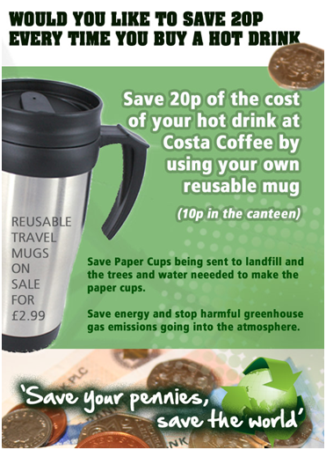

**⯈ RECYCLING**

**⯈ PRODUCT USE**

**⯈ WATER CONSERVATION**

**⯈ ENERGY CONSERVATION**

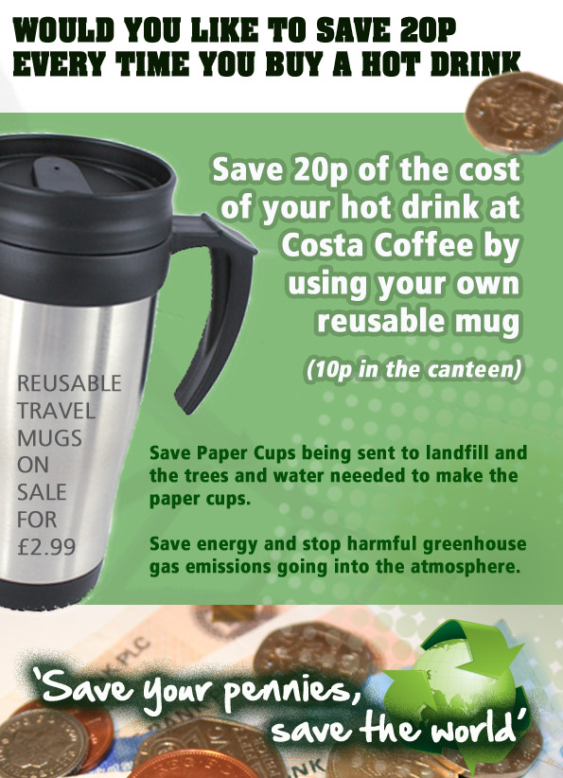

# 13 Reference List

* Carbon Trust (2009). *Carbon footprinting – the next step to reducing your emissions*. London: The Carbon Trust.
* Clark, D., Bangay, R., O’Connor M., & Roche, R. (2009).   
  The Guardian’s quick carbon calculator. *Guardian online*. Available online at: <http://www.guardian.co.uk/environment/interactive/2009/oct/20/guardian-quick-carbon-calculator> *[Accessed 26 August 2011].*
* European Commission. (2010). *Energy Efficiency*. Available online at: <http://ec.europa.eu/energy/efficiency/buildings/buildings_en.htm>   
  *[Accessed 15 August 2011].*
* Global Footprint Network (2010). *2010 Data Tables.* Available online at: <http://www.footprintnetwork.org/en/index.php/GFN/page/footprint_for_nations/>   
  *[Accessed 26 August 2011].*
* Intergovernmental Panel on Climate Change (IPCC) (2007). *Climate Change 2007: Synthesis Report 2007*. Cambridge: Cambridge University Press.
* Met Office. (2009). *UK Climate Projections 2009 (UKCP09).* Available online at: <http://www.metoffice.gov.uk/climatechange/guide/ukcp>   
  *[Accessed 31 August 2011].*
* Stern, N. H. (2007). *The Economics of Climate Change: The Stern Review*. Cambridge: Cambridge University Press.
* World Wide Fund for Nature (WWF) Scotland (2006). *Schools Global Footprint*. Godalming: WWF-UK.

