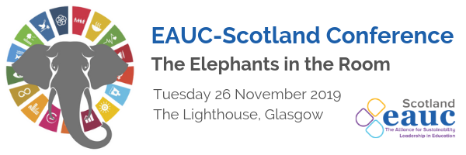
Curriculum for the Future Workshop Notes
Peter Higgins – LfSS/ University of Edinburgh
- Our disconnect from natural world makes us not realise we can change.
- We are susceptible to ‘shifting baseline syndrome’
- Sustainability is a complex of ‘wicked’ problems – how do we educate to address these? Universities and colleges are good at educating, knowledge exchange, policy and engagement – but they are measured and slow to change – which is not good in an emergency.
- Education systems of the world will have to adapt, deal with complexity, uncertainty and change. Learners will have to prepare and be prepared.
- We need to help students understand we are part of planet and not separate.
- “In science, being wrong is only just second best to being right.”
- Graduates need to help find solutions to technical issues for a sustainable future.
- Institutions are good at assessing knowledge, but we can access that already, we need the multi disciplinary thinking skills.
- We need to focus on ‘refounding’ people and civilisation.
Alec Wersun, PRME, Glasgow Caledonian University
- Barriers to transforming the curriculum: 1) Massification and standardisation, 2) Traditional learning and teaching, 3) Traditional methods of assessment
- We need to accelerate innovation in the curriculum.
- There are very few binary choices – we must teach systems thinking.
- There needs to be a big push to teach and learn emotional intelligence.
- Knowledge is inconsequential – it’s being sustainability minded that is of more importance. The ability to way up people/ planet/ profit – it’s a different type of intelligence.
- We should use the SDGs to connect and frame this thinking.
- There are 3 really good open source platforms to enable educators to develop this mindset in students: Sulitest (which gives the basic level of sustainability literacy we should all have), Aim2Flourish, and WikiRate.

