Embedding Education for Sustainable Development in the Curricula
Guidance Document
April 2021
hwunion.com
Heriot-Watt Student Union

Executive Summary
Heriot-Watt University currently has a significant number of programmes that deliver content on sustainability and sustainable development already. The aim of this guidance is to support those staff who are beginning their sustainable development journey and to help in the continuous development of the work of those already on one.

It is well-documented that we are facing a climate emergency that requires a concerted global effort. Everything from individual behaviours to corporate accountability and government policies must be radically changed if we are to reverse the increasing global temperatures to prevent catastrophic climate change. Students are acutely aware of this fact, with 91% of respondents in the 2020 National Union of Students (NUS) Skills Survey agreeing their place of study should actively incorporate SD.

Higher Education Providers (HEPs) are uniquely situated to not only provide crucial research into initiatives like carbon capture but to prepare our future generations of scholars and leaders. We are responsible for facilitating the growth of the next Sustainable Champions who will be integral to solving this climate crisis. They look to us to provide the knowledge and skills required to undertake this work and so we must rise to the challenge and play our part.

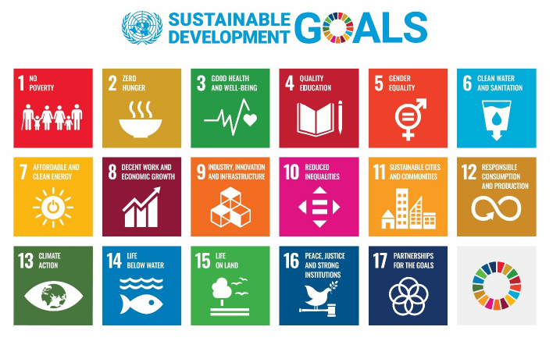
Sustainable development, unlike sustainability, is about the development of those key skills and knowledge to be able to think about the economic, sociocultural and environmental changes needed. It is about the integration of the UN’s 17 Sustainable Development Goals (SDGs) and UNESCO’s key skills and competencies within the curriculum. These are not exclusive to STEM degrees and allow for wider embedment within all disciplines as the aim for a sustainable future is not solely environmental.
Figure 1 United Nation's Sustainable Development Goals
The approach outlined in this document details a holistic, programme-level approach to embedding sustainable development in the curriculum. Sustainable development lends itself best to the whole learner journey rather than within specific courses, particularly as the development of skills and knowledge require time. It is the intention for programme teams to evaluate how they can embed this approach across all the courses in a way that connects them together instead of sitting in silo.

Section 1 – Education for sustainable development

“Our biggest challenge this new century is to take an idea that seems abstract – sustainable development – and turn it into a reality for all the world’s people.” – Kofi Annan, Former UN Secretary General, 2001

Why education for sustainable development, and why now?
There is no denying the world is at a tipping point and has been for a considerable period of time. The lack of integrated, structural changes to combat the growing concerns of our time, be it environmental or economic, has only compounded this. These urgent areas of concern range from, but are not limited to, global climate change, depletion of natural resources, deforestation, local and global biodiversity loss, air quality, access to water, hunger, gender equality, widening wealth inequalities, health and wellbeing.

In order to respond to these challenges, we must unite as a sector across all stakeholder groups to inspire the SD Champions of tomorrow. In the 2020 National Union of Students (NUS) Skills Survey, 91% of respondents agreed their place of study should actively incorporate SD – up from 88% in 2019; while 83% would like to see SD actively incorporated and promoted across all courses – up from 80% in 2019. Time and time again, students have resoundingly voiced their desire for an education more focused on SD.

What is sustainable development?
The most commonly used and accepted definition for sustainable development, from the United Nations (UN) Brundtland Commission:

‘Sustainable development is development that meets the needs of the present without compromising the ability of future generations to meet their own needs.’

For us to collectively create a truly sustainable society at all levels, it must be one that is just, equitable and conscientiousness of environmental limits. SD is so much more than just environmental sustainability; it outlines a framework which can be used to structure our society as a whole in a more sustainable fashion.

No one, be it the students or the University, expects you as curriculum designers to be experts in SD or to suddenly become one. Many academics across the world have designed ESD into their curricula without the prerequisite knowledge and the common denominator in all cases has been one thing: confidence. It is the confidence to make a start that will allow for successful embedding and carry you through the process. If you have the experience and knowledge already but were unaware of where to start, have the confidence to begin that journey and your students will be greatly appreciative.

What is ‘education for sustainable development’?
For the purpose of this guidance, we adopt the definition of ESD proposed by the United Nations Educational, Scientific and Cultural Organisation (UNESCO):

‘ESD empowers learners to take informed decisions and responsible actions for environmental integrity, economic viability and a just society, for present and future generations, while respecting cultural diversity. It is about lifelong learning, and is an integral part of quality education. ESD is holistic and transformational education which address learning content and outcomes, pedagogy and the learning environment. It achieves its purpose by transforming society.’ (UNESCO, 2019).

It is easiest to consider ESD not as focussing solely on sustainable development but a mechanism for revolutionising education into something that is grounded in transformative learning and critical pedagogy, as well as SD principles. ESD allows us to enhance our current world by working towards a vision of the future.

The UNESCO definition of ESD acknowledges the importance of holistic and transformational education. Such an education does not exist solely in the curricula but is supplemented by those activities out with the classroom. ESD goes beyond expanding one’s knowledge base and instead focuses on supporting the development of the competencies, skills, attributes and values required to address SD challenges.

Sustainable Development Goals
In 2015, global leaders committed to 'Transforming Our World: The 2030 Agenda for Sustainable Development' (UN, 2015). Central to this agenda are the 17 Sustainable Development Goals (SDGs) as highlighted in Figure 1. The SDGs are comprehensive in focus, with an ambitious aim of uniting countries in trying to address key SD challenges by 2030. They cross political, economic, social, environmental and technological boundaries and require collaboration across all sectors, meaning the 17 SDGs make for an important and useful tool for shaping ESD currently and in the future.
The SDGs provide a useful starting point for lecturers and students interested in including SD content and challenges in programmes and courses. Their breadth and depth mean that you may find resonance across all disciplines and subject areas at both the course- and programme-level. As academics, you’re encouraged to develop a greater understanding by reading the UN resources which address the SDGs and provide access to those that may be of value to educators and students alike at www.un.org/sustainabledevelopment and https://sdgs.un.org.

ESD (as highlighted in SDG4 'Quality education and lifelong learning opportunities for all') is fundamental to achieving all of the goals. In fact, one of the targets of SDG4 is 'to ensure that all learners acquire the knowledge and skills needed to promote sustainable development'. UNESCO and the UK government have established their belief in the importance of ESD in achieving the SDGs through the adoption of a new global framework 'Education for Sustainable Development: Towards achieving the Sustainable Development Goals', also referred to as 'ESD for 2030'.

Questions to consider
- Is ESD something you have considered in your teaching?
- Could you explain to external bodies, e.g. Quality Assurance Agency Scotland or the Scottish Funding Council, what the University is doing in relation to ESD?

Section 2 – Designing Education for Sustainable Development

The role of higher education in creating a sustainable future
As education providers, we are the issue and the opportunity, the problem and the solution to embedding the behaviours and knowledge needed to create a sustainable future. We are responsible for creating and inspiring the leaders of tomorrow. If the world is to adopt such radical changes to the fundamental structures of society, Higher Education is the cornerstone of this work as we are critical in transforming the thinking of our graduates. ESD can play a crucial role in this process. In this respect ESD is about:
1. Supporting students to develop the competencies and motivation to pursue visions of the future.

2. Supporting students to appreciate the complexity of our world and the problems we have caused.

3. Challenging, supporting and enabling students to co-design solutions and drive change.

Positioning ESD within the curriculum
As stated in Section 1, the 17 SDGs (Figure 1) can offer a useful starting point to initiate discussion about ESD in the curriculum. The breadth of the SDGs offers scope for ESD to include learning in relation to, for example:
• the causes of and solutions to poverty
• health, education, social and gender inequalities
• responsible consumption, production and economic development
• climate change and food production.

The breadth that the SDGs allow encourages and stimulates discussion around how best to position SD in the curriculum. It is these discussions where the SDGs can assist curriculum designers, course management and teaching teams to consider a holistic approach to how ESD can be designed into the curriculum rather than as an addition to it. The key takeaway is that academics are the most effective champions of SD and sources of inspiration for their students that a University has. With a knowledge of the concepts of SD and ESD, and adoption of a simple approach, it is easy to have a significant impact on a course-level.
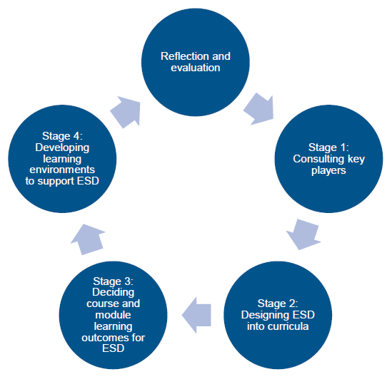

The process of positioning ESD within the curriculum is not a linear one. Instead, it requires cyclical reflection and evaluation to consider the efficacy of current approaches and how these can be adapted to suit the needs of your students. This is presented as a four-stage approach, which is outlined below.

Figure 2 The process of positioning ESD within the curriculum.

Stage 1: Consulting key players
Whether or not the 17 SDGs are used as the starting point, curriculum design is a dynamic and ongoing process, and there will be key players beyond the academic community who could help inform the curriculum design process. You may find yourself consulting these groups before the curriculum is designed (or redesigned) and that the 17 SDGs act as a cornerstone of such conversations. Some of these groups are highlighted below, but this is far from an exhaustive list and all approaches should reflect the audience, stakeholders, and expertise of the institution. Conversations with these groups should be ongoing and iterative rather than occurring solely at the start of the curriculum design process. In this respect, designing ESD into curricula can be a truly co-creative approach.

Key players to consult and areas to consider when embedding ESD within the curriculum include:

- Students
- Employers and enterprise
- Academic Staff
- Professional service teams and academic governance
- Institutional approach
- Civic engagement

Stage 2: designing esd into curricula
Designing ESD into curricula can be achieved via in a variety of ways. You may benefit from a whole curricular approach, within core and optional modules, as multidisciplinary, interdisciplinary or transdisciplinary approaches or as co-curricular or extracurricular activities. The important thing is to utilise an approach that reflects the uniqueness of your subject area in its relation to SD. Guidance for the application of this holistic approach to ESD can be found in the Advance HE publication The Future Fit Framework (2012).
In these times of uncertainty, with rapid global environmental and social change, there is an increasing shift towards seeking graduates with capacities for adaptation and resilience. ESD supports these capacities by focusing on competencies required to act on or interpret knowledge. It can be useful to think in terms of the competencies that students may expect to develop through engaging with an activity. The importance of competencies within ESD is emphasised by UNESCO:

'ESD aims at developing competencies that empower individuals to reflect on their own actions, taking into account their current and future social, cultural, economic and environmental impacts, from a local and a global perspective.'

These eight key ESD competencies for all learners of all ages worldwide (Table 1) can be adopted and adapted for higher education.
Table 1 UNESCO's key competencies for sustainability
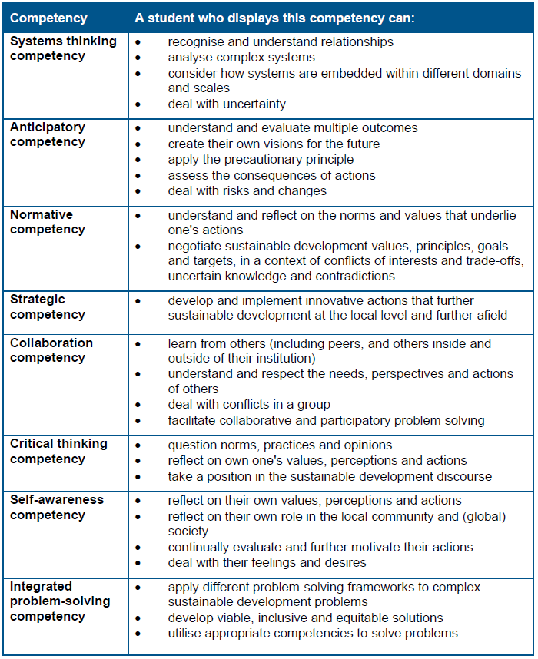
This list focuses on what is important for the students’ individual developments and growth during their studies. These are about building the necessary skills, attributes and values that are critical to achieving a sustainable future. The key competencies have relevance across all disciplines and are relevant to all modes of learning, be it in the classroom or out with it.

Stage 3: deciding course and programme learning outcomes for esd
ESD at the course-level is about recognising how students can develop the key values and thinking that will empower them to make real change in their future careers. The skills they develop through ESD, facilitate by the competencies and learning outcomes, enables them to make informed decisions and critically evaluate the consequences of their actions on current and future stakeholders.
As you adapt your learning outcomes to situate ESD in the curriculum, there are various approaches that can be taken to melding your existing ones with the cross-cutting competencies discussed in Stage 2. Make sure to use the course-level outcomes as a guide to design those at the programme-level, ensuring students are able to achieve the SD-related outcomes of the course. It is important to be cognizant of where there is SD focus within the learning outcomes of both the course and programme, allowing for adaptation across both to situate SD concepts within the curriculum content and outcomes.

The learning outcomes are not the sole opportunity for SD focus as activities can be included within the content of the programme. Examples of how this might be achieved include:
- use of data on SD issues
- inclusion of a debate with students on the relevance of SD issues to the programme ('how might the learning on this programme help someone to take action on an issue referenced in the SDGs?')
- reference to academic journal material from the discipline with a SD focus
- introduction of an organisation relevant to the discipline/profession which is explicitly committed to SD and/or the SDGs
- consideration of professional, statutory and regulatory (PSRB) bodies focus on SD
- identification of one or more SDG targets which are relevant to the programme
- inviting an external speaker with expertise to speak about SD in relation to the subject/discipline area, or
- inclusion of research which brings a SD focus to the programme topic.

In deciding the revised learning outcomes and course activities, it may be worth considering mapping out the learner journey to reach the agreed outcomes throughout the years of study. This will allow you to identify the most suitable points to introduce students to core SD principles and issues as well as develop their depth of engagement.

Stage 4: Developing learning environments to support esd
Successful embedding of ESD within the curriculum requires alignment of all aspects of the course to be designed so as to meet the key SD competencies and learning outcomes. As academic staff, you can deliver transformative learning experiences that challenge ways of thinking and empower your students to become champions of SD. These experiences require students to be exposed to a range of perspectives, reflect on their experiences, and tackle real-world issues. ESD should not be siloed to the classroom. It is critical that you inspire and facilitate exposure of your students to extra and co-curricular activities as well as experiential and work-based learning or volunteering for their local community. Assessment activities should promote reflection due to the developmental nature of the competencies, ideally through self- and/or peer assessment, synoptic assessment, and learning through assessment.

ESD requires a learning environment in which:
- interdisciplinary or transdisciplinary learning approaches are facilitated
- learning is inclusive and accessible for all
- policies support synoptic assessment
- extra and co-curricular opportunities are provided and recognised.

Take advantage of the opportunities for learning that the campus and local community present and align these with the course activities wherever possible. Do not shy away from the valuable opportunities that online spaces present either. There is a richness of activity at your fingertips that can be drawn on through modelling the campus and community as a live experiment or case study that can demonstrate the interconnectedness of SD with community development, local governance, business and economic relationships, even food production and management of natural resources.

Most importantly, the new blended learning mode that the University has adopted and will maintain presents flexible learning opportunities that can greatly benefit both the course team and students. Innovate with the use of teaching spaces, use the digital capabilities in creative ways and look at how you can modernise assessments to reflect the changing digital world that surrounds us. We are innately connected to a vast world rich with cultural experiences and knowledge to draw upon that all stakeholders can benefit from. However, it is important to refrain from being overzealous and remaining conscious of the potential digital divide that exists across your students.

Section 3 – case studies

Engineers Without Borders (EPS)

Shaping Tomorrow Together (EGIS)

Students learn through engaging, debating and presenting meaning the LOs are met more by the process than the final outcome, which is reflected in the Assessment Criteria.

Section 4 – A Toolkit to inform the ESD process
This section can be used alongside Section 2 to support the design of ESD into curricula. Below are a range of reflective questions that may be helpful in deciding the ESD focus of the course.

Reflective questions to support designing ESD into curricula
Informing the conversation/stakeholder engagement with the curriculum
Curriculum designers may wish to consider the following when consulting key players identified in Section 2:
- What do students see as a priority for the integration of ESD into this curriculum? What do they want to learn, experience and contribute?
- What challenges does the subject area face regarding the environmental and social changes taking place?
- How is SD addressed by employers of the subject area? How can we prepare graduates to help employers meet their SD challenges? What SD challenges and critiques do these organisations face from legislation and the wider society and how might they respond?
- What are the SD needs, interest and priorities of society connected with the provider, e.g. local communities, voluntary groups, and public sector organisations? Which of these might your students be able to engage with and how can the course facilitate this activity?
- How is the University engaged with SD? What actions are estates management teams taking to make the organisation ‘green’? What relevant research does the University conduct, particularly in your department? Which of these might your students be able to learn from and engage with during their studies?
- Is the Student Representative Body active in SD-related activities? Do they run any clubs or societies that may interact with curricula, e.g. sustainability or academic societies?
- In terms of stakeholder input, what are the core educational priorities for embedding ESD into your course, with regards to content, connection and experience? How can stakeholders co-facilitate this happening?
- Which key players are interested in partnership working to create educational experiences (projects, experiential learning, case studies, simulation activities) linked to these priorities?

Integrating at the curriculum design level
These questions are of particular use to curriculum designers.
- What understandings and experiences of your subject area related to ESD do you want every student on your course to have? How can you incorporate this into the learning outcomes for your course?
- There will be students who want to explore the relationship between the subject area and SD on a deeper level. What understandings and experiences do you wish to offer them, and how can this choice be provided?
- What content, e.g. themes, case studies and questions, arising from SD would support the educational priorities for ESD you have identified in the course?
- What perspectives and ideas can you draw on from other disciplines to promote an interdisciplinary/transdisciplinary approach? How can you challenge your students beyond the conventions and ways of knowing of the subject area?
- What educational experiences do you want to provide to your students that will most effectively address course and subject priorities and engage students with the eight UNESCO competencies?
- How can you effectively offer a meaningful interdisciplinary experience? What might be the barriers (if any) to interdisciplinary learning and how can you overcome these?
- How can you connect the key players consulted to the educational experience, e.g. surveys, focus groups, industrial events?
- Are your students provided with and supported in developing opportunities to put their ESD learning into practice? If not, how might you facilitate this?
- How can your course encourage students to seize and shape opportunities and respond to authentic SD challenges beyond the institution? Are there extracurricular activities that the course can provide?
- Does your course offer multi-disciplinary approaches to the curriculum that allow students to develop their networks and create wider experiential opportunities linked to ESD?
- How will you evaluate the integration of ESD into course design?
- Are there institutional key performance indicators that designing ESD into curricula may support? How can this be used to gain traction for ESD?
- Is there need for staff development to enable any of the above considerations to progress? If so, which internal and external support could you utilise?

Student experience beyond the curriculum
These questions are of particular use for institutional leads.
- Does your student induction include a SD focus, including an understanding of institutional activity, and how students can contribute?
- Is there student representation on institutional/local committees with a SD focus?
- Are students involved in conversations beyond the committee structure about ESD?
- Can staff and students contribute to and critically engage with institutional strategy and actions on ESD?
- Do the volunteering and extracurricular activities you promote cater for students wishing to engage with SD challenges?
- Is the Careers Service able to guide students who wish to actively contribute to SD challenges in their careers?
- Is the Careers Service able to provide students with information on the environmental and social performance of potential employers? Is it able to effectively support students who wish to take such considerations into account in their career search?
- Have all graduates had curricular, co-curricular and extracurricular opportunities to develop a range of ESD competencies in order to be future change leaders throughout their lives?

Strategic, institution-level questions
It is well-recognised that a strategic institution level commitment is importance when looking to progress ESD in Higher Education. Those staff and committees which focus on academic standards, quality and enhancement are critical to the ESD process. The following questions may be useful to staff who are able to effect change at an institutional level by supporting academic colleagues designing ESD into curricula.
- How is a commitment to ESD incorporated into the University’s educational strategy, e.g. L+T Strategy, Curriculum Framework, Graduate Attributes? Are any there any strategic objectives, targets and KPIs adopted?
- Is ESD and the curriculum discussed in the annual review of each programme?
- Is ESD, and how it is incorporated within curricula and the student experience, part of academic appraisal and/or promotion criteria?
- Are new academics introduced to institutional strategies and drivers for ESD as part of their induction/training process?
- How can ESD positively contribute to the University’s cross-cutting agendas such as EDI, decolonisation, accessibility of the curriculum, civic engagement, widening access and participation? How might explicitly articulated and integrated ESD objectives help strengthen such activities?
- Is there an institutional commitment to ESD that is presented to all new students as part of their induction?
- Can the institutional and local academic quality and standards committees help academics and course teams in designing ESD into the curriculum?
- How can quality assurance and enhancement staff, as well as the Learning and Teaching Academy, enable course teams to design ESD into curricula?
- Do you receive student feedback that can inform the design of ESD into curricula? Are there subject-relevant ESD parts of the student surveys, course feedback, placement and work experience feedback?
- What approach is or can be taken to evaluate the efficacy of ESD at the University?
- Do academic colleagues understand the SD context of their own subject area and associated professional contexts? If not, how can you enable this?
- Are academic colleagues encouraged to create opportunities for the sharing of SD ideas, knowledge exchange and experiences across the institution?
- Do academic colleagues have the knowledge and skills to facilitate discussion of SD from different disciplines, subjects, places, cultures and generations? If not, how can this be enabled at an institutional level?
- Can academics critique different perspectives on ESD dilemmas, issues, tensions and conflicts within their subject area? If not, how can this be enabled at an institutional level?
- Do academics have the knowledge and capacity to include ESD competencies and learning outcomes in developing their learning and assessment activities? If not, how can this be enabled at an institutional level?
- Are educators supported to align ESD with enterprising and entrepreneurial activities?

Appendix – Current Practice Audit Tool
Please tick the most appropriate response for your course, being as open and honest with yourself as possible.
1 – Always 2 – Often 3 – Sometimes 4 – Rarely 5 – Never

 |  | 1 | 2 | 3 | 4 | 5
1 | Is ESD something you have considered in your teaching?
2 | Could you explain to external bodies what the University is doing in relation to ESD?
3 | Do you include SD as part of tutorials?
4 | Do you explore short courses/modules/topics you could develop with a sustainability theme?
5 | Do you speak to local businesses about mutually beneficial courses and activities?
6 | Do you seek to widen your local networks to bring in more funding and expertise from outside?
7 | Do you build ESD into the learning outcomes for your course?
8 | Do you consider opportunities to incorporate SD into existing assessments?
9 | Do you explore the sustainability issues in your community?
10 | Have you identified potential learning opportunities in how the University is managed?
11 | Do you look at future plans within the University to see if there are learning opportunities?
12 | Do you explore opportunities for cross department or cross faculty collaboration?

References
Advance HE and QAA Scotland (2021) Education for Sustainable Development Guidance. 1st ed. 2021.
Brannigan, J., Deacon, H., Esat, E., Grimshaw, P., Harry, L., Kelly, M., Meakin, D., Patton, I., Salter, J., Sinnott, G., Stanley, A. and Summers, D., n.d. Embedding Sustainable Development in the Curriculum. [ebook] Sustainability Exchange. Available at: <https://www.sustainabilityexchange.ac.uk/files/embedding_sustainabilyt_in_the_curriculum_guide.pdf> [Accessed 23 February 2021].

Further reading
Global Education Monitoring Report: Inclusion and education: all means all (2020) https://unesdoc.unesco.org/ark:/48223/pf0000373718
The 2020 GEM Report assesses progress towards Sustainable Development Goal 4 (SDG 4) on quality education and its 10 targets, as well as other related education targets in the SDG agenda. The Report also addresses inclusion in education, drawing attention to all those excluded from education, because of background or ability.
Education for Sustainable Development Goals: learning objectives (2017)
https://unesdoc.unesco.org/ark:/48223/pf0000247444
The UNESCO document is the key publication supporting the Education 2030 Agenda. It frames ESD with reference to the delivery of the UN SDGs while exploring learning objectives in relation to the SDGs, and the integration of ESD principles in curricula.
Education for Sustainable Development Lens: A Policy and Practice Review Tool (2010) https://unesdoc.unesco.org/ark:/48223/pf0000190898
Output developed by UNESCO linked to the Decade of Education for Sustainable Development (DESD), to assist reorientation of education at school level and relevant to all tertiary education. Prepared by recognised global ESD experts, piloted in three of five UNESCO regions (Africa, Asia, Latin America and Caribbean) to include regional and country views. Coverage includes overview of ESD principles and how this relates to mainstream education goals, reviewing ESD practice and policy, quality assessments and learning outcomes in ESD.
Shaping the Future We Want: UN Decade of Education for Sustainable Development (2005-2014) Final Report (2014) https://unesdoc.unesco.org/ark:/48223/pf0000230171
Closing report on the UN Decade of ESD, points to leadership challenges in embedding ESD in higher education as well as the need for staff development, capacity-building and institutional networks. Developed by the Decade of ESD monitoring and evaluation expert group, supported by commissioned papers from various global experts in ESD and sustainable development.

Leal Filho, Salvia, Pretorius, Brandli, Manolas, Alves, Azeiteiro, Rogers, Shiel, Do Paco, Salvia, Amanda Lange, Pretorius, Rudi W, Brandli, Luciana Londero, Manolas, Evangelos, Alves, Fatima, Azeiteiro, Ulisses, Rogers, Judy and Shiel, Chris (2020) Universities as Living Labs for Sustainable Development. 1st ed. 2020.
Leal Filho, Azeiteiro, Alves, Molthan-Hill, Azeiteiro, Ulisses M, Alves, Fátima and Molthan-Hill, Petra (2017) Handbook of Theory and Practice of Sustainable Development in Higher Education. 1st ed. 2017.
Caniglia, Guido, John, Beatrice, Bellina, Leonie, Lang, Daniel J, Wiek, Arnim, Cohmer, Sean and Laubichler, Manfred D (2018) ‘The glocal curriculum: A model for transnational collaboration in higher education for sustainable development’, Journal of cleaner production. Elsevier Ltd, 171, pp. 368–376. doi: 10.1016/j.jclepro.2017.09.207.
van den Hoven, Jeroen (2019) ‘Ethics and the UN Sustainable Development Goals: The Case for Comprehensive Engineering: Commentary on "Using Student Engagement to Relocate Ethics to the Core of the Engineering Curriculum"’, Science and engineering ethics. England: Springer Netherlands, 25(6), pp. 1789–1797. doi: 10.1007/s11948-016-9862-2.
Holm, Tove, Sammalisto, Kaisu, Grindsted, Thomas S and Vuorisalo, Timo (2015) ‘Process framework for identifying sustainability aspects in university curricula and integrating education for sustainable development’, Journal of cleaner production. Elsevier Ltd, 106, pp. 164–174. doi: 10.1016/j.jclepro.2015.04.059.
Leal Filho, Walter, Salvia, Amanda Lange, Pretorius, Rudi W, Brandli, Luciana Londero, Manolas, Evangelos, Alves, Fátima, Azeiteiro, Ulisses, Rogers, Judy, Shiel, Chris and Do Paco, Arminda (2019) Universities As Living Labs for Sustainable Development, Cham: Springer International Publishing AG.

