3D printer and extruding machine for open Day, workshop programme and module Teaching for Sustainability
Name and possible Level | Picture and Price | Website
ProtoCycler+ Filament Makers (2pc) | 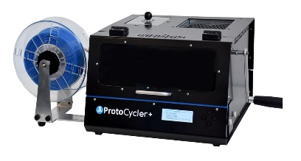 $3,999.00 USDx2  £3296.38x2 | https://redetec.com/products/protocycler?variant=39805373743152
CREATBOT F160 - PEEK VERSION (higher temperature of 450Deg) | 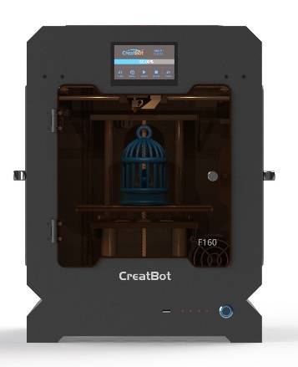£1,926.90/pc Inc. VAT | https://technologyoutlet.co.uk/products/creatbot-f160-peek-version#tabs  https://technologyoutlet.co.uk/products/creatbot-f160-peek-version#tabs  or  https://3dprintersdepot.com/products/creatbot-f160-3d-printer
Ultimaker S3 3D Printer 3-Year Warranty Extension | 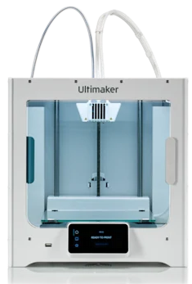 £602.47/pc  (inc. VAT) | https://uk.rs-online.com/web/p/3d-printer-software/2121293
Upgraded Speed Adjustable 3D Filament Extruder Machine 3D Filament Extruder Machine | 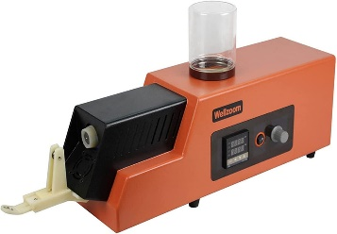£1,094.28/pc | https://www.amazon.co.uk/Upgraded-Adjustable-Filament-Extruder-Machine/dp/B09JC479DN/ref=sr_1_14?crid=3DEUYE5BIBMYE&keywords=filament+extruder+machine&qid=1674073359&sprefix=filament+extruder+machine%2Caps%2C518&sr=8-14
Total | £10,216.41 | £10,216.41
Installation, Commissioning, and Training: | £500 | £500
Operating and Maintenance costs per annum: | £400 | £400
Total | £11,116.41 | £11,116.41

