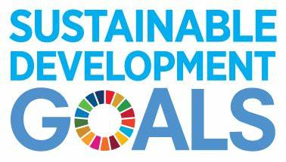

This simple activity is best completed with a copy of the curriculum you are mapping beside you. For each SDG you should consider how your course or module links to this SDG. If you do not teach consider how each SDG relates to your job role.

In the spaces provided detail what you are already doing which links to that particular SDG, and suggest what you could be doing to embed that SDG further in your practice.

Already Doing:

Could do:

Could do:

Already Doing:

Could do:

Already Doing:

Already Doing:

Could do:

Could do:

Already Doing:

**QUICK**

**MAPPING**

Could do:

Already Doing:

Could do:

Already Doing:

Could do:

Already Doing:

Already Doing:

Could do:

Already Doing:

Could do:

Already Doing:

Could do:

Already Doing:

Could do:

Already Doing:

Could do:

Already Doing:

Could do:

Already Doing:

Could do:

Could do:

Already Doing:

Could do:

Already Doing: