Communicating Climate Change Adaptation at The University of Edinburgh

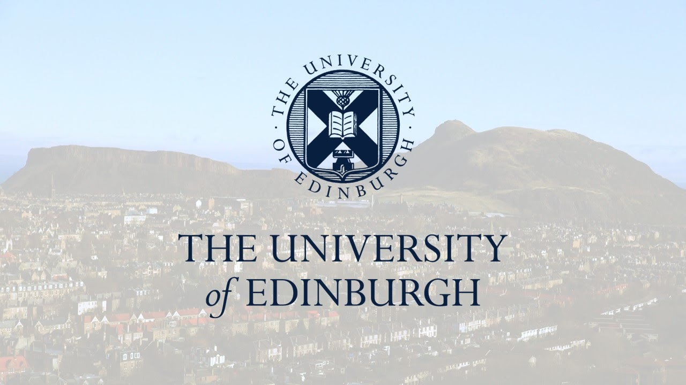
August 2017
Chris Guest

  - Executive Summary
The University of Edinburgh Climate Change Strategy 2016-2026 presents a bold vision to become carbon neutral by 2040. Importantly, however, the Strategy also recognises the role of adaptation in ensuring that the University is sustainable and resilient in the face of the climate changes that are already, and that may become increasingly, ‘locked-in’.
Communication is fundamental in ensuring University stakeholders understand, support, and act upon, climate change adaptation measures taken by the University. It is therefore important to identify these stakeholder groups, and to consider how adaptation communications can be tailored to different groups effectively.
This brief report outlines eight recommendations for the University of Edinburgh when considering communicating the University’s forthcoming adaptation strategy, as well as the University’s pre-existing and future adaptation measures, to a variety of key stakeholders.
The recommendations are as follows:
- Use a range of communication methods
- Values-based communication
- Communicate additionality
- Communicate a narrative
- Communicate choice
- Use adaptation language effectively
- Manage audiences’ expectations
- Evidence leadership through adaptation

  - Introduction
Section 44 of the Climate Change (Scotland) Act places duties on public bodies relating to climate change, requiring them to contribute to Scotland’s carbon emissions reduction targets, climate change adaptation, and to act sustainably.
As such, The University of Edinburgh Climate Change Strategy 2016-2026 presents a bold vision to become carbon neutral by 2040. Importantly, however, the Strategy also recognises the role of adaptation in ensuring that the University is sustainable and resilient in the face of the climate changes that are already, and that may become increasingly, ‘locked-in’. As noted in the Strategy, climate change in Scotland has already brought warmer, wetter autumns and winters and hotter summers.
The Scottish Government’s Climate Change Adaptation Programme, launched in 2014, addresses issues raised by the climate change risk assessment undertaken for Scotland, and its aims and themes provide the foundation for the University of Edinburgh’s approach to adaptation: climate ready natural environment, climate ready buildings and infrastructure networks, and climate ready society.
However, several barriers to action in adaptation have been identified by the Scottish Government, including a lack of awareness and support, a tendency for organisations and individuals to focus on short-term measures, and a resistance to behavior change. Furthermore, decision-makers often know too little about the possibilities of, and benefits to, adapting to climate change. As such, communication is fundamental in ensuring University stakeholders understand, support, and act upon, climate change adaptation measures taken by the University.
The University recognizes this, identifying the following priorities for communications as part of a climate ready community:

- Raising awareness of the importance of adaptation amongst staff and students through targeted events (etc)
- Raising public awareness of University projects in this space, considering how to communicate messages effectively, including signposting at sites

This brief report outlines eight recommendations for addressing these priorities and simultaneously communicating the University’s forthcoming adaptation strategy, as well as pre-existing and future adaptation measures, to a variety of key stakeholders.
The paucity of examples of public sector organisations communicating their adaptation activities presents an opportunity for The University of Edinburgh to become an exemplar globally of how to strategically communicate climate change adaptation in a university context.

  - Understanding Adaptation Stakeholders
The University of Edinburgh’s Climate Change Strategy 2016-2026 presents a ‘whole institution’ approach, which encompasses, and makes connections between, University research, learning, teaching and operations. Such a holistic approach has been taken by universities such as Harvard, Stanford and UBC.
Nevertheless, such a holistic approach must recognise the different approaches required to communicate adaptation as opposed to mitigation activities. Furthermore, different stakeholder groups may need different information to be effective in their decisions and way of acting on the challenge of adaptation to climate change. It is necessary to understand the nature of the different audiences to be successful in effective, tailored communication. For that reason, the following groups have been identified as being a priority consideration for the University, each requiring a strategic approach to adaptation communications:
External Groups
- Local Community: As the University of Edinburgh’s physical infrastructure is integrated within, and across, the city of Edinburgh, ensuring the support of the local community is critical in any physical adaptation measures taken. The local community also offers a wealth of knowledge in understanding where climate change impact ‘hotspots’ may exist.
- Future Students: Ensuring future students and parents are free from the fear of adverse climate change impacts in and around the University’s spaces is important in future business continuity. Communication of adaptation activities can create a positive brand image that can present the University as a ‘safe’ environment, especially to students for regions or countries significantly impacted by similar adverse climate impacts in the future.
- Adaptation Support Organisations: The University is an active member of a number of local and national groups that address adaptation. Continuing to communicate with these groups is an important means of ensuring shared learning that is specific to the University’s geographic context.
Internal Groups
- University Risk Managers: Ensuring that University staff with responsibilities for risk management are regularly engaged on adaptation activities is critical in understanding the language required to be used to gain support for such activities internally, and for ensuring an understanding of the barriers and opportunities for such activities.
- Current Students: Current students represent a wealth of information about the University’s physical environments, the surrounding areas, and innovative ideas. Students benefit from routinely having to engage in foresight and are thus used to imagining a world different to that experienced now. Envisaging likely climate change impacts, and their potential solutions, is therefore likely to suit willing students.
The recommendations in this report identify the stakeholder groups who are likely to benefit most from implementing each recommendation. To reiterate, it may be the case that such groups may be more/less ‘important’ when it comes to communicating the University’s mitigation activities, and thus again a tailored approach should be sought.

  - Recommendations

Recommendation 1: Use a range of communication methods
Stakeholder groups targeted: All
Various formats for communication exist and can prove useful. Such formats include personal consultations, internet communication/platforms, and mass media. These formats should be bundled and refined in ways suitable to different stakeholder groups where possible.
Similarly, publishing communications in different languages can ensure that prospective international students – especially those from regions likely to be significantly impacted by climate change – view the University as a potential ‘safe’ environment in which to study.
When addressing internal audiences, especially when seeking buy-in to a proposal, consider communicating by non-standard methods. Rather than generic powerpoints, consider, for example, site visits to at-risk parts of the campus.

Recommendation 2: Values-based communication
Stakeholder groups targeted: All
When communicating adaptation it is important not to focus solely on profit. Instead, it can be beneficially to target an individuals’, or groups’, values. According to XXXX, when designing adaptation messages, one should focus on ‘self-transcending’ values wherever possible. For example, by explaining that food on University sites will be predominantly sourced locally – as a means of adapting to uncertain long-distance supply chains for example – this can be framed around advancing a food system that provides greater social and economic benefits for the local community, thus potentially appealing to stakeholders’ values.
As such, it can be important to identify what the target audience is passionate about and consider how this may be impacted by climate change. For example, communicating to students the adaptation measures being put in place to ensure sports facilities remain resilient to climate change.

Recommendation 3: Communicate additionality
Stakeholder groups targeted: Internal budget holders and decision-makers
In advancing a ‘whole institution’ approach there will be many opportunities to communicate the ‘additionality’ of adaptation measures, whether they be cost-savings, increased non-climate related resilience, or brand enhancement.
Importantly, current work being undertaken by the University to build business sustainability that can be seen as a climate change adaptation measure can also be used to communicate additionality.
Finally, where adaptation work simultaneously advances research and/or teachning/learning alongside building climate resilience this may also be framed in terms of the additionality of the adaptation work.
An example of additionality is where adaptation involves the expansion of green and blue spaces, which has benefits in terms of student experience of campuses, well-being for both staff and students and biodiversity conservation.

Recommendation 4: Communicate a narrative
Stakeholder groups targeted: External stakeholders
It can be important to communicate adaptation decisions and activities as a ‘narrative’, which can be enhanced through images and relatable stories. This can connect the ‘bigger picture’ of climate change to people’s lives and communities. In these instances, it’s important to deliver a headline message before scientific caveats and uncertainties. Whilst these narratives should also be kept succinct or include key bullet points at the start.
It may be beneficial to use severe weather to start a discussion about long-term preparedness and adaptation, however it is important not to over-exaggerate the link between a single weather event and climate change.
Finally, communicate a holistic narrative that incorporates Zero by 2040 and the University’s adaptation strategy, where possible, as this enables a richer story to be delivered.
See Adaptation Scotland’s adaptation stories for examples of communicating a relatable narrative: http://www.adaptationscotland.org.uk/get-involved/our-projects/local-climate-stories

Recommendation 5: Communicate choice
Stakeholder groups targeted: Internal budget holders and decision-makers
Frame adaptation thinking as a decision-making tool, and present a range of scenarios and options, with estimated costs and risks where possible, to provide internal stakeholders with a sense of ownership over decisions made about adaptation.
Emphasising the benefits of action rather than the risks of in-action can also be important in accompanying the presentation of such options.
Moreover, considering adaptation when making strategic business decisions more generally enables (or at least does not inhibit) greater flexibility and more robust scenario planning.

Recommendation 6: Use adaptation language effectively
Stakeholder groups targeted: All
When communicating adaptation it is important to recognise that adaptation may be an unfamiliar term, thus concrete actions must first be describes in order to illustrate what is meant by the term.
Where adaptation is a negatively loaded term, it’s important to reframe adaptation in ways that makes it consistent with, or an extension of, responsible planning, existing high-priority management concerns, and already familiar decision-making in the face of uncertainty.
It is also important to use language that taps into values that are resonant with the audience (preparedness, responsibility, resilience, transparency, etc) – see Recommendation 2.

Finally, it is important to highlight the positives of uncertainty. Climate change science is characterised by uncertainty, and therefore adequate attention must be given to how both the terms ‘risk’ and ‘uncertainty’ are framed to ensure that the two are not conflated.
A new Uncertainty Handbook released by the University of Bristol and the Climate Outreach and Information Network distils research finding and expert advice to set out 12 principles of smarter communication around climate change uncertainty.

Recommendation 7: Manage audiences’ expectations
Stakeholder groups targeted: All
One of the main reasons for identifying an organisation’s stakeholders is so that the expectations of such stakeholders can be managed more effectively. These stakeholders may differ to those being engaged with for the purpose of climate change mitigation, and therefore may require different levels of engagement and action from the University than has been foreseen through the broader Climate Change Strategy.

Recommendation 8: Evidence leadership through adaptation
Stakeholder groups targeted: External stakeholders
Universities should provide leadership in communicating anticipated local and regional climate changes, and articulating what these changes mean for local and regional residents and businesses.
By acting as a centre for leadership on adaptation, the University of Edinburgh can enhance its reputation within the local community – something which may prove appealing when attempting to secure the buy-in from internal stakeholders to adaptation measures.
  - Case Study: Cornell University
Cornell University was the first major U.S. university to include climate adaptation in its Climate Action Plan.
Based on estimates, Cornell could experience significant capital losses and health related costs in the range of $10,000 to $10M per event from predicted increases in severe droughts, flash floods, heat waves, and disruptions to water filtration systems as a result of climate change. If climate adaptation planning can help the University to anticipate and mitigate just 10% of these losses, savings could range from $1,000 to $1M per event – or more.
The goal of the University’s adaptation activities therefore is to educate students and staff on campus about climate change impacts, engage faculty in climate adaptation research and demonstration projects, and help reduce future climate-related risks to the Cornell and Ithaca community through appropriate upgrades to campus infrastructure and protocols.
As such, Cornell’s approach could be seen to be representative of a ‘whole institution’ approach and thus represents a potential case study for the University of Edinburgh to study.
See more at: http://www.sustainablecampus.cornell.edu/initiatives/climate-adaptation-planning
  - Useful Links
Adaptation Scotland. Communicating climate change adaptation: A practical guide to values-based communication.
https://www.adaptationscotland.org.uk/how-adapt/tools-and-resources/communicating-adaptation

Adaptation Scotland. Local Climate Stories.

http://www.adaptationscotland.org.uk/get-involved/our-projects/local-climate-stories

Climate Outreach. The Uncertainty Handbook: A Practical Guide for Climate Change Communicators.

http://www.climateoutreach.org.uk/portfolio-item/uncertainty-handbook/
Cornell University. Climate Adaptation Planning.
http://www.sustainablecampus.cornell.edu/initiatives/climate-adaptation-planning

S. Mosey (2014). Communicating adaptation to climate change. WIREs Clim Change 2014, 5:337–358. doi: 10.1002/wcc.276

The Guardian. 12 Tools for Communicating Climate Change More Effectively.
https://www.theguardian.com/sustainable-business/2015/jul/06/12-tools-for-communicating-climate-change-more-effectively
The University of Edinburgh. Climate Change Strategy 2016-2026.
http://www.ed.ac.uk/about/sustainability/themes/climate-change/climate-strategy/read
For further information, please contact:
Chris Guest
+44 (0)750 3180313 / S0810186@ed.ac.uk

